Basics

**A design pattern**

help us identifying recurring problem and provide ready to use solution to solve that problem

**Singleton :--**

want to create only one object of a class , no matter how many times the class is used in the application

**A design Problem**

Is a solution of problem in a given environment or context

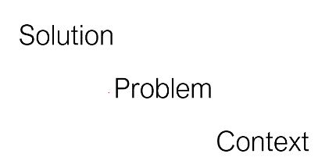

**Why Patterns**

When similar problem happen we can reuse it solution across application

Define the system structure better

Provide a common design language

Project will be structured better when we follow design pattern

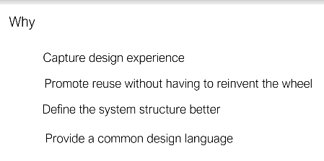

**Pattern Identification**

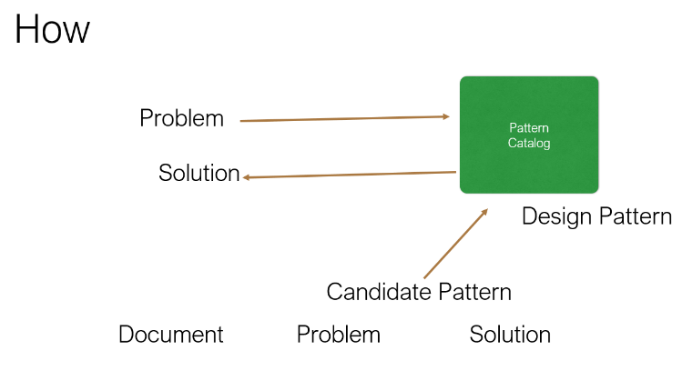

If pattern is not there we document a problem and solution which will become a candidate pattern

And over time if problem is recurring and same solution is applying then it becomes a design pattern

And added to pattern catalog

**Pattern Catalog**

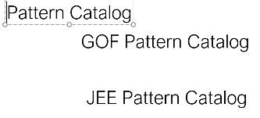

**GOF( gangs of four) pattern catalog or core pattern---- three types**

**Creational Pattern :**

provide guidelines to create a single object or group of object. It all about object

 creational design patterns are design patterns that deal with object creation mechanisms, trying to create objects in a manner suitable to the situation.

**Structural Pattern:**

They provide a manner to define r/s in classes.

It is used when we want to create diff type of relation among classes

Structural design patterns are concerned with how classes and objects can be composed, to form larger structures. The structural design patterns simplifies the structure by identifying the relationships. These patterns focus on, how the classes inherit from each other and how they are composed from other classes

**Behavioral Patterns**

How communication should happen among classes and object

Note :

There are multiple pattern under each of these catalogue

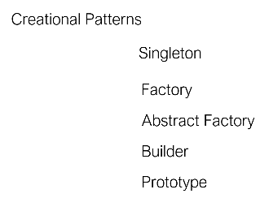

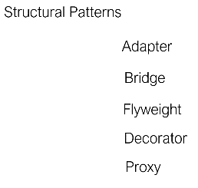

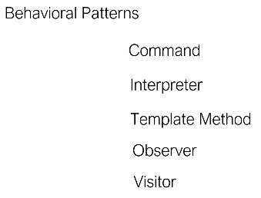

**Java EE Pattern Catalog**

**Data Access Layer :-** responsible for performing d/b operation

**Service Layer :-** all our business logic will go there

**Presentation Layer :**

present our application to the end client

Responsible for presenting the data

**Integration :-** responsible for integrating with other application or communicating with other application

and also letting other application to communicate our application

Each layer uses the services provided by other layer

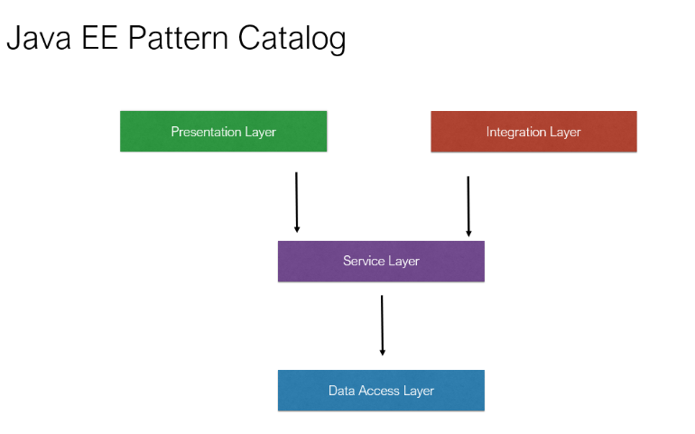

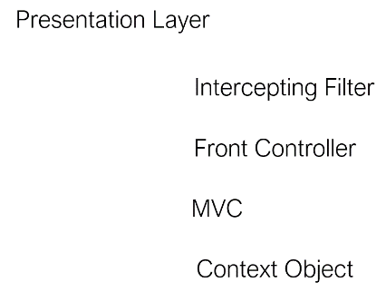

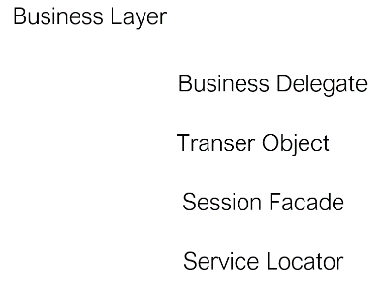

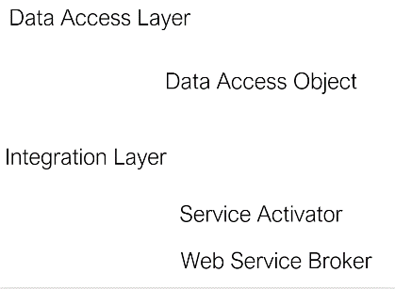

**Core Pattern**

**1- Singleton**

What is singleton pattern and why we need it

Only one instance of a class can be created and that can be shared across all other application classes as required

A singleton pattern is an object creational pattern that allows our application to create one and only one instance of a particular class, no matter how many times that class is used in our application.

**For example** a **PropertyReader** class that can read the properties from a file and it is used multiple times in our application by different classes. We will create only one object of the PropertyReader and not multiple saving a lot of memory using the singleton pattern. So all application classes will use the same property reader object to perform the property reading from a file.​

**Another good example** for singleton is a **logger**. Using logger's we can log different types of information errors debugging information and just general information from our application to a log file so that developers can read that log file later on to see what is happening with our application. So a logger can be a singleton the same logger object can be shared across our application classes.

**Another good example** in the JDBC world, the java database connectivity world is the data source class in the JDBC API the **data source** class is responsible for maintaining a connection pool and giving a connection from the pool to our application classes. We can have different classes in the application that need a database connection but there will be only one instance of the data source. So a DataSource is also an example of singleton.

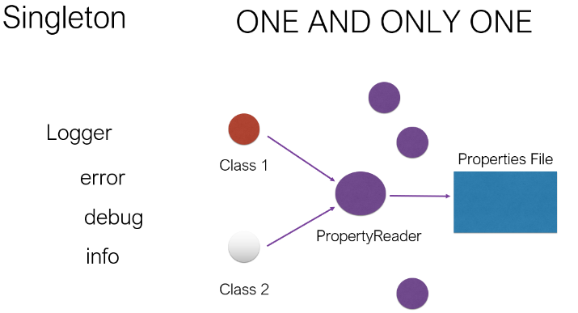

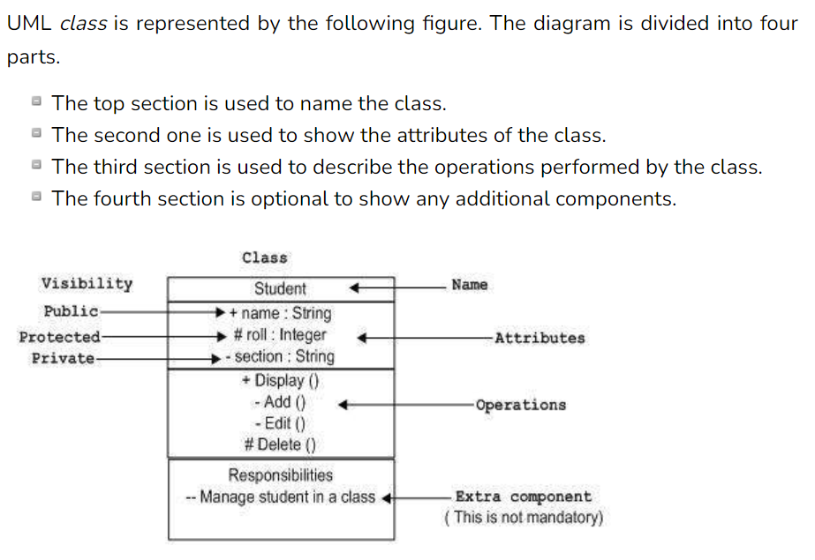

**Singleton UML class diagram**

**Uml diagram represents a singleton pattern.**

**First step**

is to mark constructor of DateUtil as private so that no other class or object will be able to instantiate

DateUtil directly because they cant access private constructor

**Second step**

Define a static field on DateUtil of same type and in getInstance() which is public static will assigned a new object to this instance and return the instance back. getInstance() will create instance of DateUtil only once.

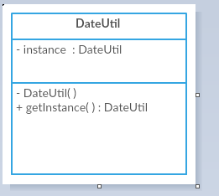

**Steps**

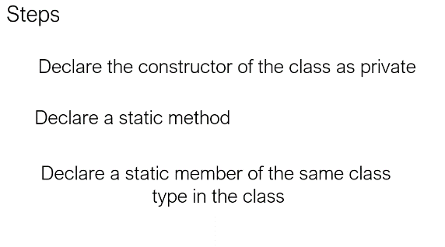

**Create a singleton class**

**Follow above three steps :**

Create instance only when it is null otherwise return existing instance

**Lazy initialization**

only when it required create a instance of it

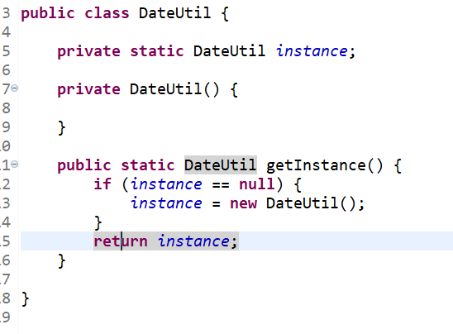

**Test Singleton**

We need to make sure it always return the same instance no matter how many times will call getInstance

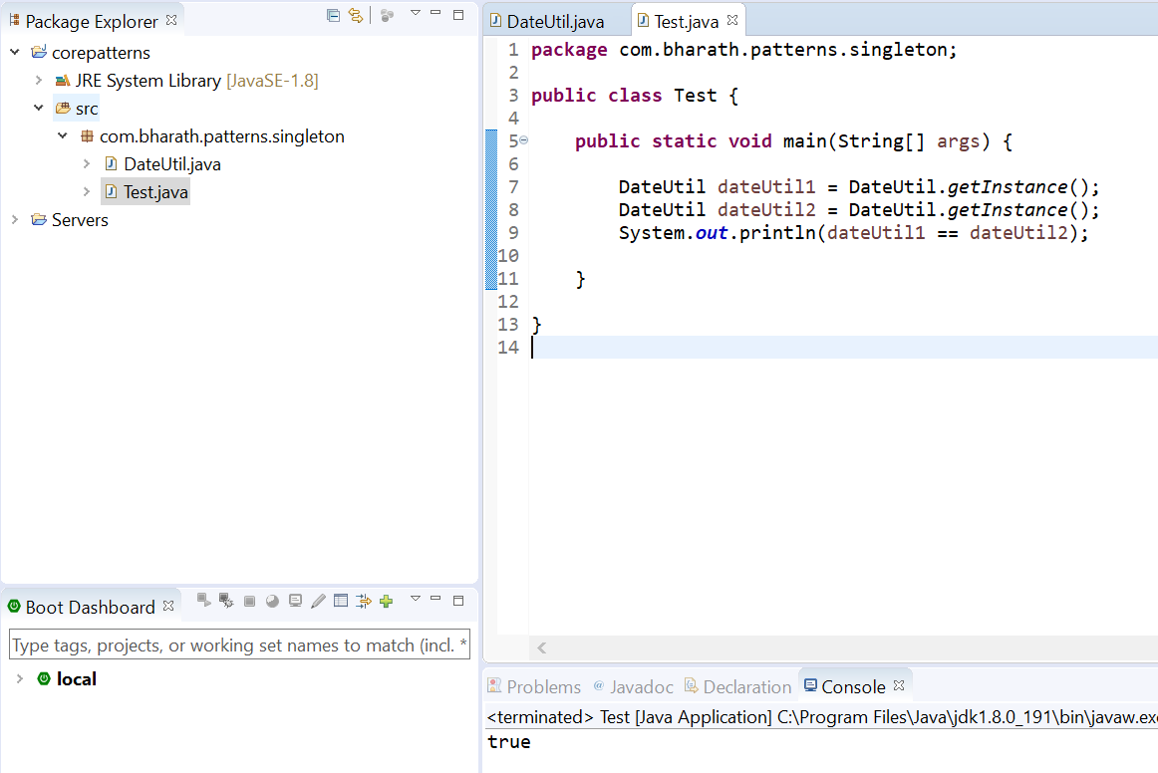

**Eager Initialization**

There are several ways DateUtil can be improved and implemented

**Eager initialization:**

This is the simplest method of creating a singleton class. In this, object of class is created when it is loaded to the memory by JVM. It is done by assigning the reference an instance directly.

Note :

When we are sure atleast DateUtil once will be use in the application.

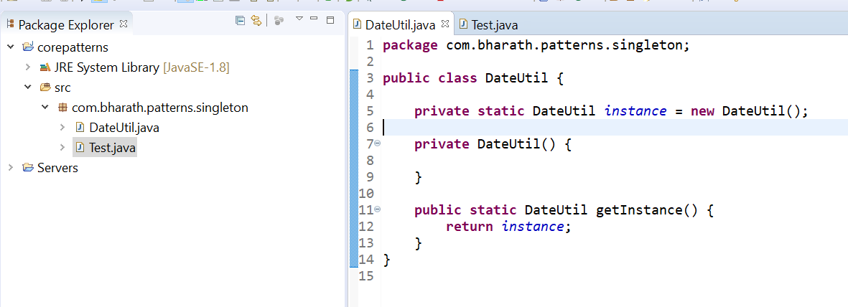

Note :

Static block in java are get executed when class is loaded into memory

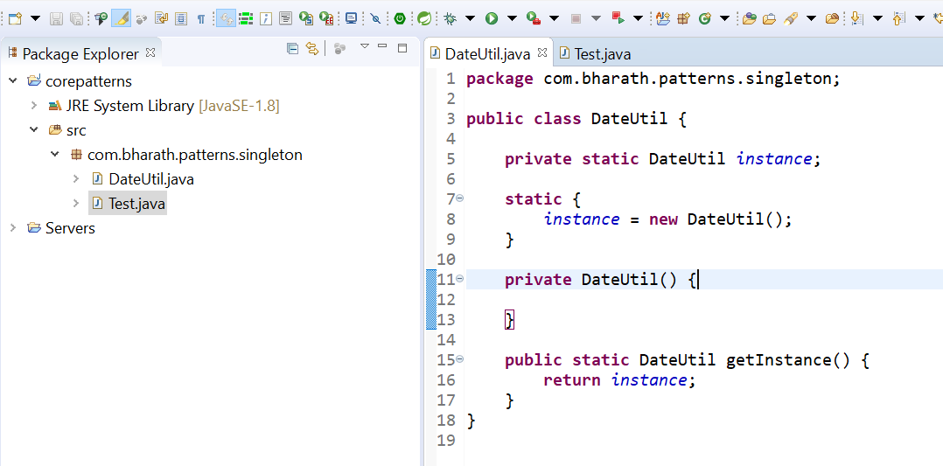

Above both example are two different ways creating instance and these are called eager initialization.

And we can go for it if we are sure singleton will use atleast once because instance will be created when class is loaded.

**Lazy initialization is preferred more over eager initialization**

**Handle Multiple Threads**

**IMP question :**

We need to make sure our singleton is thread safe

That is when multiple thread trying to access getInstance() we still to make sure that there is only instance

create

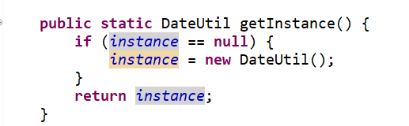

Suppose there are two thread , first thread enter inside instance ==null and about to create instance then

Another thread also check install==null and it found true in this case two instance will be create

**To avoid this problem in java** we can marked this method as **synchronized**

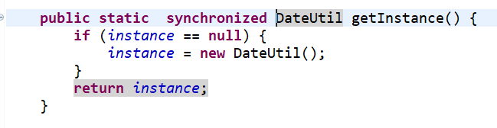

**Synchronized** keyword make sure that this method will be access by one thread at a time

To make more better we can write like this class level lock is there

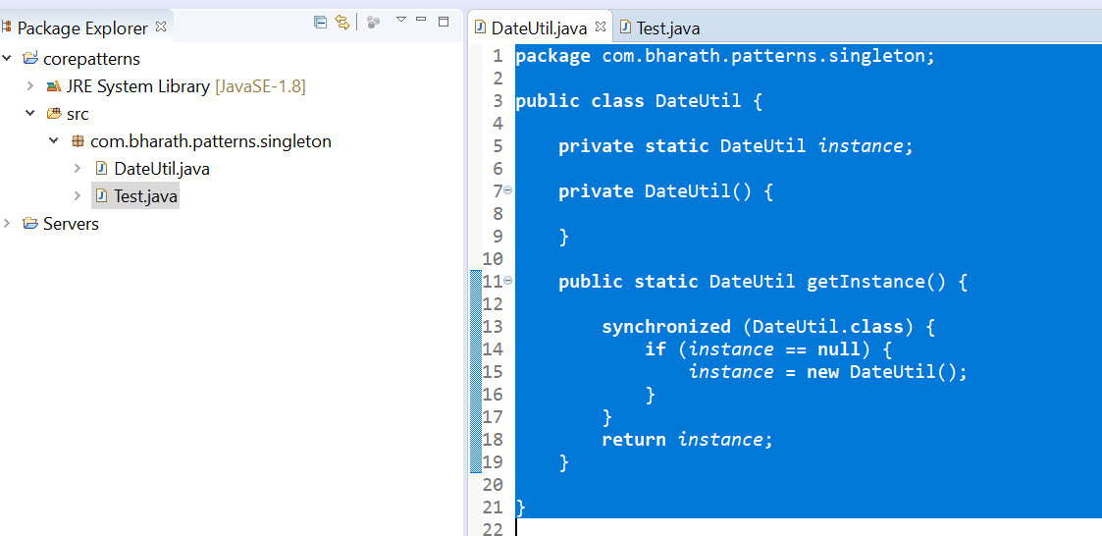

**Improve Multithreading logic**

**Note :-**

**Acquiring a lock is very expensive process**

In above case we don’t want everytime class level locking even if instance is not null

We want class level locking only when instance is null

**So put one more null check and it recommend to use volatile keyword**

Volatile ensure that multiple threads read the correct instance value. When a variable is declared volatile we suggest the compiler to never store the value of the variable in cache memory.

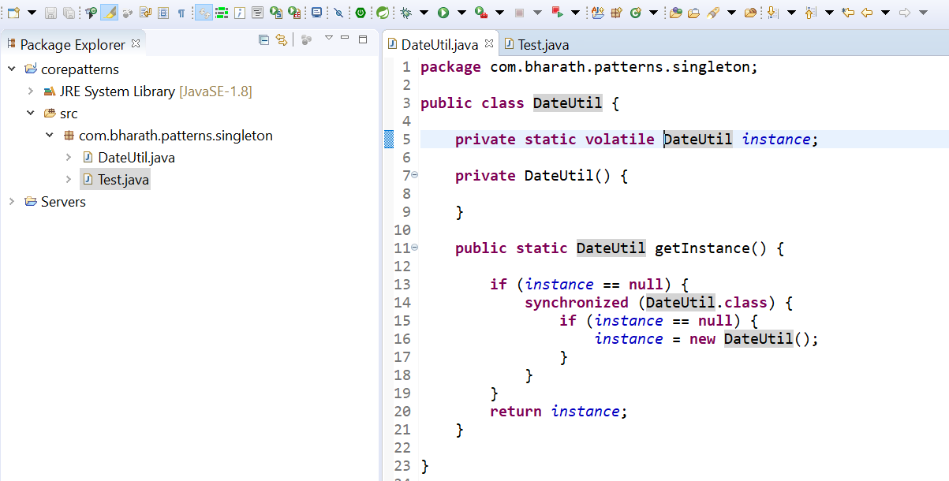

**Serialization and singleton**

**While working with singleton classes we need to handle serialization problem**

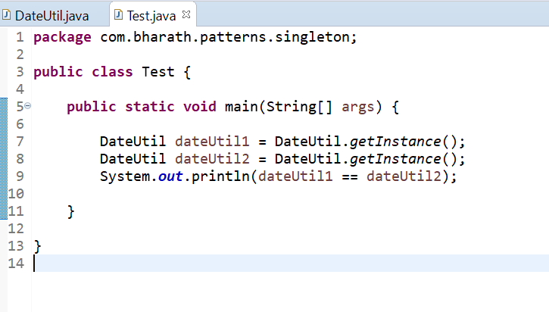

**Note :-**

if we serialized dateUtil1 instance and deserialized it back from file then will see different instance

**See what the problem is**

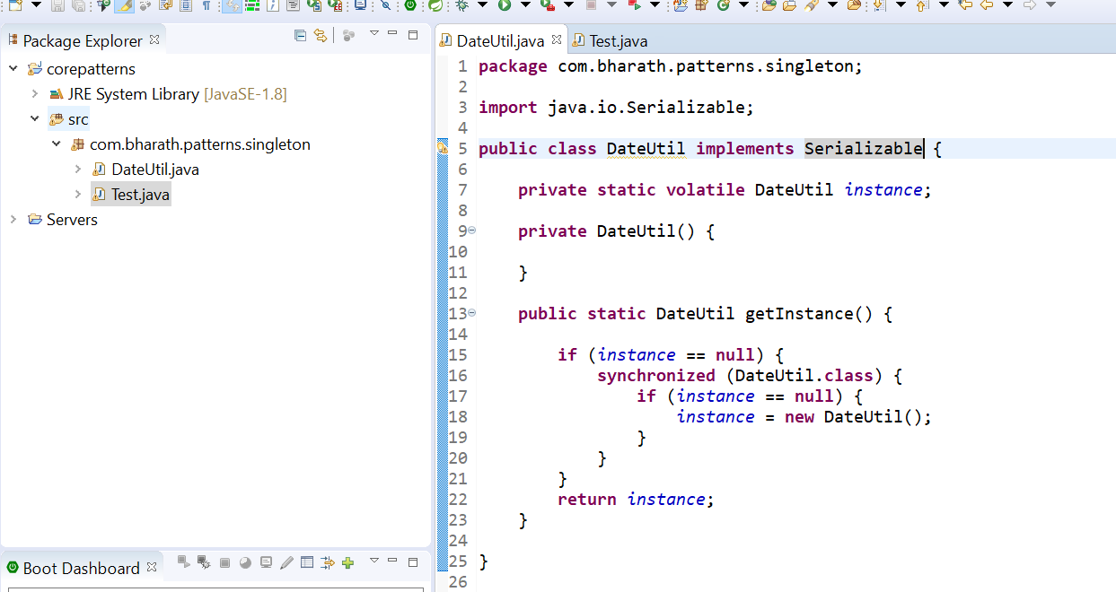

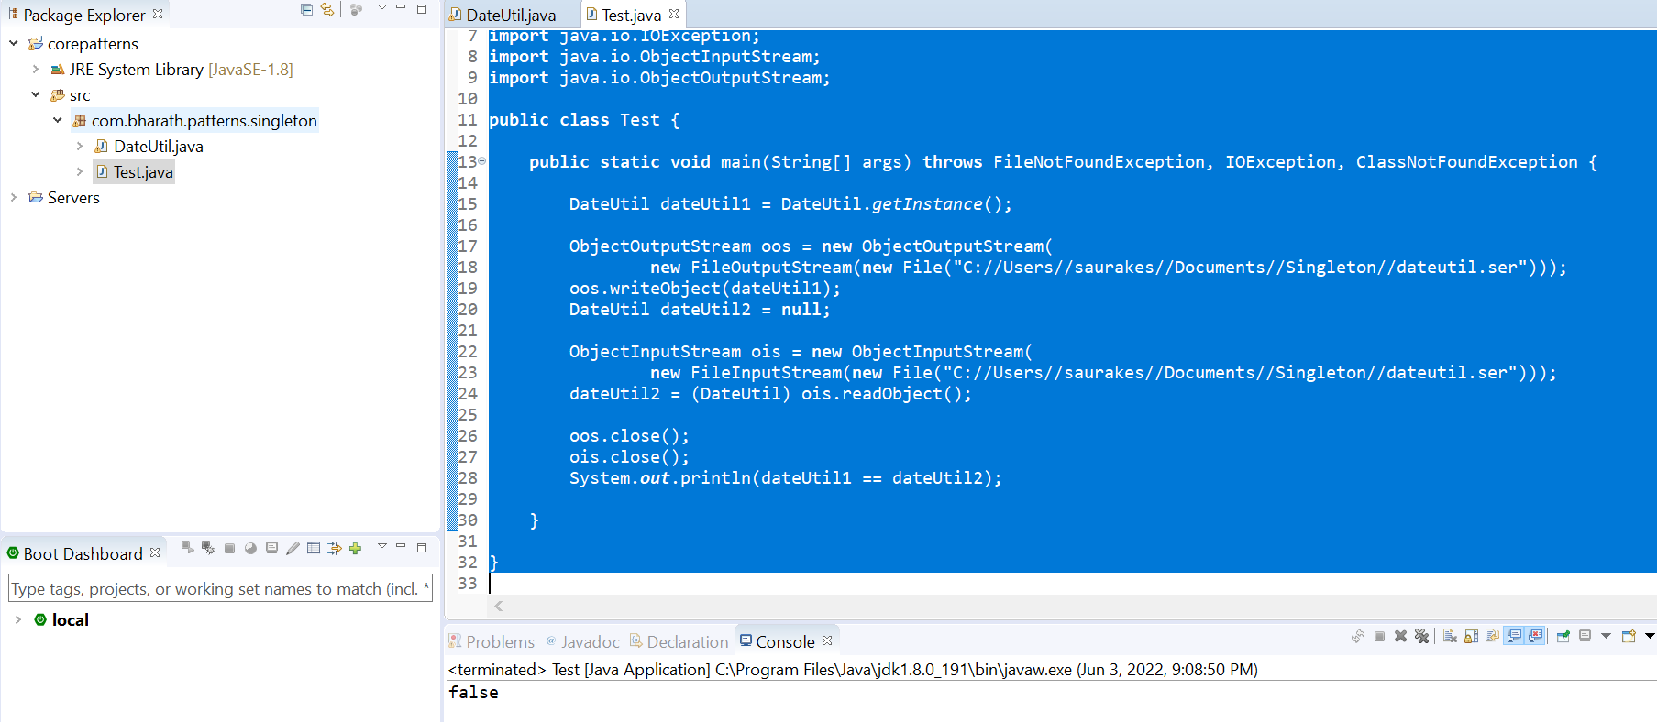

**Handle Deserialization**

This problem can be resolved using **readResolve()**

**Note :**

When we deserialized it will invoke readResolve method that we need to implement

**readResolve** will be invoke internally by **ObjectInputStream**

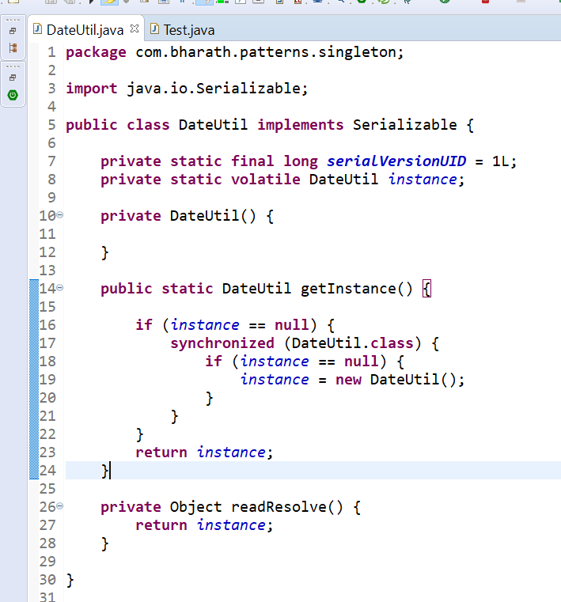

**Instead of creating a new instance it will use above instance when we deserialized object**

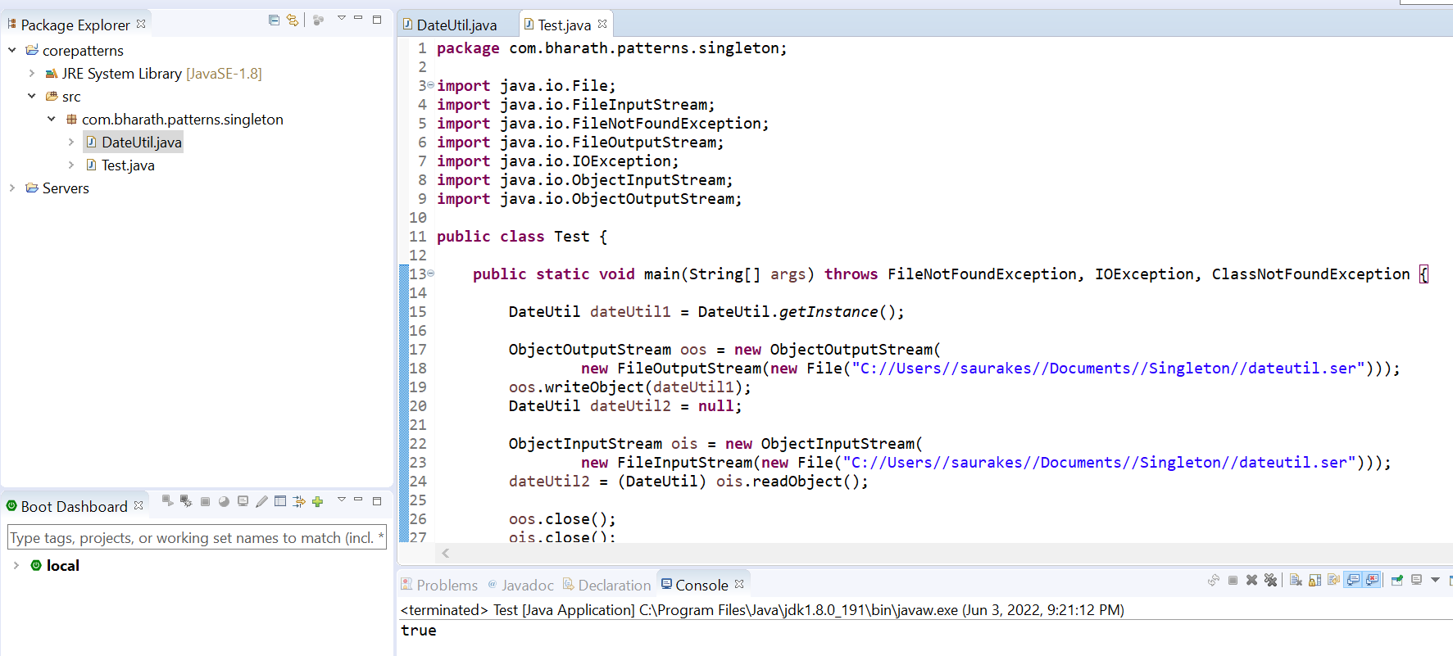

**Because we are getting same instance back in DateUtil2**

To addressed the serialization issue our singleton class should implement readResolve which will return same instance

The readResolve method is called when ObjectInputStream has read an object from the stream and is preparing to return it to the caller. ObjectInputStream checks whether the class of the object defines the readResolve method.

**Override the cone method**

**Note :**

We don’t want our singleton object to be clone if some other class extends singleton class that’s why we will override clone method

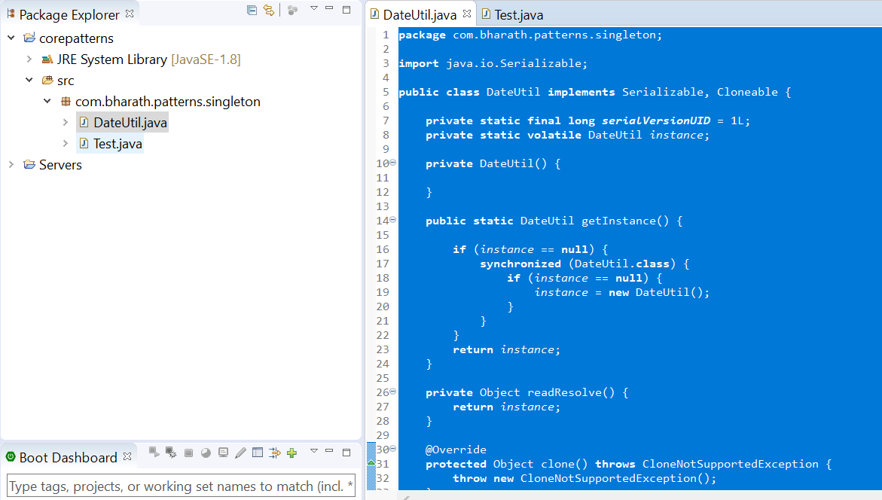

**The Reflection Problem**

**How to break singleton pattern using java reflection and also the solution**

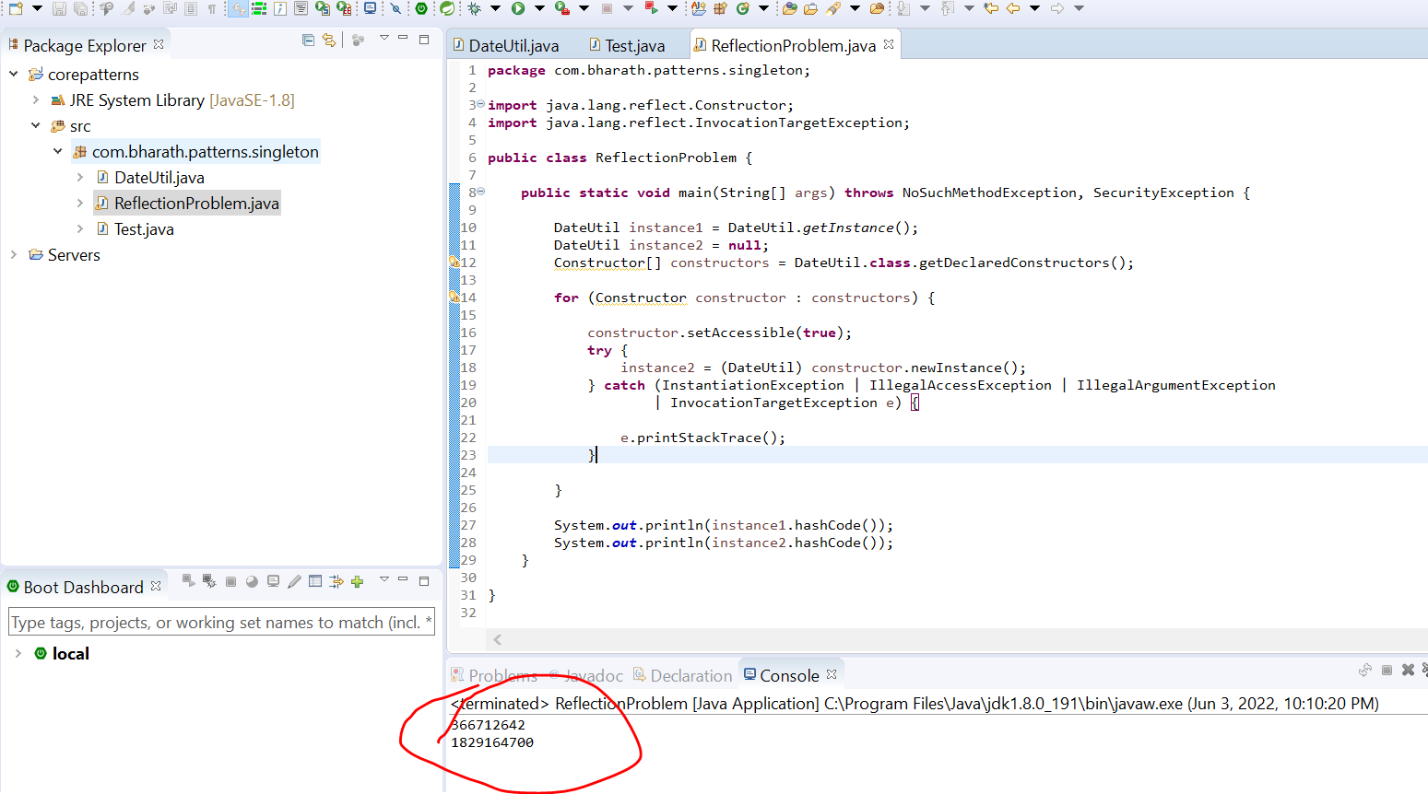

**The Enum Solution**

To solve the reflection problem we can use enum

This is the only way we can access enum

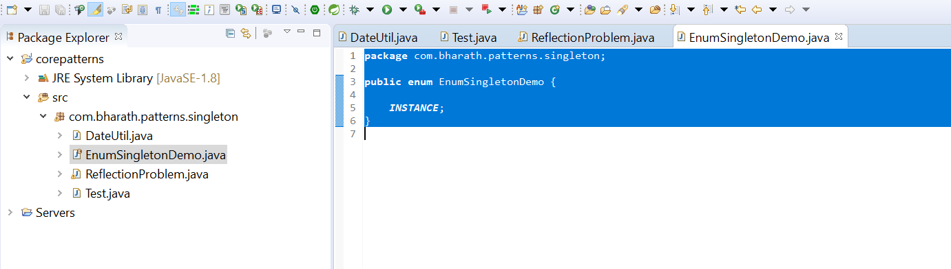

|  |  |
| --- | --- |
| **The benefit of enum in java there is no constructor so there will be no access through reflection** |  |

The key is here we can create only single instance and reflection problem is resolved

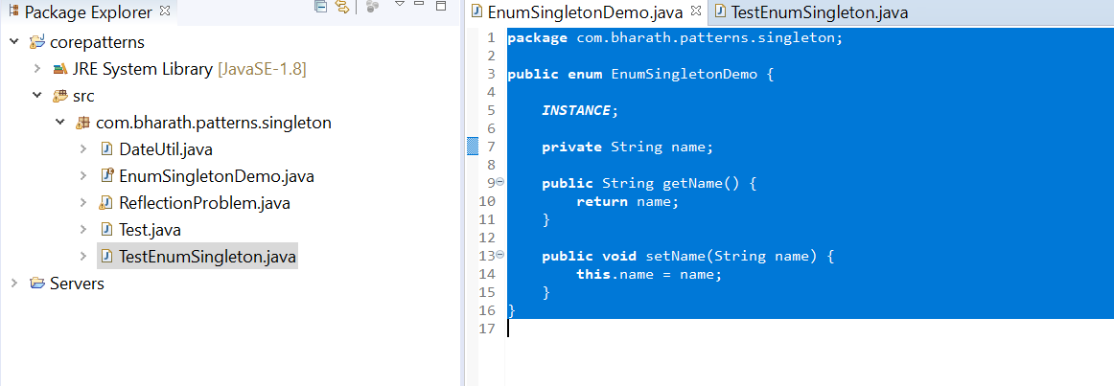

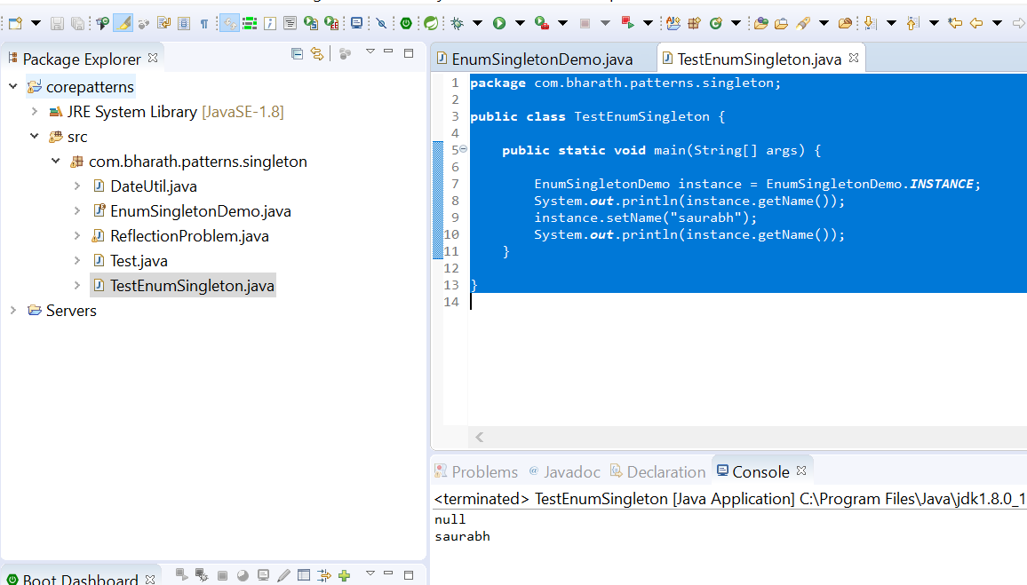

Enum singleton thread safe

1. Factory

It is a creational pattern that abstract or hides the object creation process

It hides the complex details of object creation and it is responsible for creating the object and giving them to the classes or program

A factory pattern is a creational pattern that abstracts or hides the object creation process.

**Example**

1- When you think of factory you can think of a car factory a chocolate factory or a toy factory.A car factory is responsible for manufacturing the cars .A car dealer need not worry about how the car is manufactured. He simply asks the car factory to deliver him some cars. The car factory is responsible for manufacturing them and delivering them to the dealer.

2-Similarly the Chocolate Factory delivers different types of chocolates based on what the chocolate store asks them to deliver.

1. An example from the JDBC space when we use different databases like Oracle, MySql, SqlServer. In Java we use something called JDBC driver to connect to a database.Driver is an interface in the JDBC API and the implementation for this driver is provided by different vendors. The responsibility of the driver is to connect to a particular database and execute sql statements against it.To get a connection we need not remember each and every driver in how it works. For example if we want to connect to Oracle you need not deal with the Oracle driver and same for other databases.You simply use DriverManager which is a class in the JDBC API to get connection and you pass in a connection string which is specific to a particular database where it is different for mysql, it's different for sql server.The driver manager acts as a factory and it will return the connection for us by using the appropriate driver for Oracle it will use Oracle driver for my sql it will use the my sql driver and so on.It hides all the details of finding a driver and creating a connection against the database for us. So give it a string it will give you a connection. So here the get connection is a static method on the factory class.We need not create the instance of the driver manager to create objects of type connection.We simply use the static method on the factory class and get the object we need.
2. Another example is a pizza store .A pizza store delivers different types of pizzas.We will a parent interface which is implemented by the veg pizza cheese pizza and meat pizza.The pizza store need not worry about how to create each of these pizzas.It simply asked the pizza factory to deliver the type of pizza it wants or to create a type of pizza it wants.so that it can give it to the customer or it can deliver it to the customer.The pizza factory hides the complexity of creating the different types of pizzas from the pizza store.

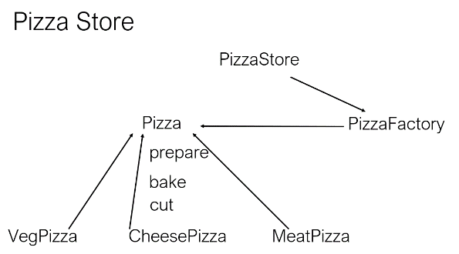

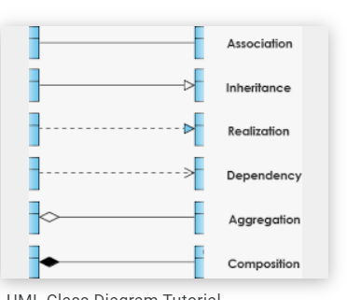

**Uml class diagram :--**

**Pizza store** :--- client

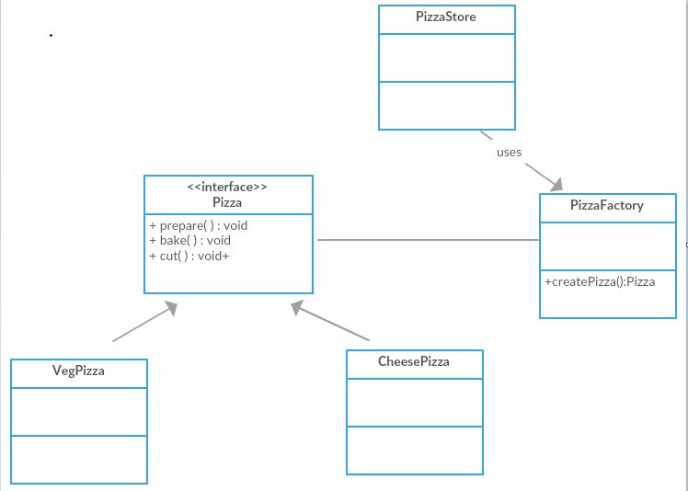

**Implement Pizza store usecase**

First will create pizza interface with three method in it then will create different type of pizza classes that will implement the interface

Pizza store class which will handle order for us

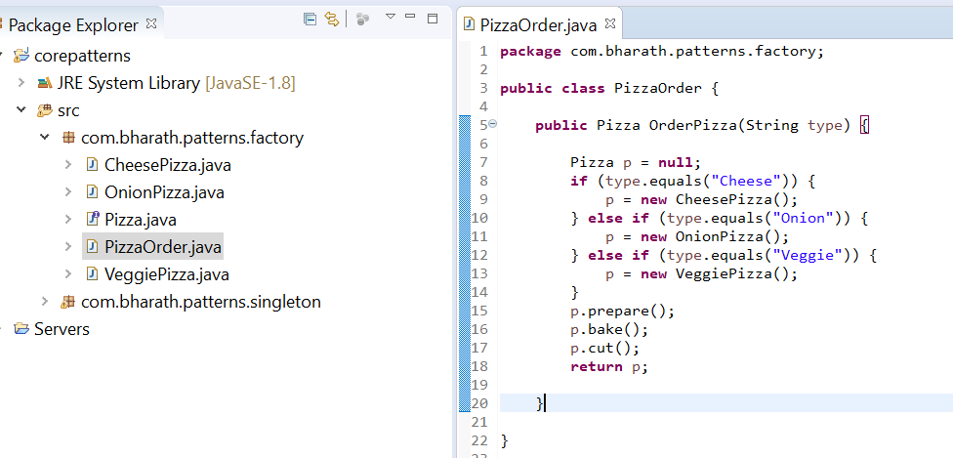

**Create a test class**

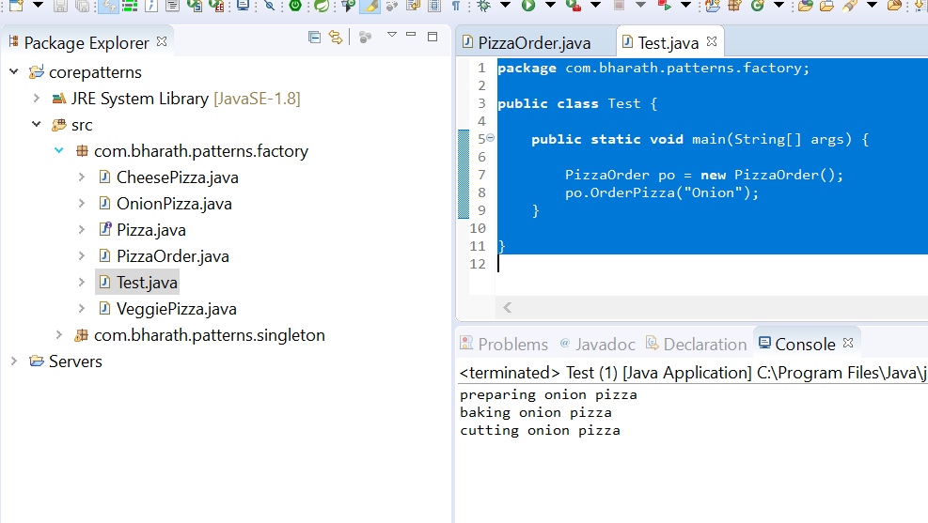

**Note:**

Will create a factory class that will take away instantiation

**Create a Pizza Factory**

Instead of creating object this in every class will move object creation in factory class

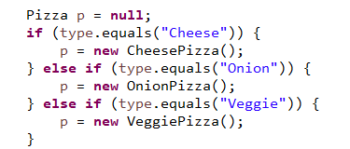

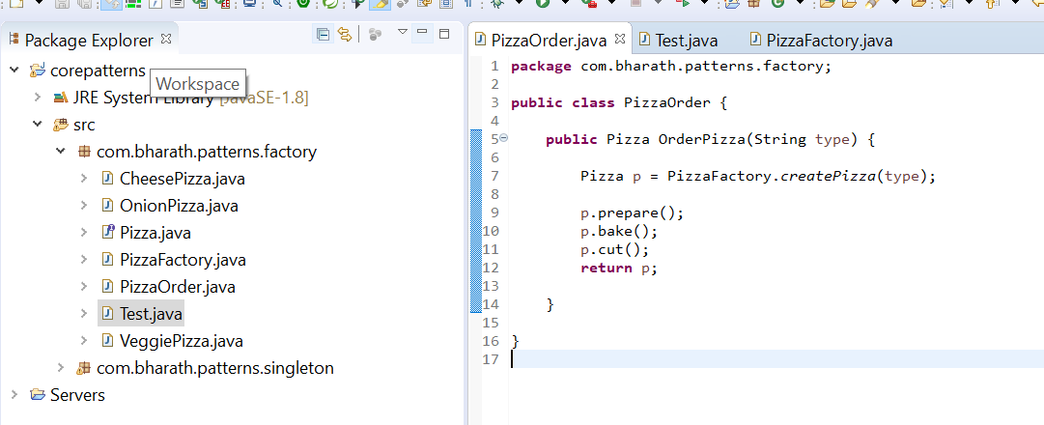

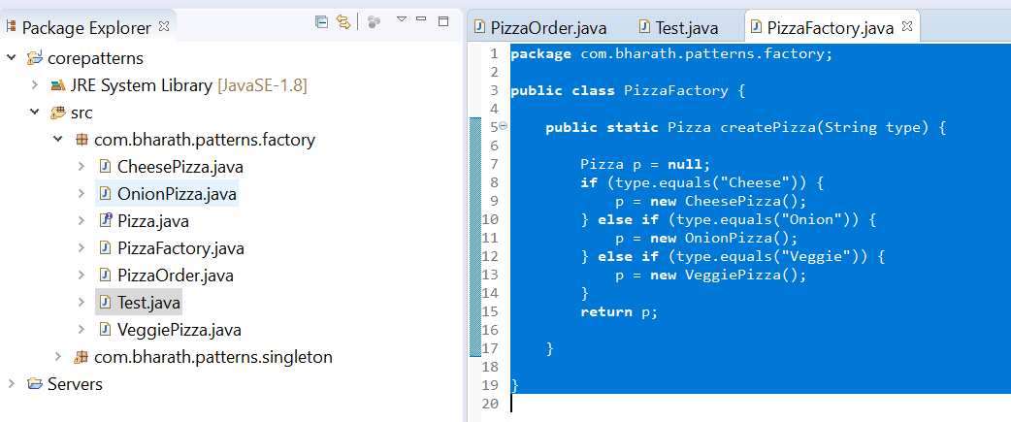

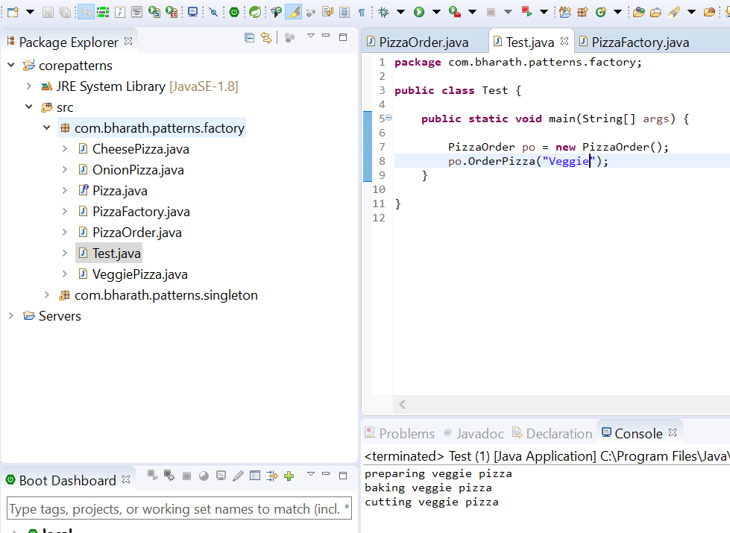

1. **Abstract Factory**

It is Factory of factories

Now that you have mastered the Factory design pattern learning and implementing the Abstract Factory pattern will be quite easy because an abstract factory is a factory of factories.That is a factory pattern was hiding the details of object creation and factory of factories or an abstract factory.hides the creation of the factory itself.

**A good example in the Java space is the JAXP AP**I . JAXP stands for Java API for xml parsing . Using this API we can read or write and update the elements in a xml file the key class in this API is the document class that represents a xml document in memory to create a document class.We use that document builder.So this document builder is a factory class and there is one more class document.Builderfactory which is responsible for creating the document builder itself.So the document builder factory is a abstract factory because it is a factory of factories and the use case you are going to work on to give you

**Another example is a DAO factory.** DAO stands for data access object.We'll learn more about it in sections later on.It simply is a class that can read write create update data we can have different types of DAO'sDAO's that deal with xml data and DAO's that deal with DB data and within xml we can have employee information department information.

Similarly within that database we can have employ information and department information.So you can see that we can have a factory to deal with these separate DOA's we can have a DB DAO factory that can give us one of these classes here when our application needs them and we can have a xml DAO factory which can give one of the classes here.Now to get one of these factories themselves these factories will first implement a DAO abstract factory or they will extend DAO abstract factory class and we will have a producer which is responsible for creating one of these factories so abstract factory is a factory off factories.

It simply creates the factory we need. when we have multiple factories we see in our application.

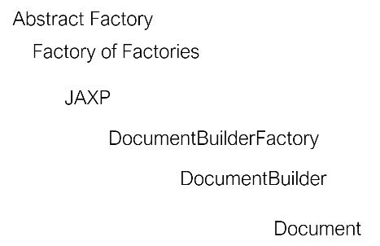

**Abstract Factory UML class diagram**

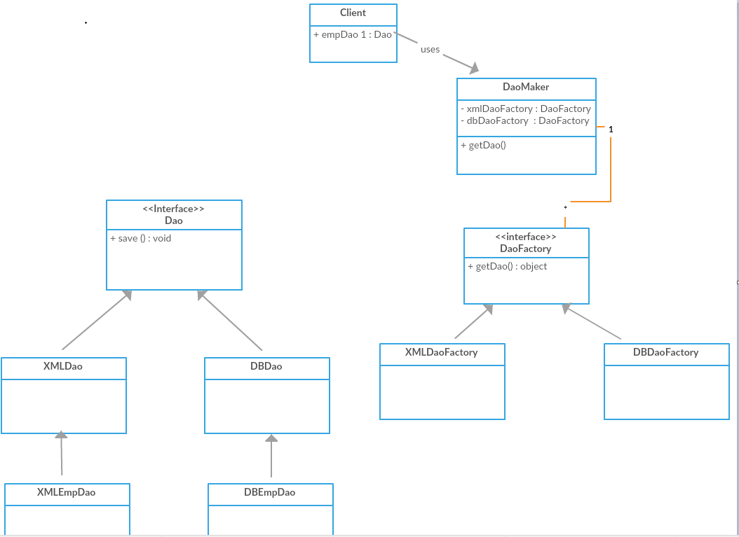

**Create DAOs and Factories**

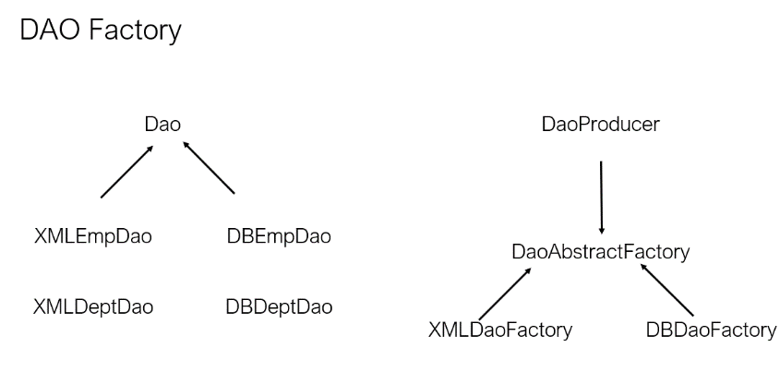

**Step1 :--** create diff type of DAOs which will implement DAO interface

**Step 2:-** will create a DaoAbstractFactory which will extended by XMLDaoFactory and DBDaoFactory. These two factory will responsible of

Creating the appropriate DAO object

**Step 3:** will create factory of factory DaoProducer reponsible of creating the XMLDaoFactory and DBDaoFactory

**Step 1**

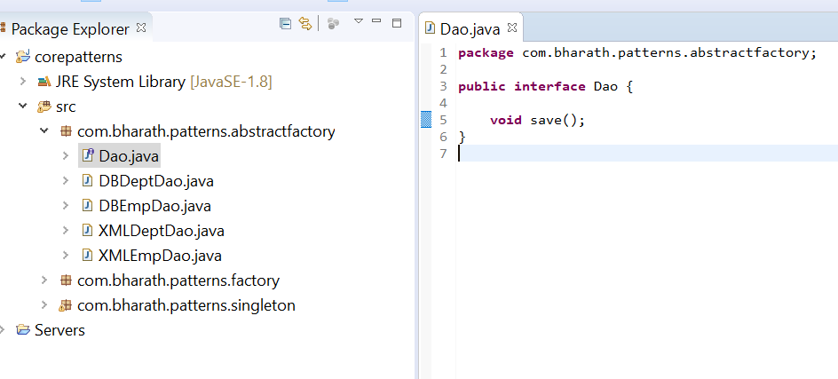

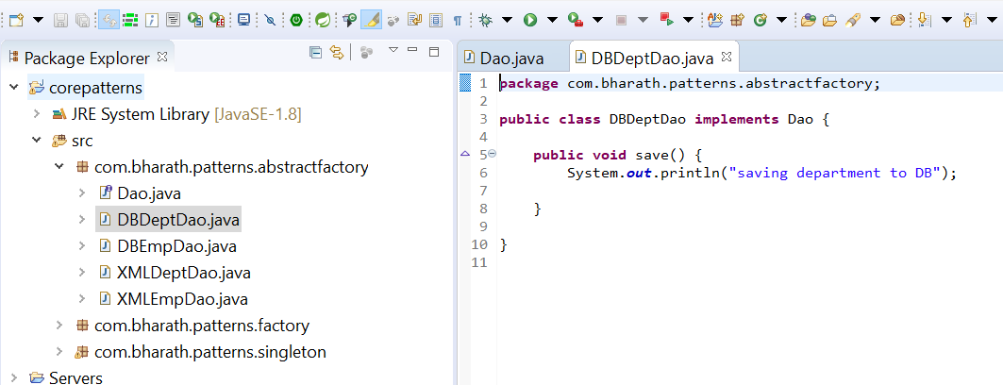

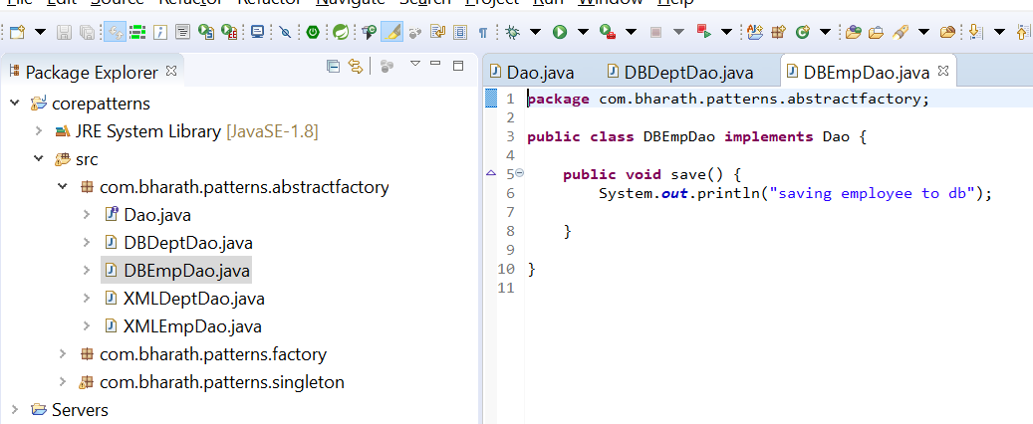

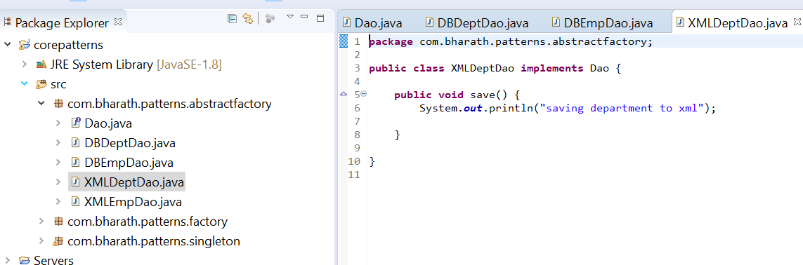

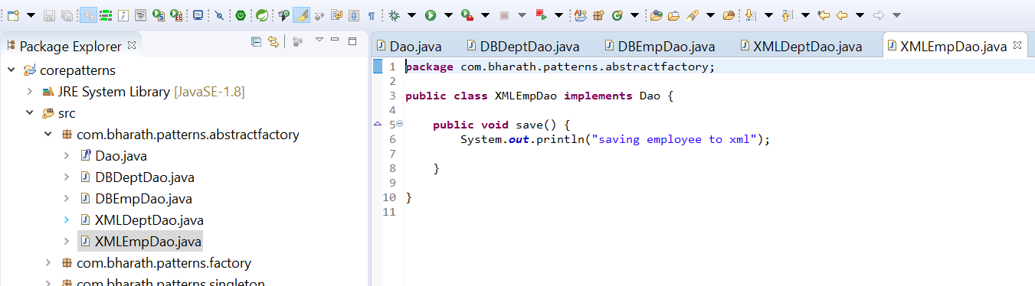

Step 2:-

DaoAbstractFactory will abstract out creation of these factory( XMLDaoFactory and DBDaoFactory)

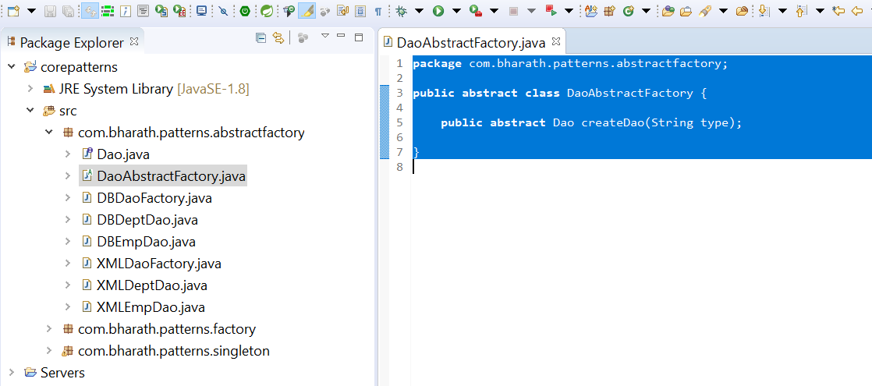

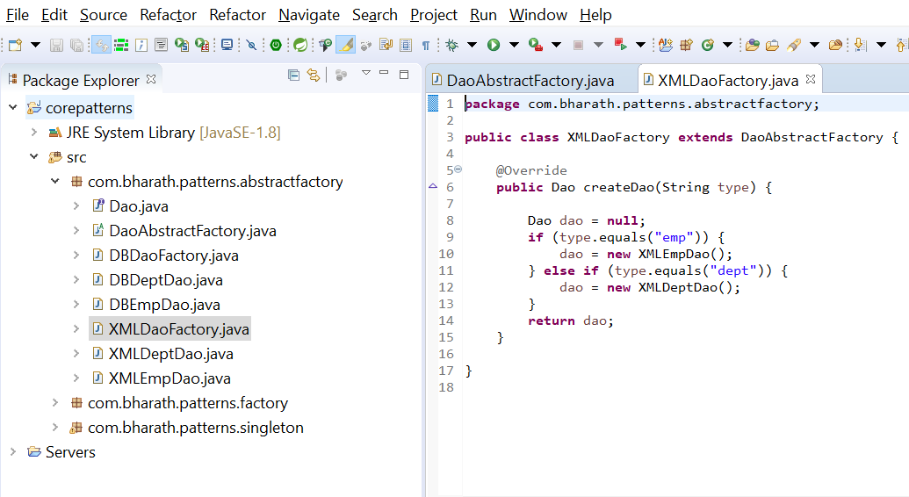

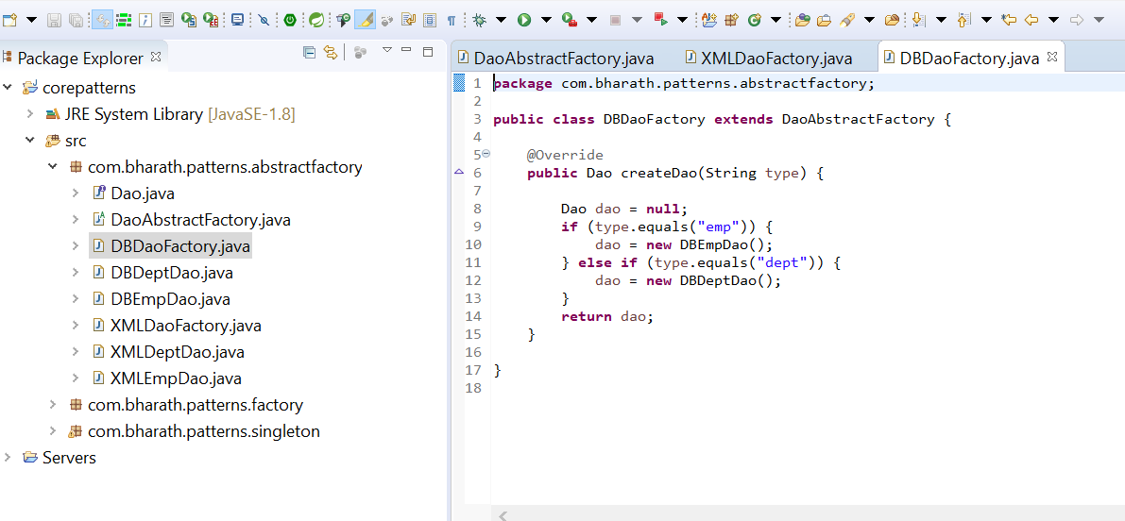

**Create Factory of factories and test**

**Will create factory of factories which is responsible for creating different type of factory**

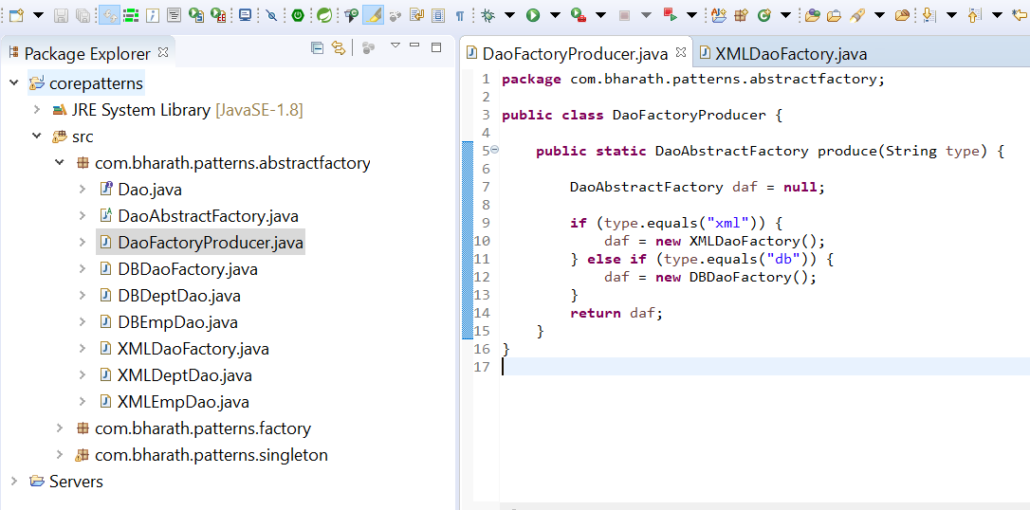

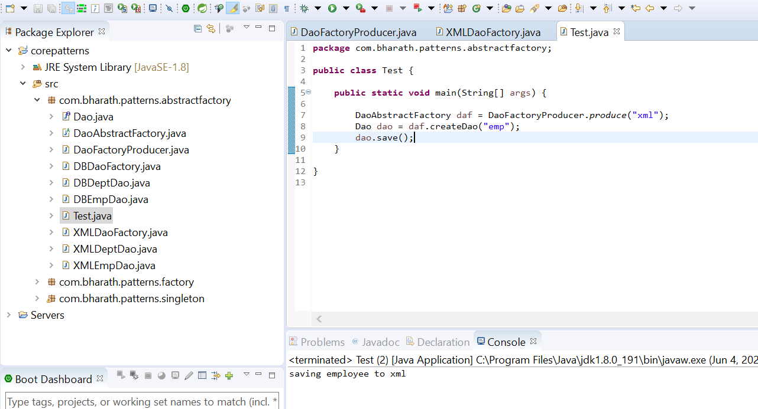

**First line :---**factory of factory

**Second line :-** getting a factory

1. Template Method

Template Method is a behavioral design pattern that allows you to defines a skeleton of an algorithm in a base class and let subclasses override the steps without changing the overall algorithm's structure.

The intent of the template method is to define the overall structure of the operation, while allowing subclasses to refine, or redefine, certain steps.

**Template Method:**

The template method pattern is a **behavioural pattern**. And as the name itself says it provides a base template method. When we are working with inheritance in our applications we provide a base template method that should be used by the child classes. The child classes can override certain methods but they should use the base template method as is.

**For example** we have a data renderer class which can read the data, process the data and then render or display that data to the end user.But in our application we want to render the data in the same way no matter in which format the data is coming in that is if it is xml data or if it is CSV data. We want to render it using the render method in the base class reading the data and processing that data is up to the child classes. The child classes can override the readData and the processData.But we want to provide a base template method with all the implementation in it in that data renderer superclass. This pattern is called template method ,as we are providing a template for a particular method from the parent class that should be used by the child classes.

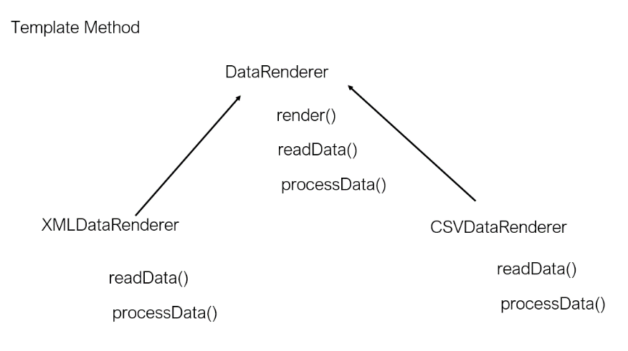

Note :

here render() we want as it base class only in child class

We are providing a template for particular method from the parent class that should be used by the child classes

**Template method uml class diagram**

readData and processDate are abstract method which need to be overridden by child method

The template method is present in parent class it knows how to invoke other method and it will render the data

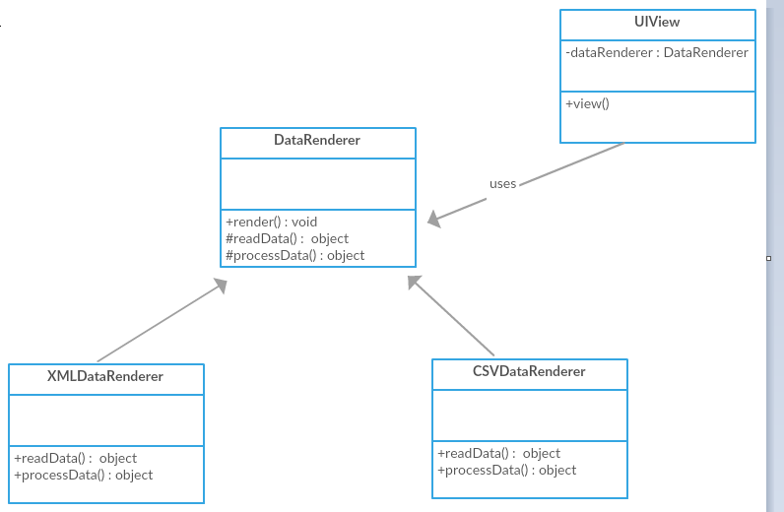

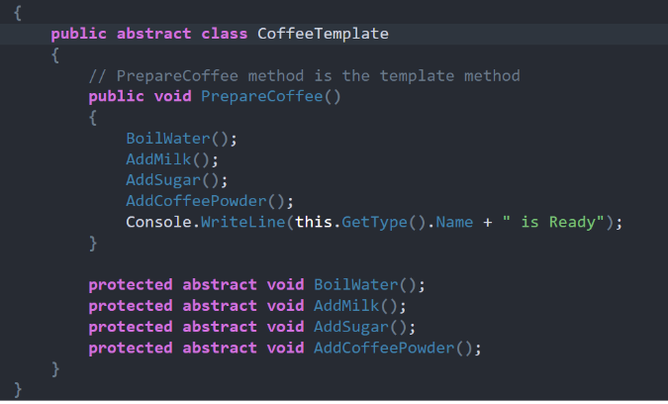

**Implement Template Pattern**

**Parent class will call child class method and it will render the data**

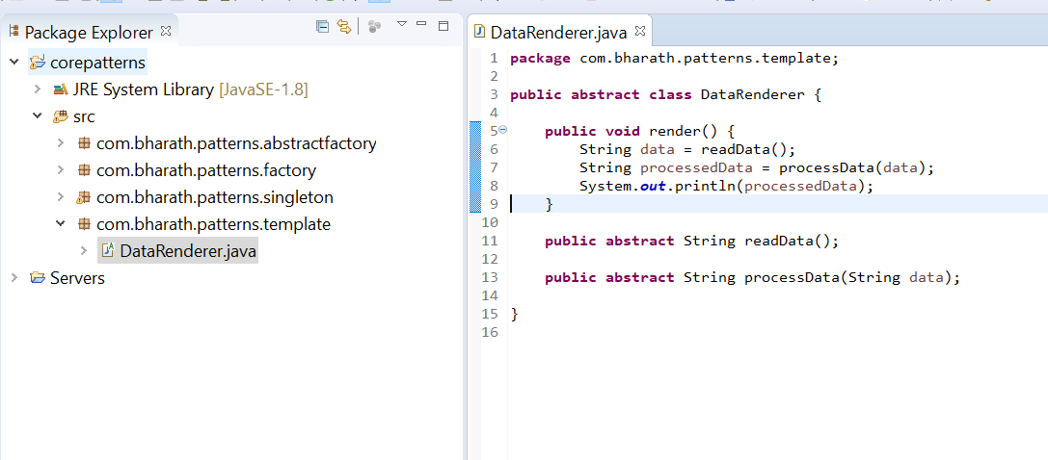

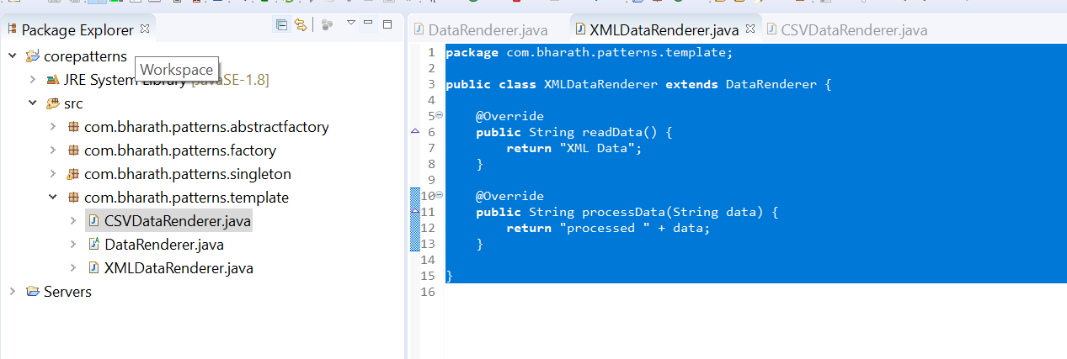

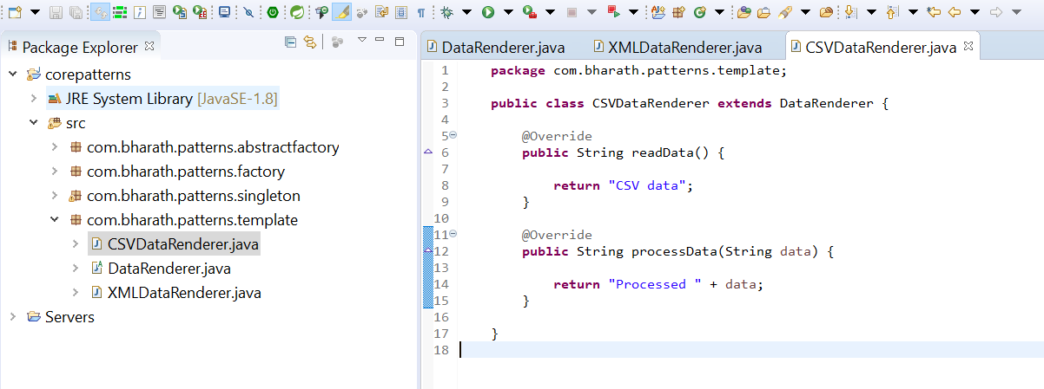

**Test Template method**

This logic will not be changed by child classes

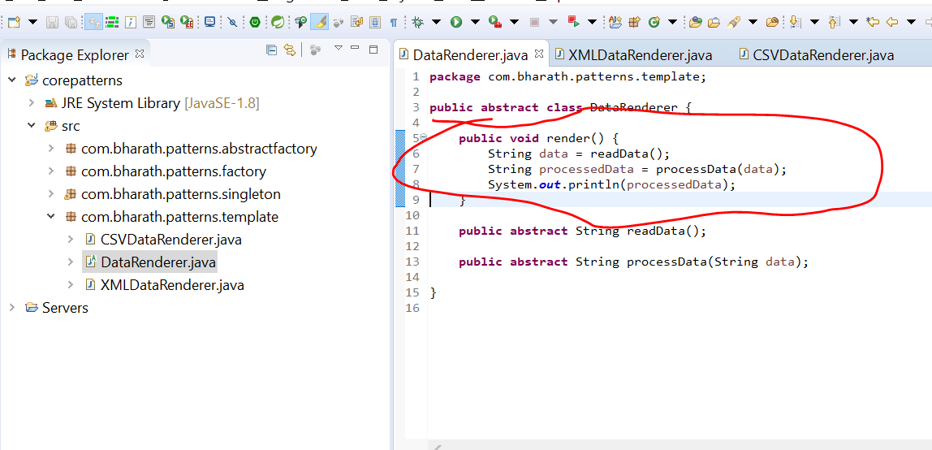

Test class act as view . It will use DataRenderer class and render the data

What is the use of an interface reference?

An interface reference variable **only knows that methods which are declared by its interface declaration**. It does not allow accessing any other variables or methods that might be supported by the objects. This concept is similar when you use a parent class reference to access a child class object.

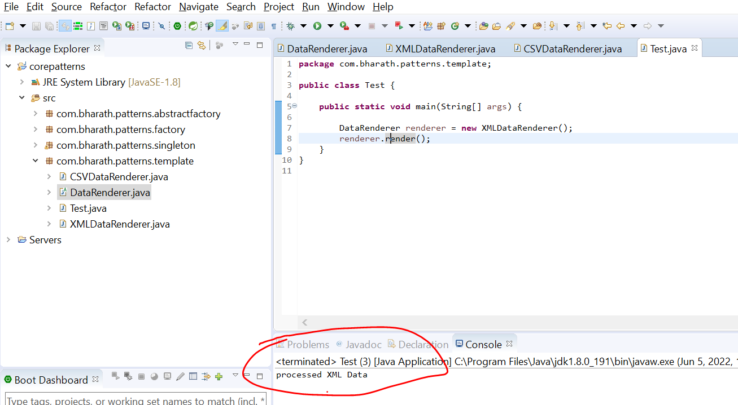

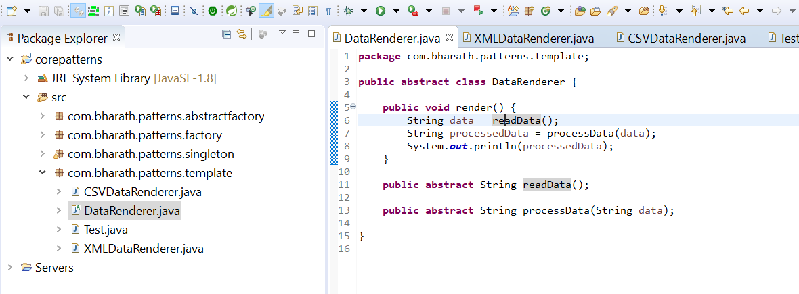

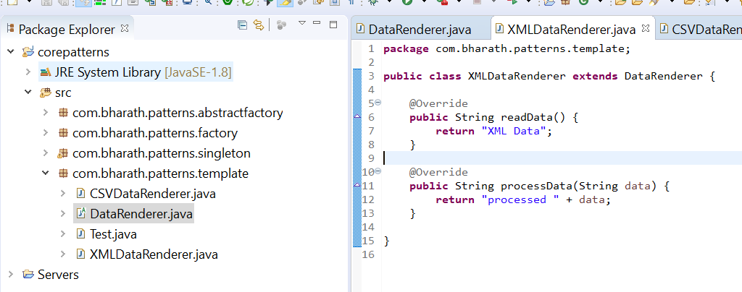

1. Adapter

**Adapter is a structural design pattern, which allows incompatible objects to collaborate. The Adapter acts as a wrapper between two objects**. It catches calls for one object and transforms them to format and interface recognizable by the second object.

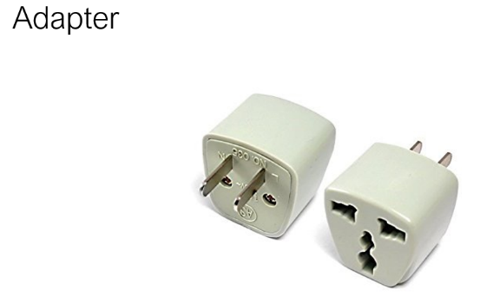

**Adapter**

If you have used a power adapter then you already know what an adapter pattern is .The job of a power adapter is to adapt it to a particular location and a particular switchboard.For example the same laptop plug pins that work in USA will not work in UK and in India.We will have to use appropriate power adapter that can take our laptop pins into it and on the other side of it it will have pins that can go into the local countries switchboard and it can also adapt to the appropriate range in that country.

Similarly in the world of programming when we have two applications communicating with each other or two objects using each other and one object invokes the method of another object.Then we have to adapt in some cases.

**For example** here we have a WeatherFinder class which has a findWeather. By passing in a city you can get the weather and we have an implementation of it which will return the weather back and there is a UI class that wants to use the weather finder . But the UI only knows the zip code of the city. It does not have the city information it only has the zip code but it wants to get the weather of it.

That is where an adapter comes in. We will implement an adapter which will take the zip code. The weather UI will invoke the findTemperature Method on the WeatherAdapter it will pass in the zip code. The weather adapter is responsible for looking up for the appropriate city that matches the zip code and hen invoke the weather finder, take the results and return the results back to the weather UI. So it exactly acts like a power adapter. It takes the inputs from the class that wants to use another class because the inputs here are different from what the other side of the relationship expects.

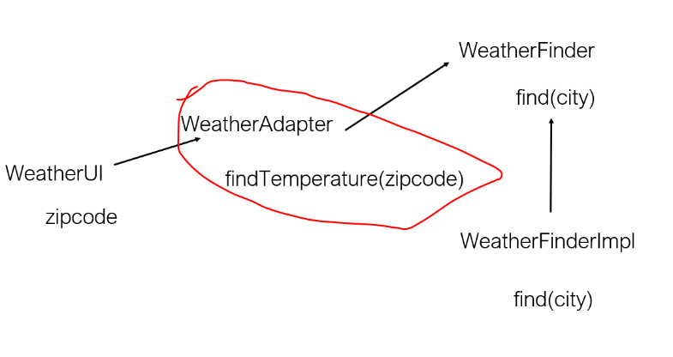

**Adapter uml**

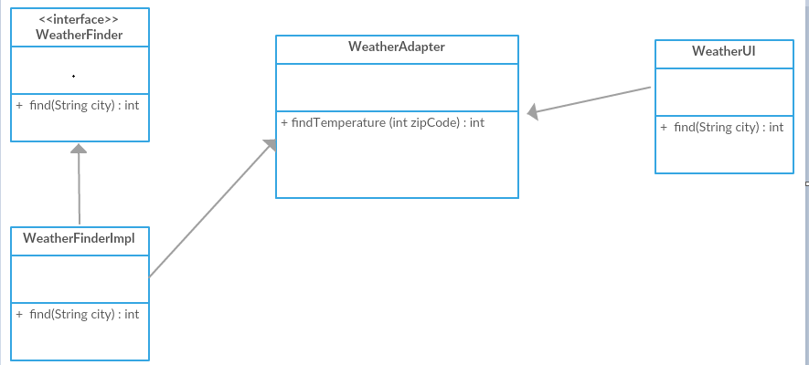

**Create weather finder class**

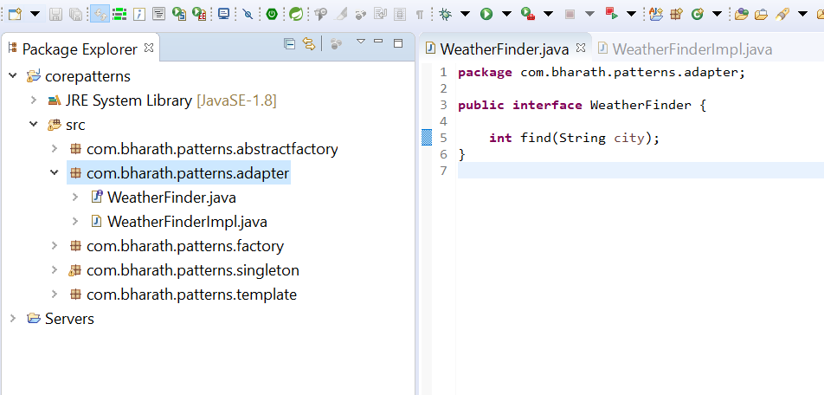

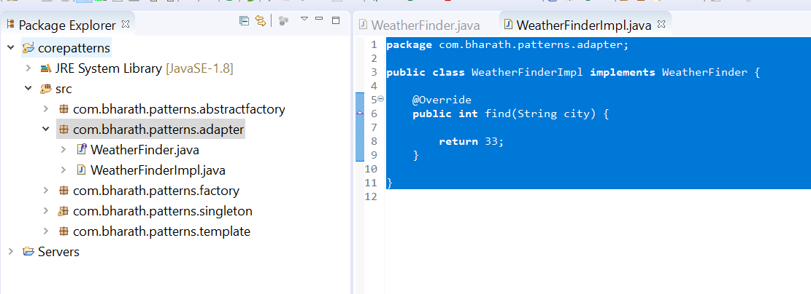

**Create adapter class**

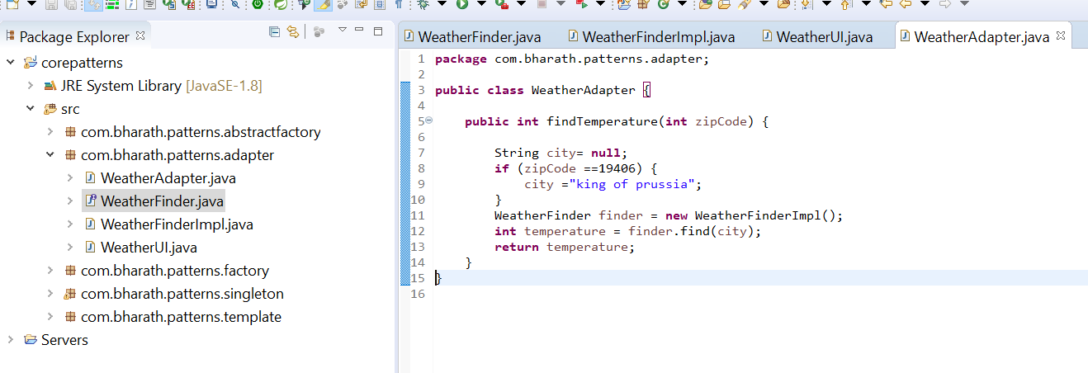

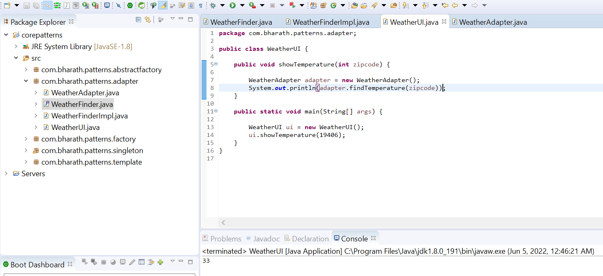

**Note:**

weatherAdapter convert zipcode into city .WeatherUI act as client

Flyweight

Flyweight is a **structural design pattern** that lets you fit more objects into the available amount of RAM by sharing common parts of state between multiple objects instead of keeping all of the data in each object.

A flyweight design pattern can be used to save memory. A flyweight is a structural design pattern instead of creating a large number of similar objects.We can reduce the number of objects that are created by reusing the objects and saving memory. Memory is a huge concern especially when it comes to mobile applications with limited memory.

Let's say we are working on a paint app that allows users to draw different shapes that is circles and rectangles.

Here we have a shape interface with a draw method on it.

When we have a circle class and the rectangle classes that implements that interface using a circle.

The user can draw a circle using a rectangle of course he can try her rectangle to do that.

He will have to create a circle and assign a radius for each circle he wants to create.

Similarly for each rectangle he will how to set the length and the breadth by creating a separate object by using the flyweight pattern.

You will do all that by creating one single circle and one single rectangle he will see what the problem is he will implement the problem first and then you will resolve that problem of multiple object creation by using the fly design pattern in the next few lectures.

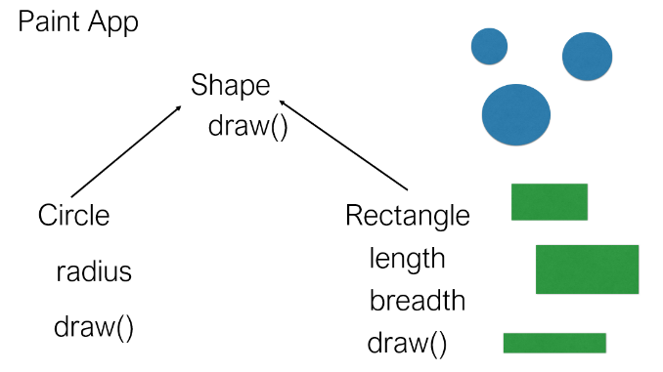

1. Command Pattern

What is Command pattern in Java?

A Command pattern is **an object behavioral pattern that allows us to achieve complete decoupling between the sender and the receiver**. (A sender is an object that invokes an operation, and a receiver is an object that receives the request to execute a certain operation.

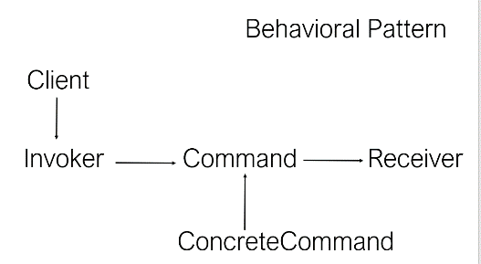

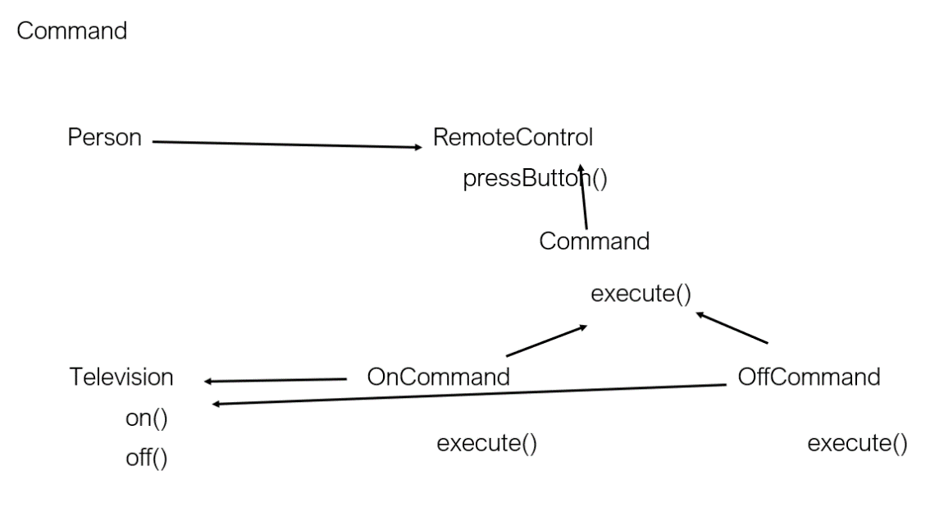

**Command**

A command design pattern is a behavioural design pattern from that gang of four patterns. It is used to encapsulate a request as an object and pass it to an invoker the invoker does not know how to service the request from the client. It will take the command and pass it to a receiver who knows how to perform the action typically.

There are five actors in the command design pattern. They are the **command** itself. The **client** the invoker the concrete command that implements the command and a **receiver** who knows how to perform all the actions.

Let's take a look at an **example** to see all these five actors in action. Let's consider a person who is using a television or is watching a television and he uses a remote control typically to perform several operations. But let's simply take the on and off operations and let's see how the command pattern fits in here.Here the person is the client who wants to execute the on and off command on it television, the remote control is the invoker so he uses remote control to invoke a particular command by pressing a button and the commands themselves are the on command and off command that implement a interface called Command which has a execute method.

So the person will wrap this on command passes it to the remote control the remote control will send that command to the television and the television knows how to perform that action based on the command that comes in when it is on.

it will execute the command which is passed in which is the on command execute method. And when it is off it will perform the Execute method of the off command to switch off the television.

Here person is the client remote control is the Invoker command is the command interface on command and off command are the concrete command classes. And finally television is the receiver who knows how to perform the action. The huge advantage of the command pattern is that the invoker which is the client and the remote control are completely decoupled from the receiver.

The person need not touch the television or he need not know how to perform the on and off command he simply uses the remote control and presses the button the remote control also doesn't care how the actions are performed. It simply passes the command to the television. That way they are completely decoupled the invoker does not know the details of the action that needs to be performed.

The receiver here the television can change the implementation of how the on and off should be performed without impacting the remote control and the person.

**Command UML**

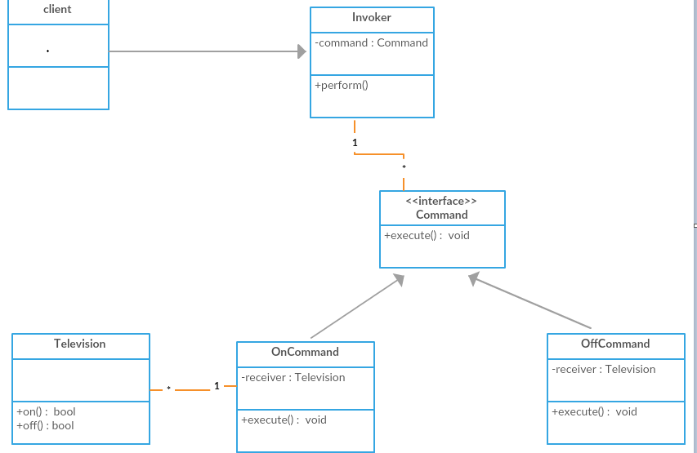

Here client want to perform certain operation on receiver is the television. Between the client and receiver there is a invoker which takes a command from client , the command itself is an interface but there is a concreate implementation of it namely onCommand and offCommand so these are concreate command which client give to invoker. The invoker simply send these command to the receiver to television which will execute the command based on what command is passed

**Implement the command pattern**

**Step 1:**- create television class which is receiver which knows how to on and off television

**Step 2:-** create command interface with execute method on it which will be implemented by OnCommand and OffCommand which knows how to invoke Method on receiver

**Step 3:-** finally will implement Remote control which know how to use OnCommand and OffCommand

Receiver method

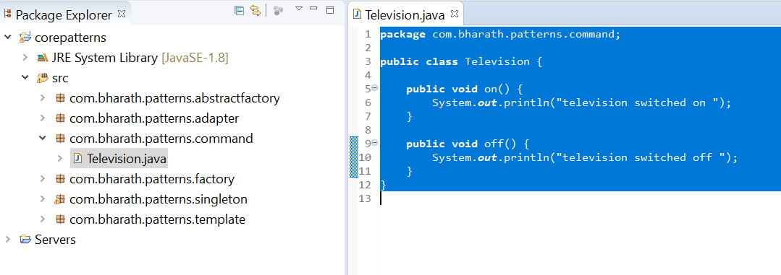

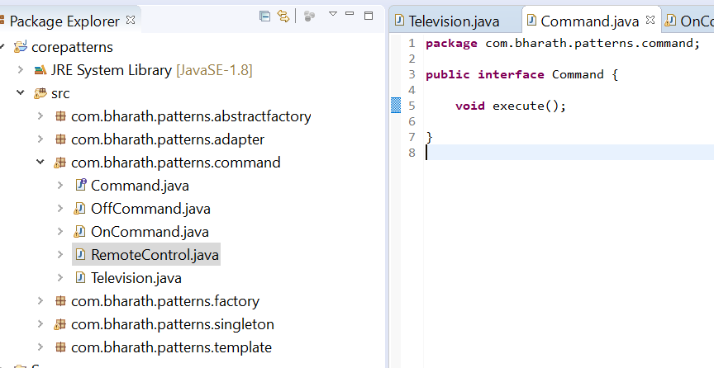

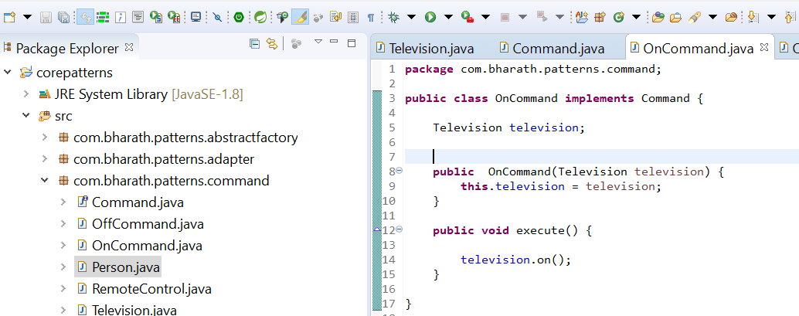

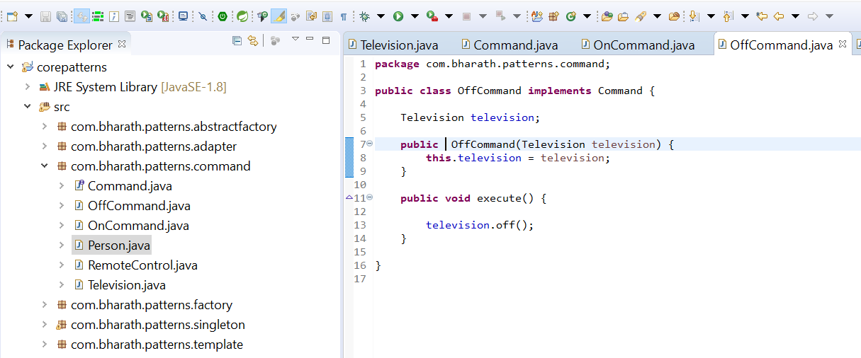

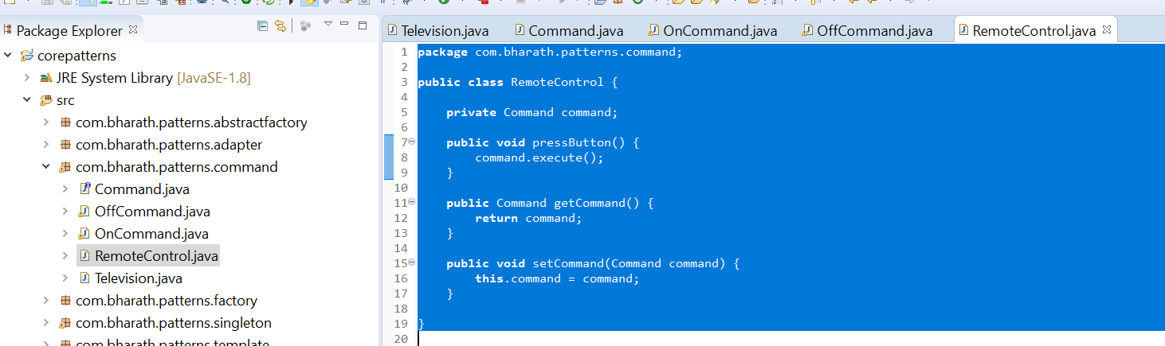

Test Command Pattern

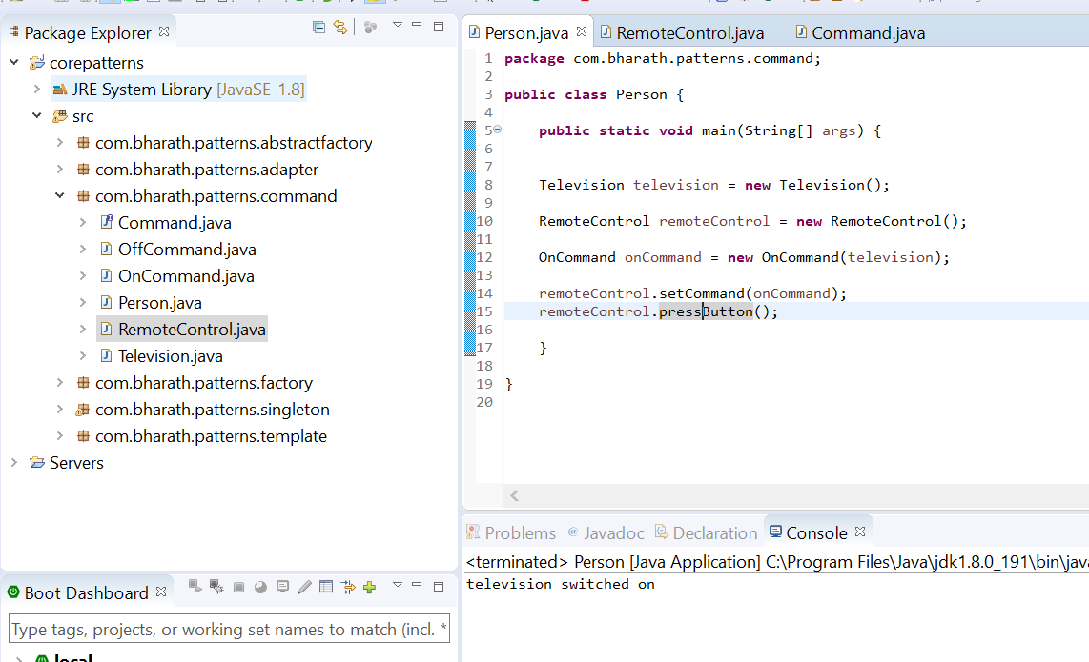

1. Decorator Pattern

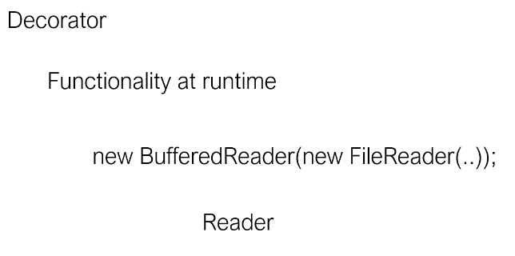

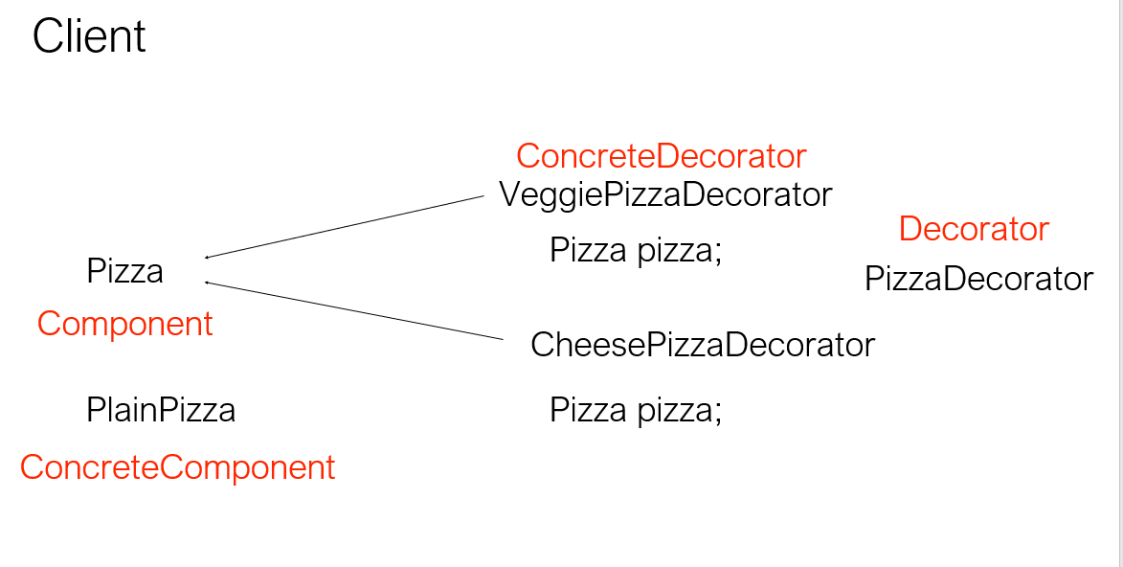

The Decorator Pattern is used for **adding additional functionality to an existing object** (i.e. already instantiated class at runtime),

**Decorator**

A decorator pattern is a behavioural pattern that adds additional functionality to an object dynamically at runtime. A decorator wraps an object with additional behaviour without affecting other objects of the same type. The classes in the input output streams in Java use the decorator pattern to read and write files.

For example lets consider a pizza shop. We have a pizza and we have a base pizza. A plain pizza, pizza by itself doesn't mean anything it is very abstract. A plain pizza probably it is just the dove without any cheese or veggies or any meat on it. And now when the client wants a plain pizza or he can ask for a veggie pizza or a cheese pizza or meat pizza

At runtime we can dynamically add all these toppings using a pizza decorator as required. A pizza decorator will be implemented by veggie pizza decorator and a cheese pizza decorator. Each of these bring in additional functionality. So if the client asks for a veggie pizza we are going to use the veggie pizza decorator at run time.

The client ask for a cheese pizza. We can ask the cheese pizza decorator to decorate the plain base pizza with cheese and with veggies as required. The pizza here is the component the plain pizza is a concrete or a base component. The decorator is the pizza decorator and these two are concrete decorators. Both the veggie pizza decorator and the cheese pizza decorator are called concrete decorators so you are going to implement all of that in the next few lectures.

**Decorator UML Class Diagram**

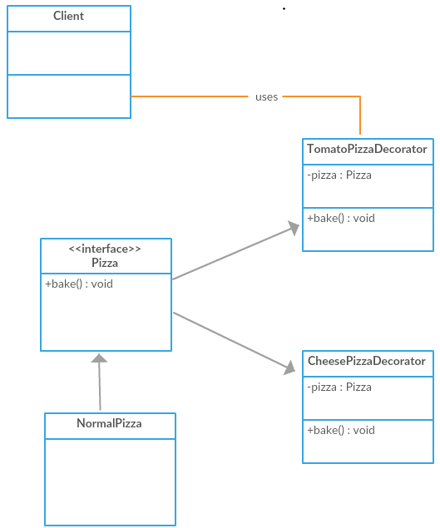

Client ask cheesePizzaDecorator and it knows how to decorate NormalPizza

**Implement Decorator Pattern**

**Note**

Whatever pizza instance is passed in pizzaDecorator it will call that pizza since it is base pizza

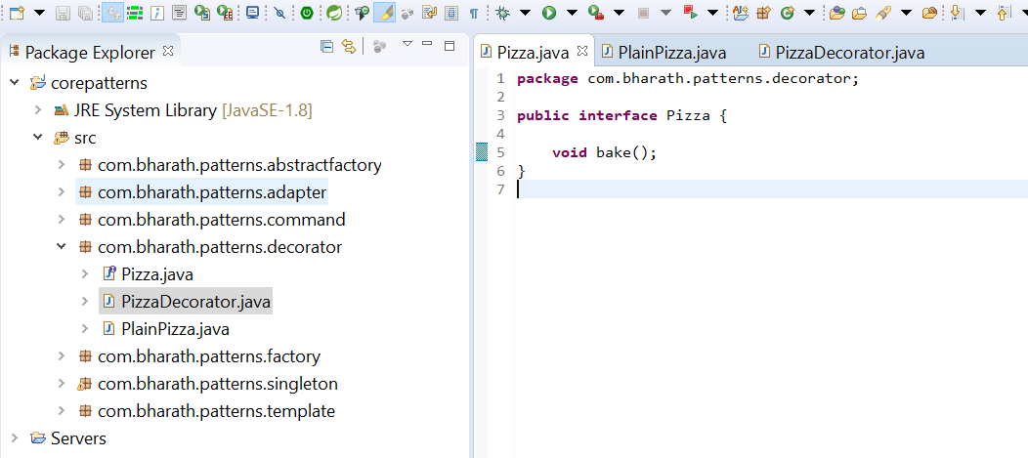

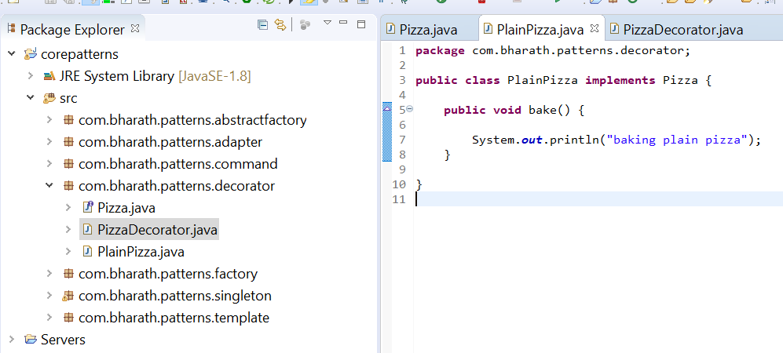

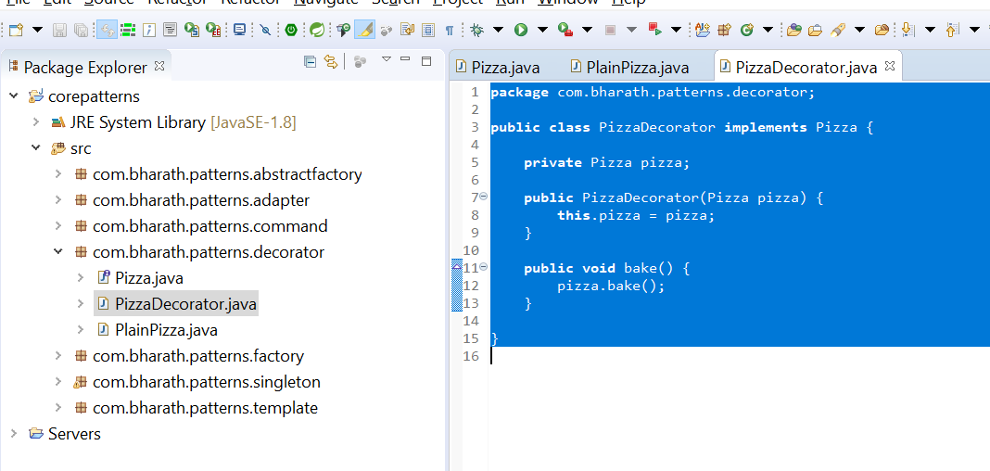

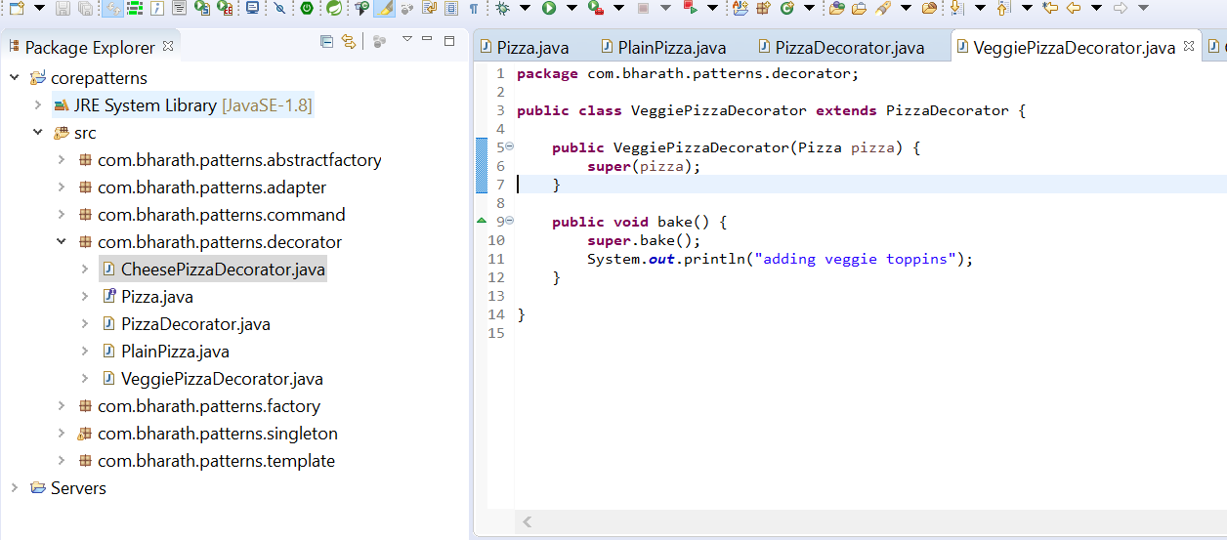



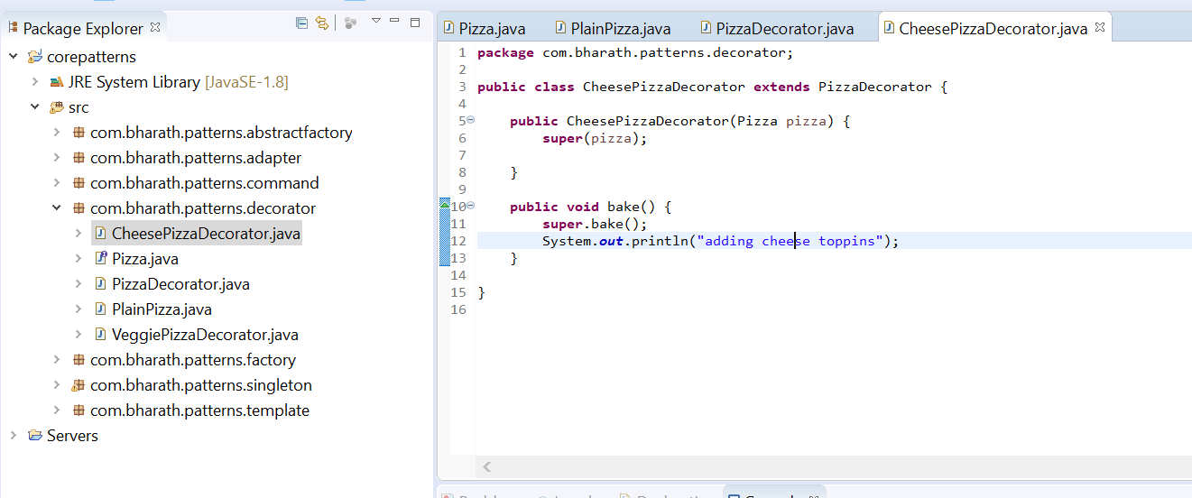

**Test Decorator**

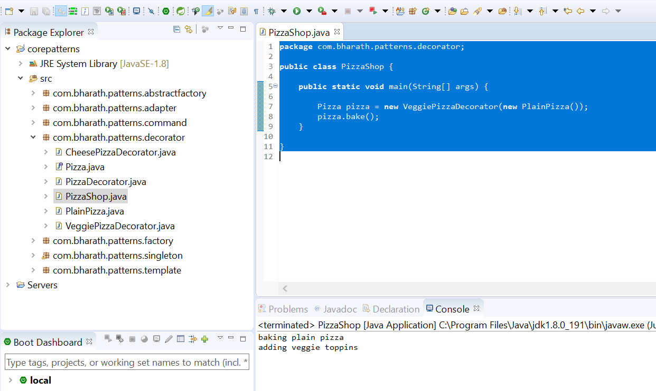

**Note :**

**We can wrap one decorator inside the other**

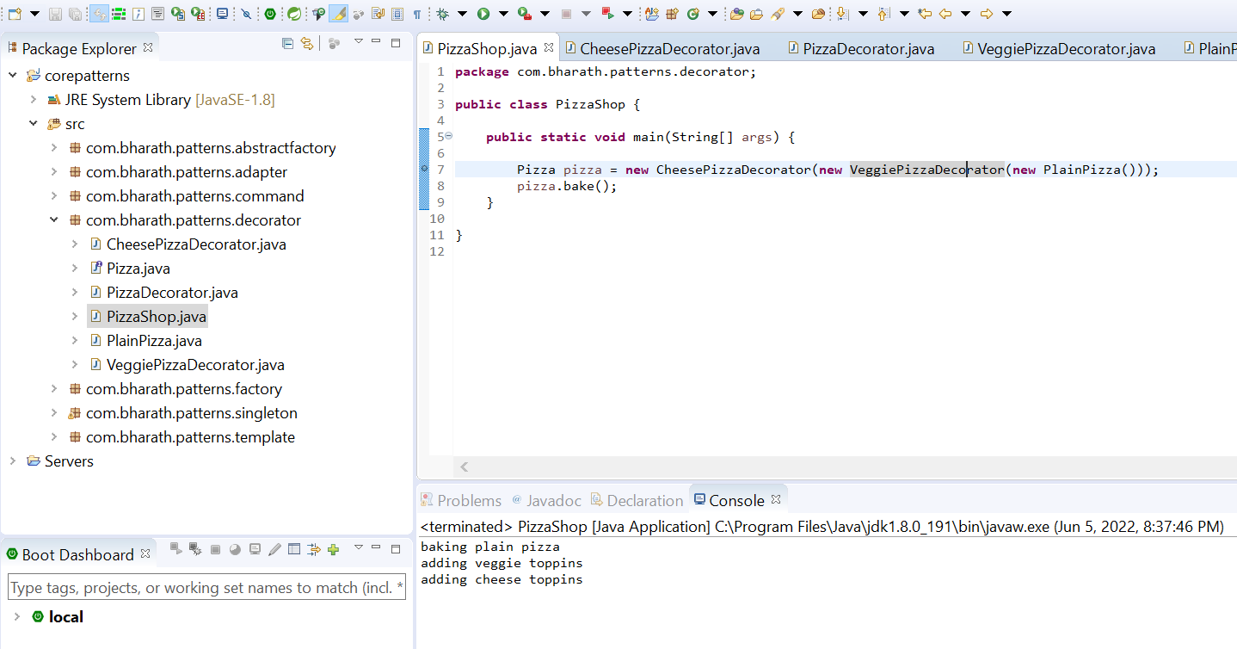

1. **Inversion of control(IOC) pattern**

**Di and IOC Introduction**

**The process** of asking an external container to create an object and inject it into runtime is called inversion of control. So we achieve dependency injection throug**h inversion of control.**

**Dependency injection** is a mechanism providing a dependency to a class which need it dynamically at runtime by creating a object of that type

By delegating the dependency injection to a container we achieve Inversion Of Control

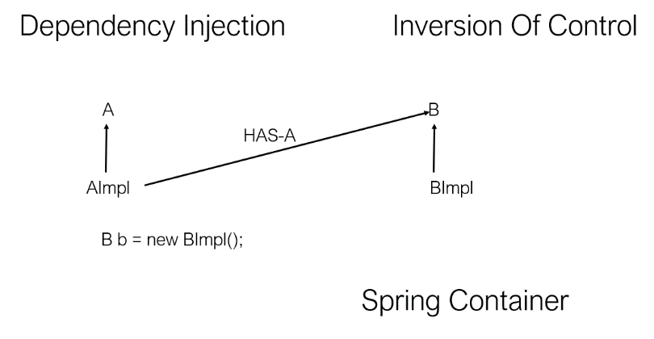

**Create the project and classes**

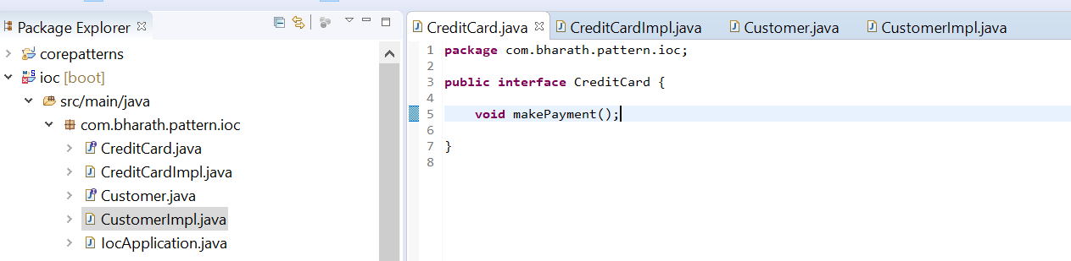

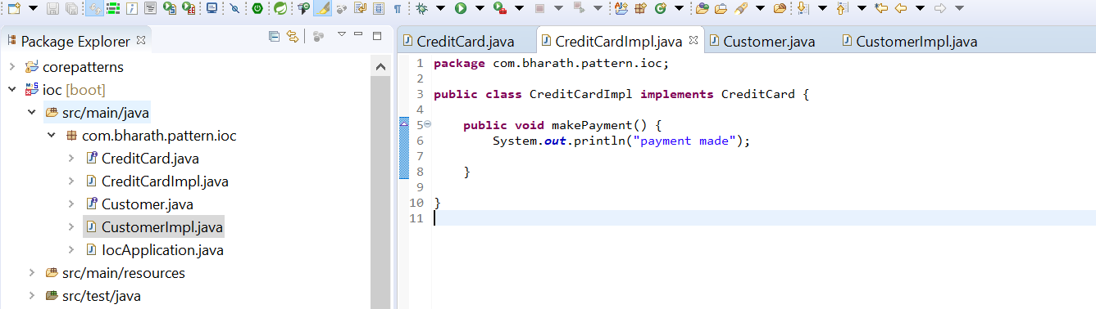

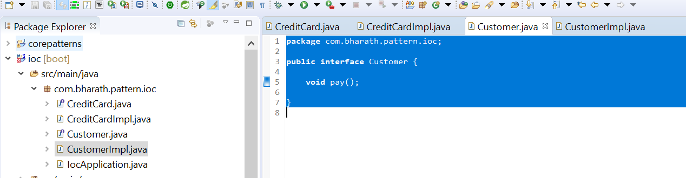

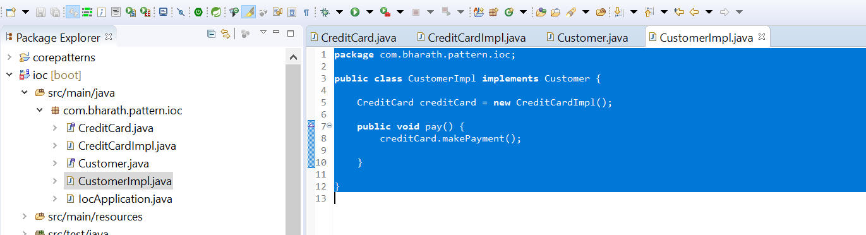

**Note :**

Here in customerImpl we are creating object of credit card

**Implement DI and IOC**

Since autowired is marked at interface, spring is smart enough it will search impl class create a object and inject into field creditCard

But we need to tell spring framework this credit card can be instantiated.

@Component:- stereotype annotation which tell spring at runtime object can be created

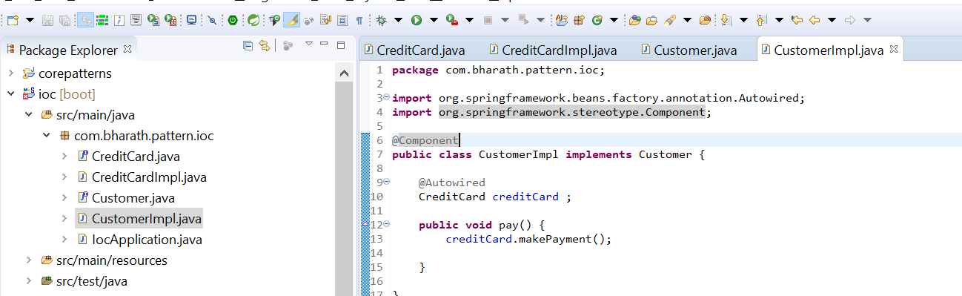

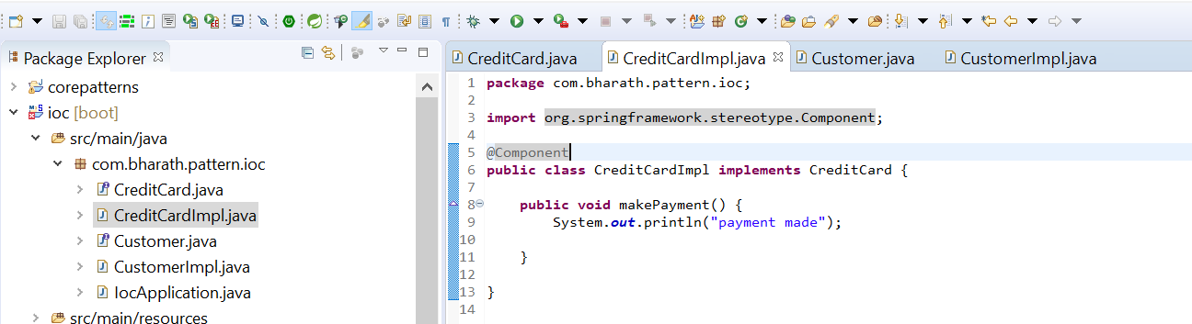

This is called field level dependency injection

**Test Dependency Injection**

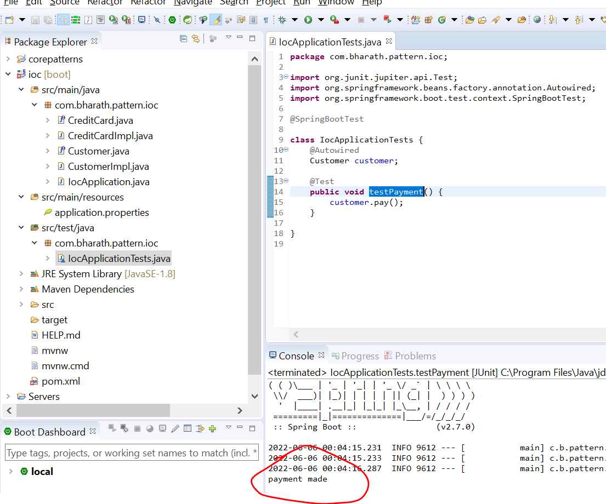

Spring container will scan all the packages and it sub packages within which this IocApplication class is present.

It will check which class is marked with @component annotation. It will create the instance of those classes and wherever we use autowired it will inject those there

**Setter Injection**

Everything else will remain the same

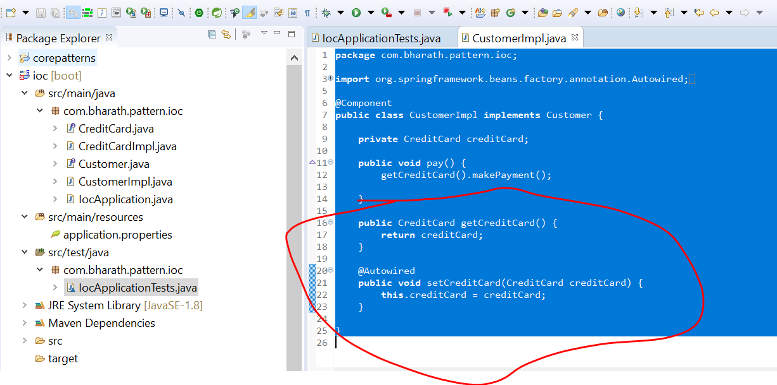

**Constructor Injection**

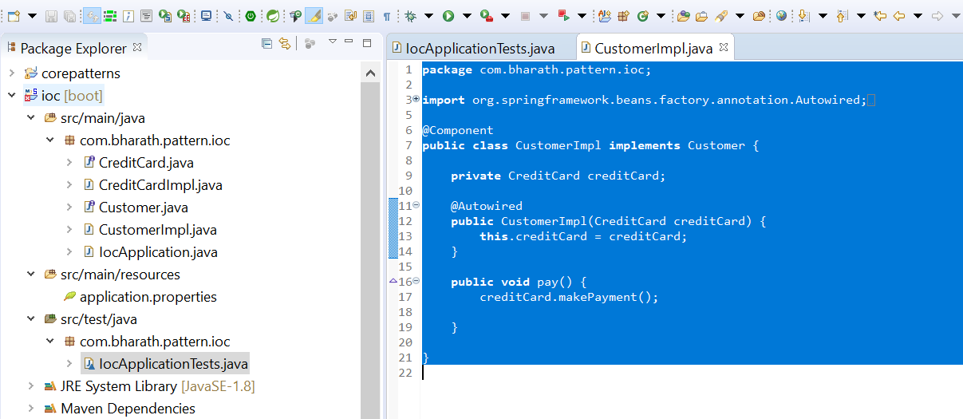

**Java EE Basic**

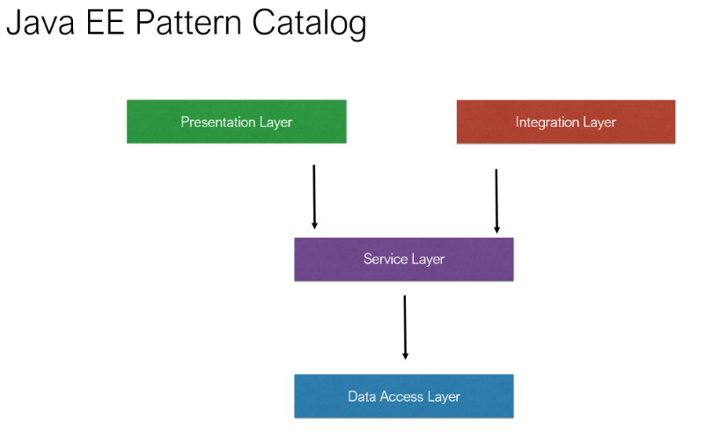

**Data Access Layer :** responsible for performing crud operation

**Services Layer:--** business logic or application logic reside

**Presentation layer :-** responsible for generating the user interface

**Integration Layer :-** allow our application to access other application in an organization or third party application or allow other application to access our application

Model class :--- it represent data which will use across the application

Utility class :--- perform special operation across all layer

Validator class :- data come from user and goes back to user

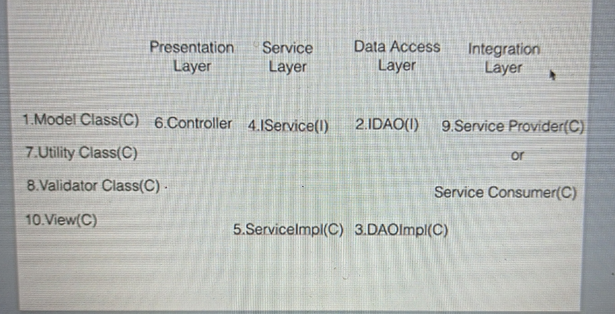

**Why layers**

**Advantages**

Simplicity

Separation of concerns

Easy Maintenance

**Layers and patterns**

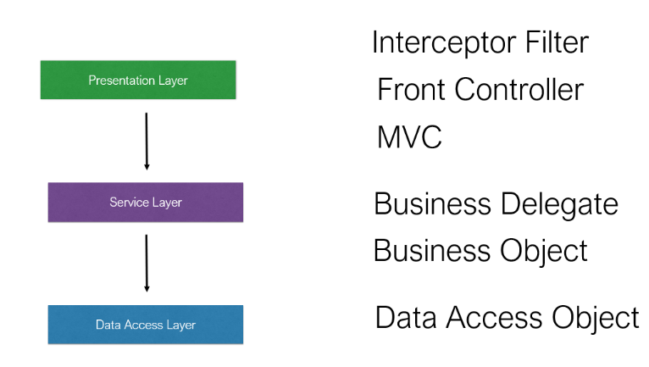

**9-Presentation - Tier Patterns**

**Intercepting Filter :-** what it is and where we use it

The filter which will write will handle the request and they will do some special processing before the request reaching the target

Requirement :- request will come chrome browser and reject from all other browser

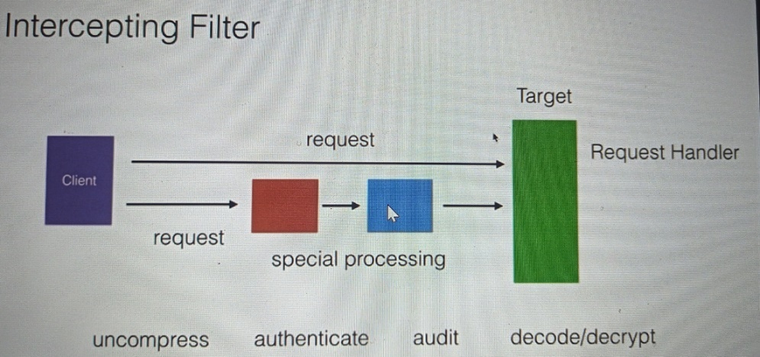

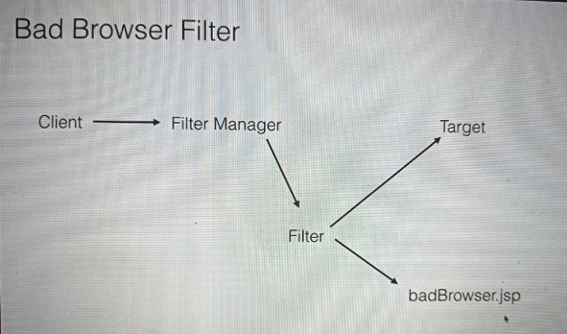

**Create the target Servlet**

If the request come from chrome it will go to target(servlet) and it will send to home.jsp else it will go to badbrowser.jsp

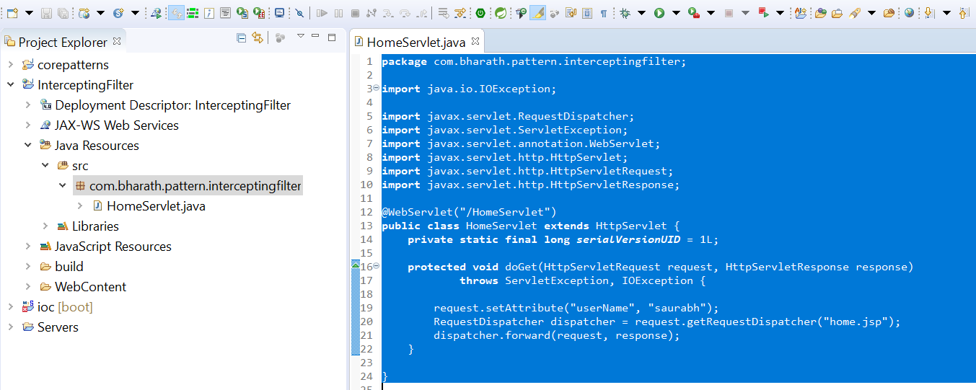

**Create The filter class**

**Requirement :-** Filter out client who is not using chrome browser

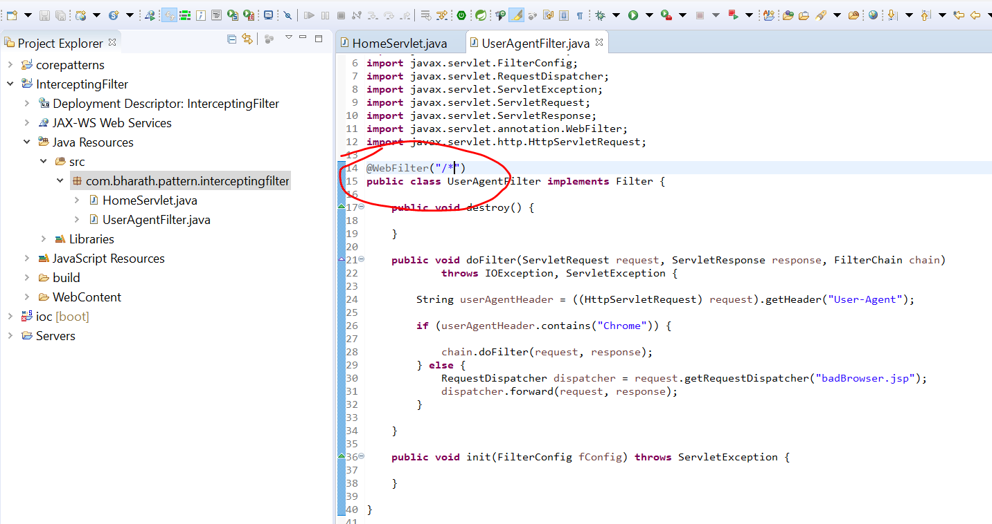

**Create The JSP**

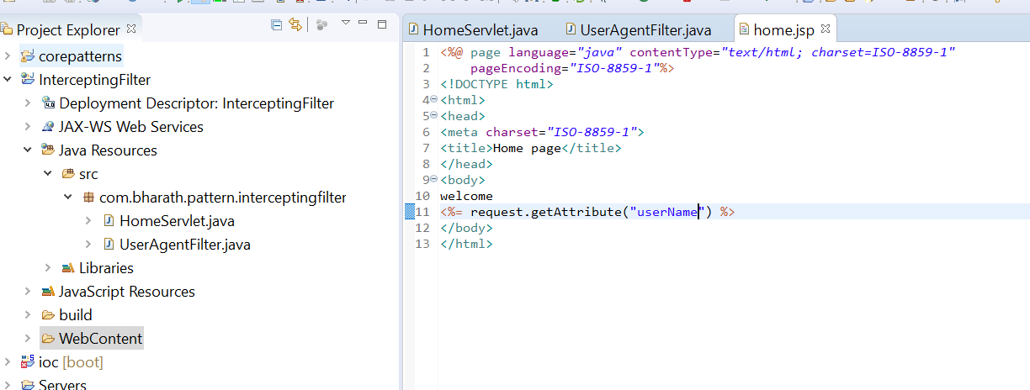

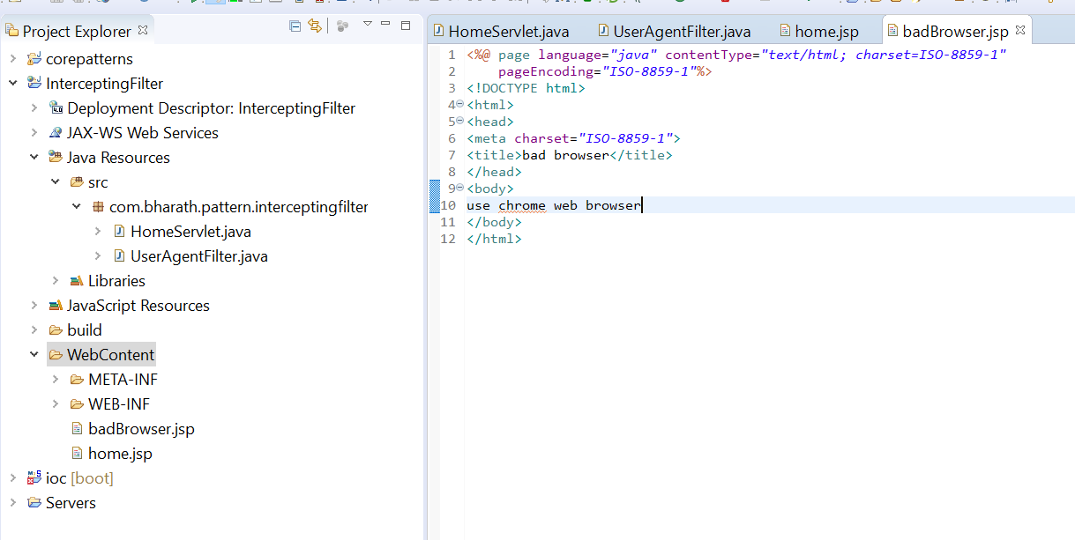

**Test**

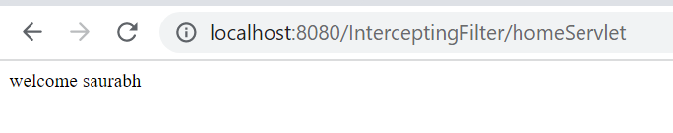

**Running the url from firefox**

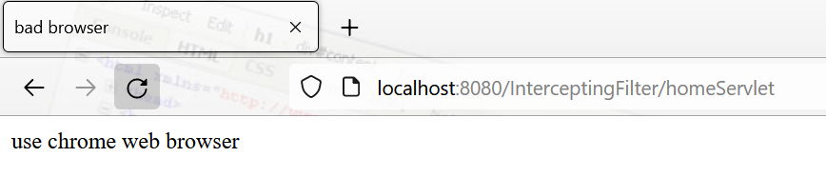

It means filter is working here

**Front Controller**

When we navigating from view to view then we face two problem

1. Need to write processing logic in each page
2. view navigation code we need to write

And also if any special processing like security then we need to **repeat this code in all view page**

And view will become cumbersome and to maintain

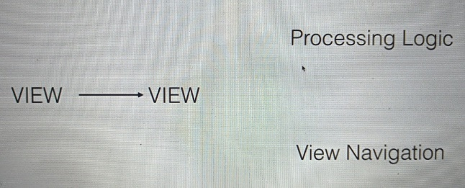

**This is where front controller come in picture**

**Front controller :--**

Will handle business processing and view navigation for us

When request come in it always go to front controller

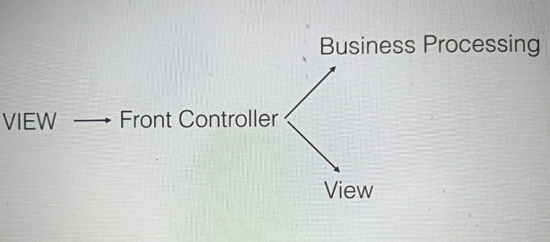

**10-Model View Controller (MVC)**

**Introduction**

Mvc is a design pattern that split the layer into three parts model , view and controller

Model :- represent current state of application . It can connect to d/b and can do lot of work

View : responsible for displaying the current model to the end user

Controller :- it act as glue between view and model . It is responsible for selecting the appropriate model to serve the appropriate request

When request come from client it goes to controller. The container will call the controller. The controller will select the appropriate model

Which does the work the business logic and the model will return a response the controller will select a appropriate view to display data back to the client

That will be html

**Advantages**

Maintenance

Parallel development

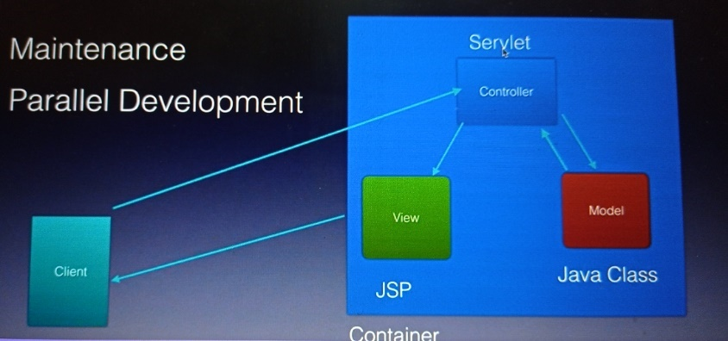

**Create The Project**

**Steps:**

Create the project

Create the view

Create the model

Create the controller

**Create the view**

Where user enter some number

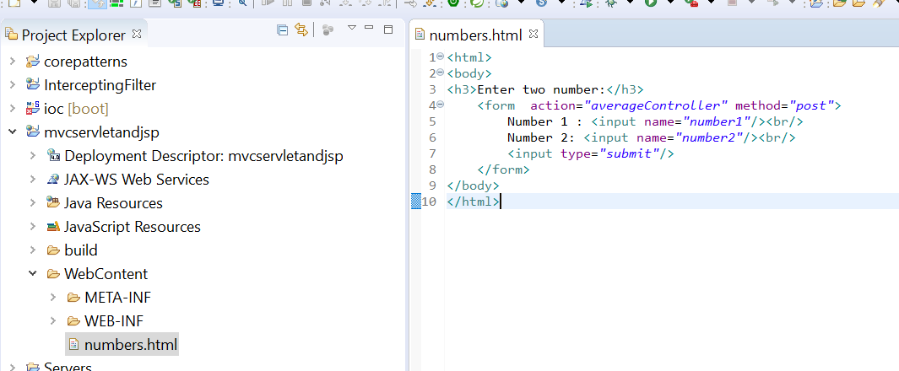

**Create the model**

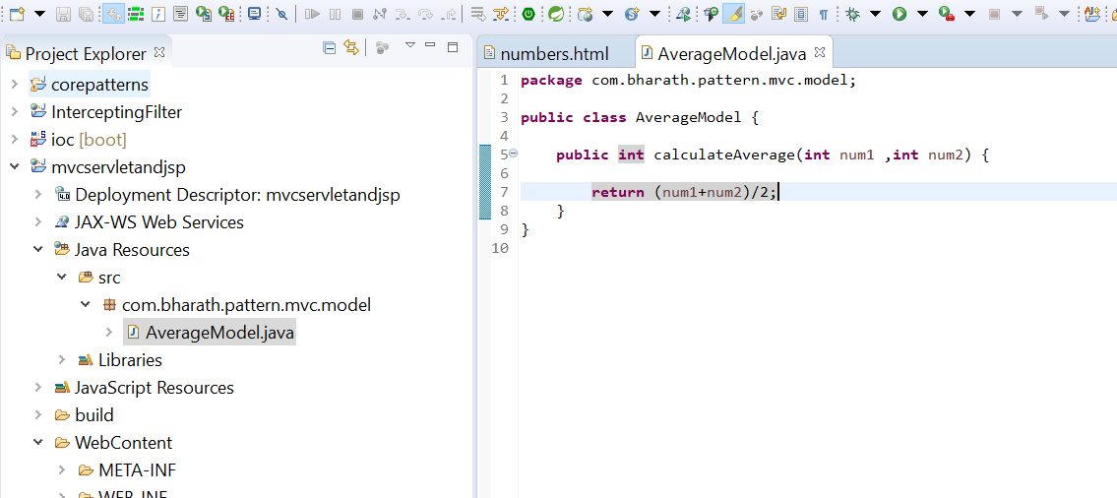

**Create the controller and create the next view**

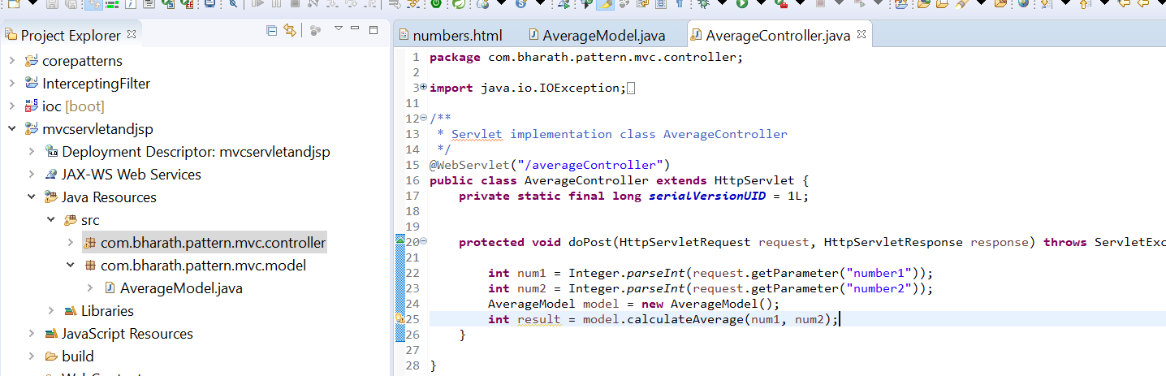

We will send this result back to next view

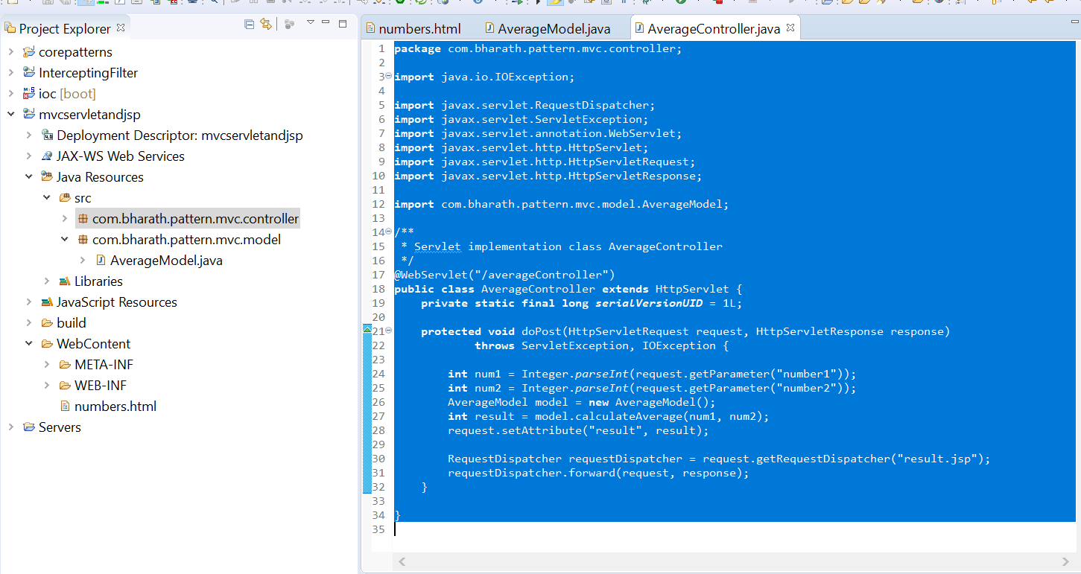

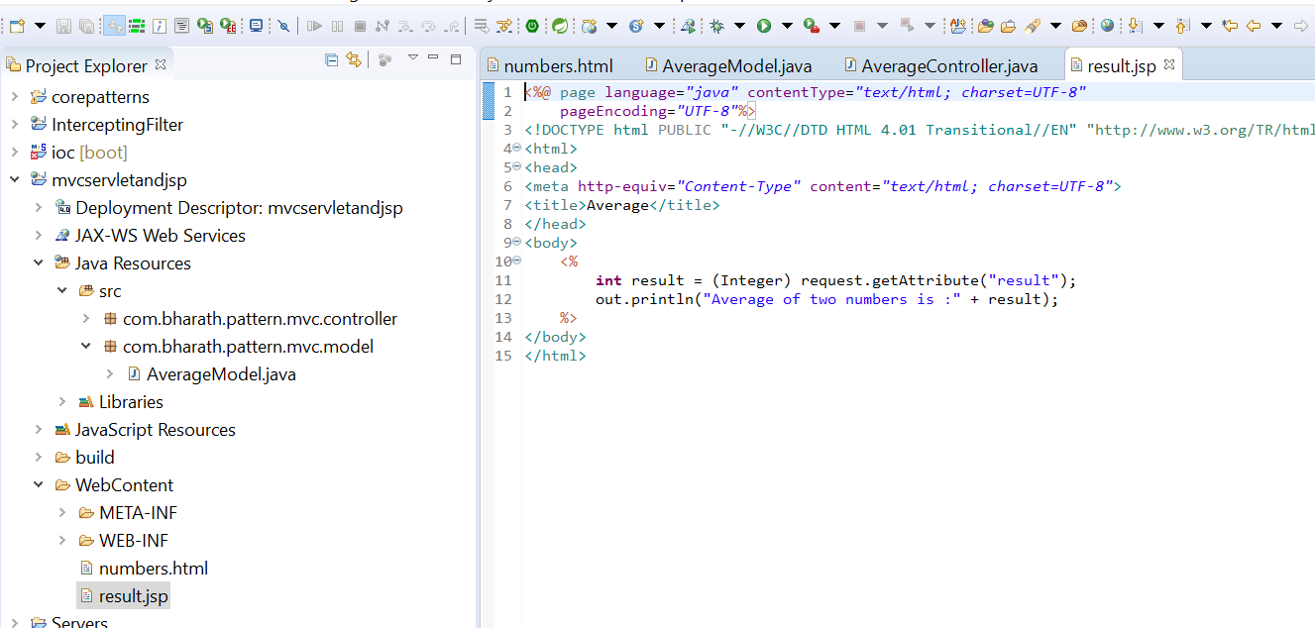

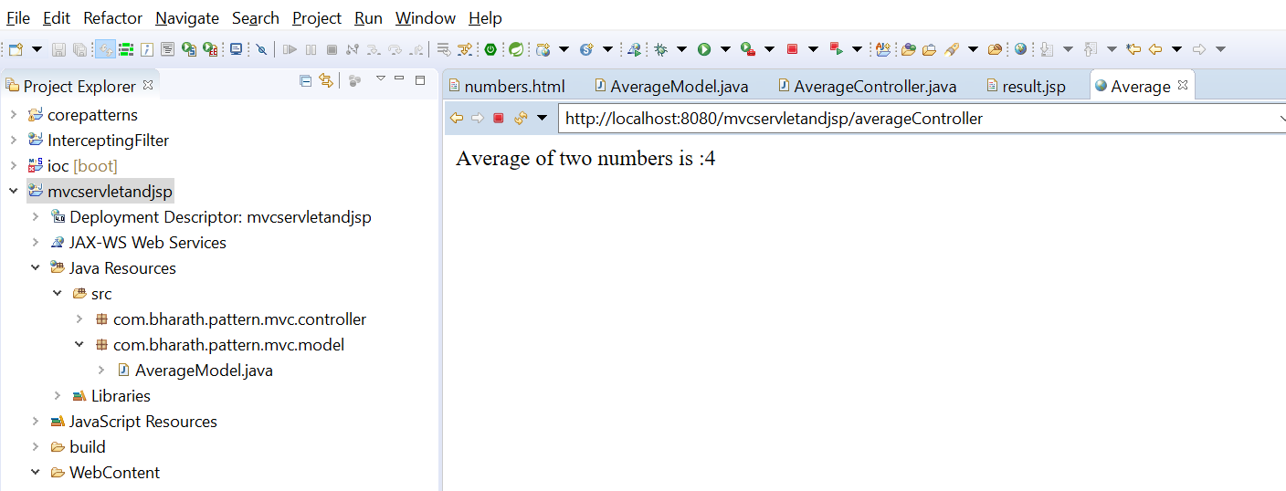

MVC Using spring boot

Create the project

**Create the controller**

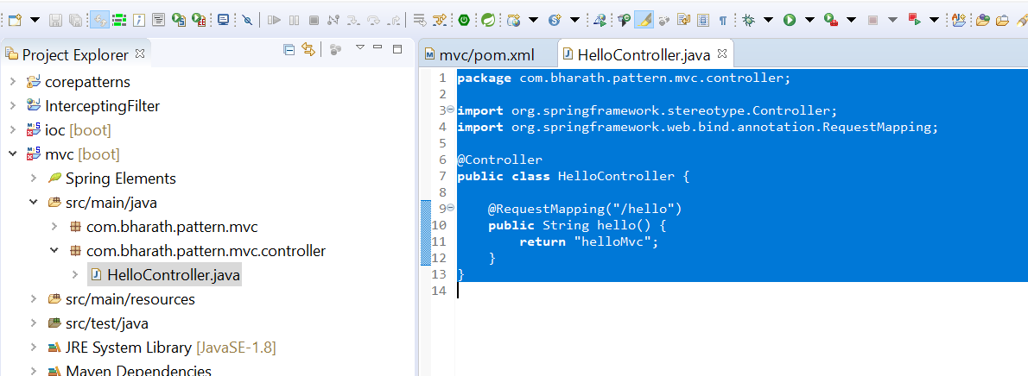

**Create the view**

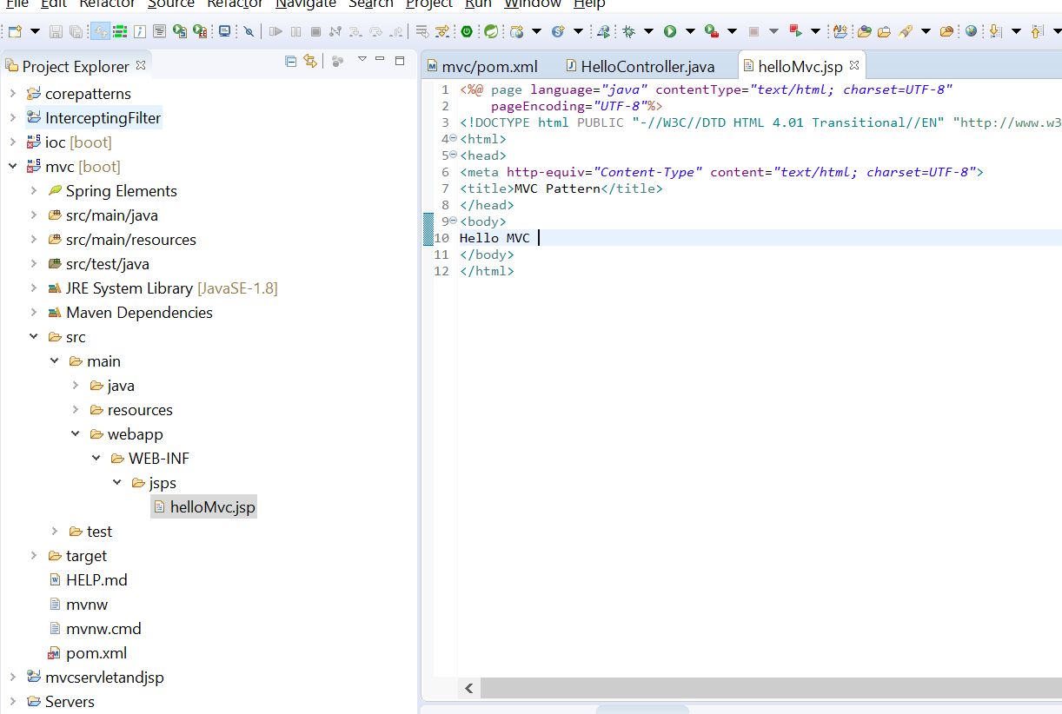

**Configure the prefix and suffix for spring mvc view resolver**

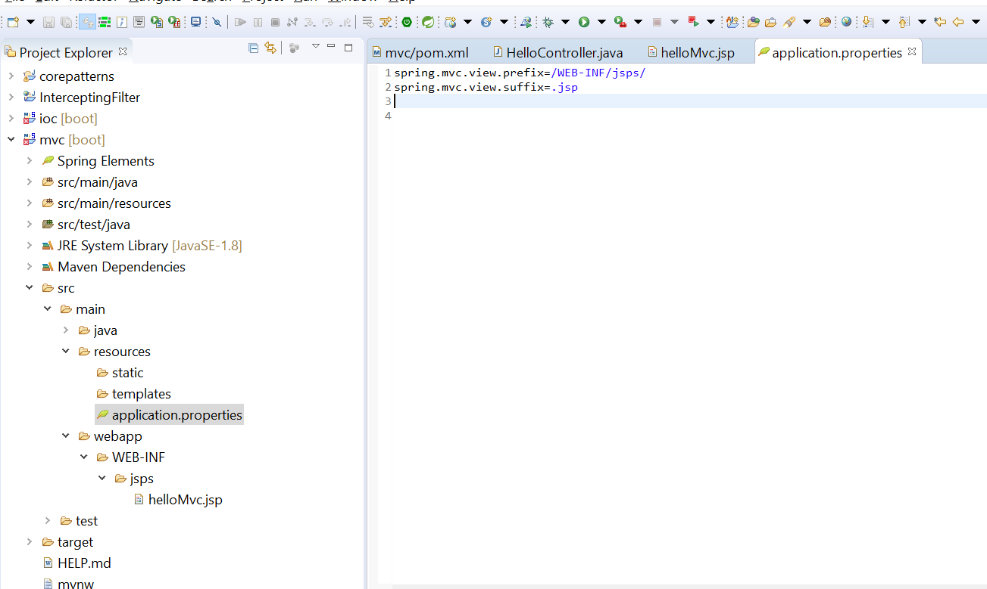

**Add the jasper dependency**

**To server the JSP page we need to add this jar**

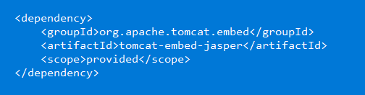

This is only required running on embedded tomcat

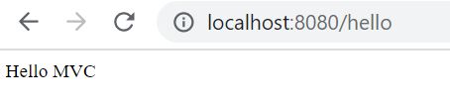

**Configure a context**

**Added context path**

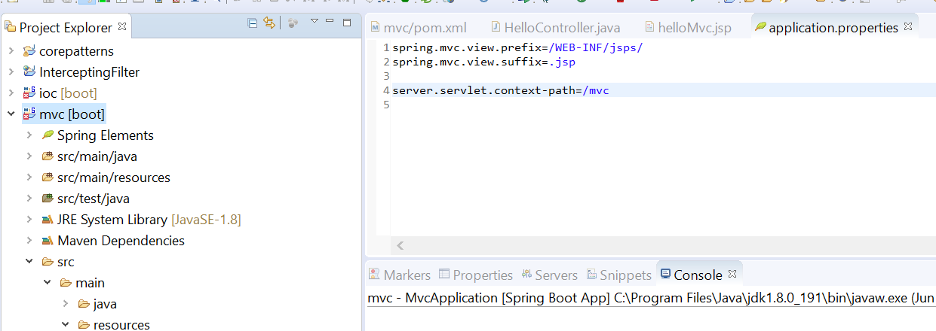

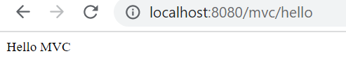

**Use Model**

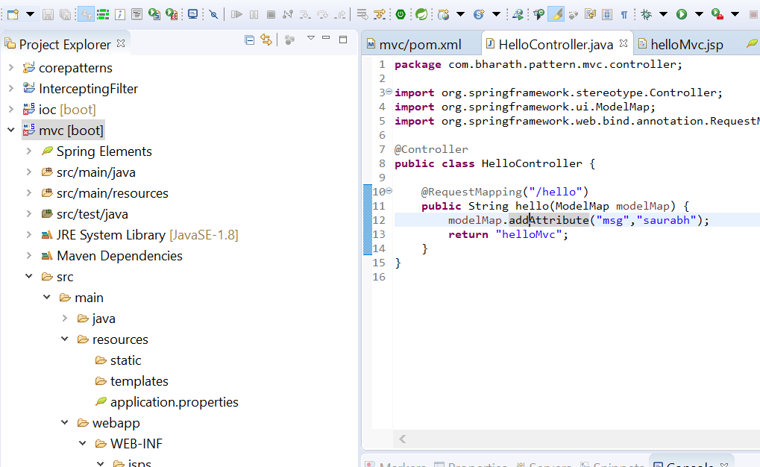

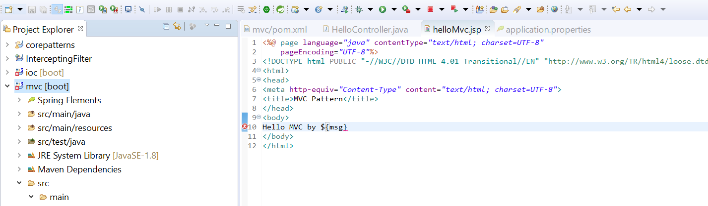

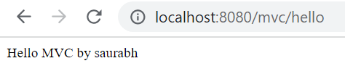

**11-Data Access Object (DAO ) Pattern**

Responsible for performing crud operation in d/b

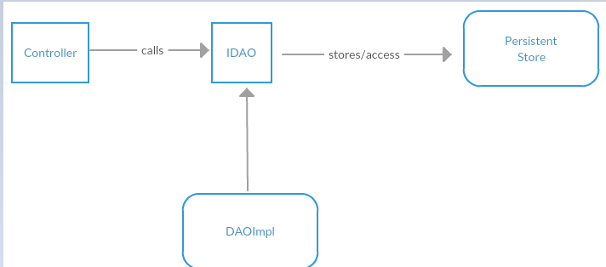

**Create the d/b table**

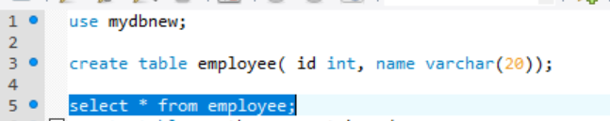

**Create the project**

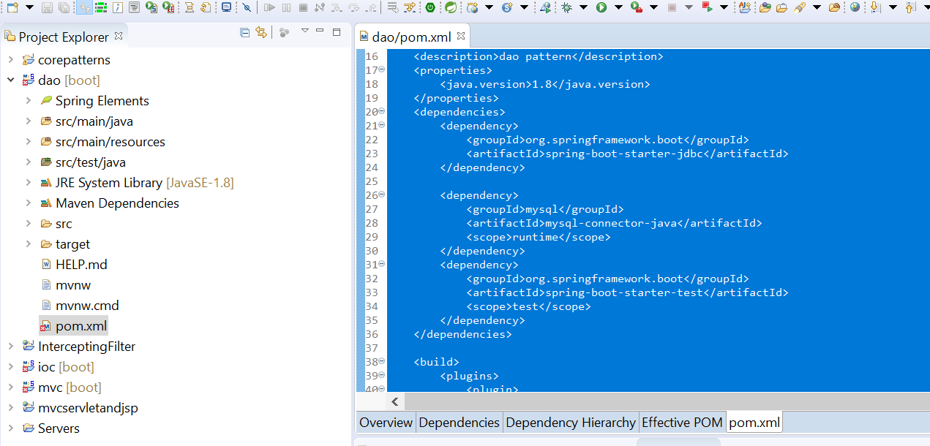

**Create the dao classes**

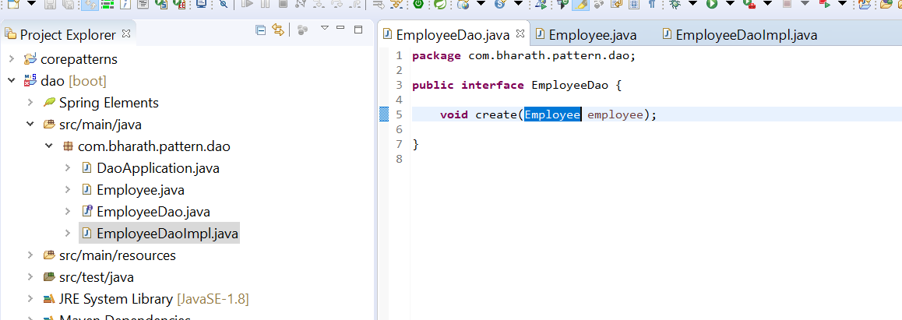

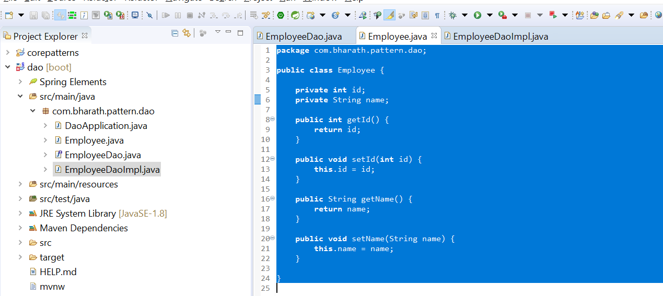

**Implement the create method**

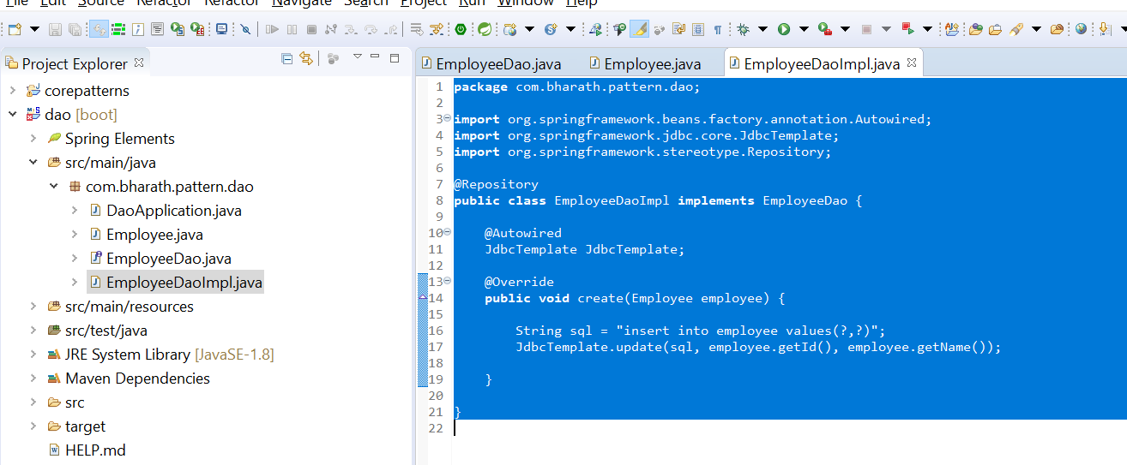

These two question mark will be replaced whatever we passed in update method

**Configure the data source information**

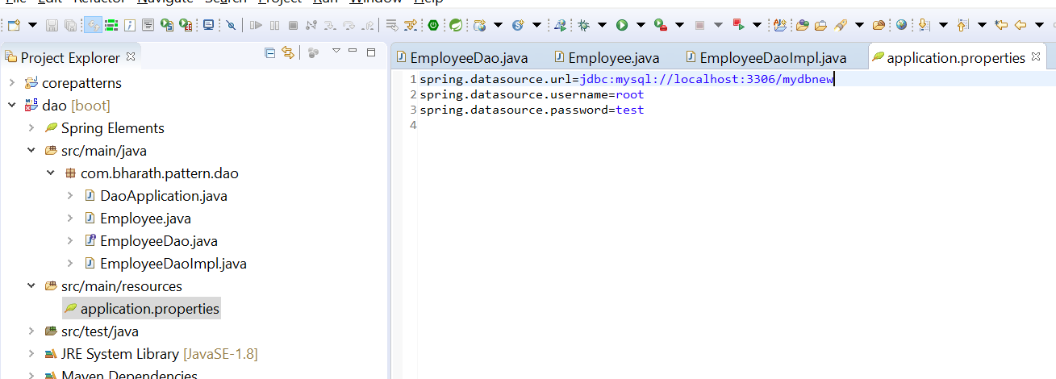

**Test**

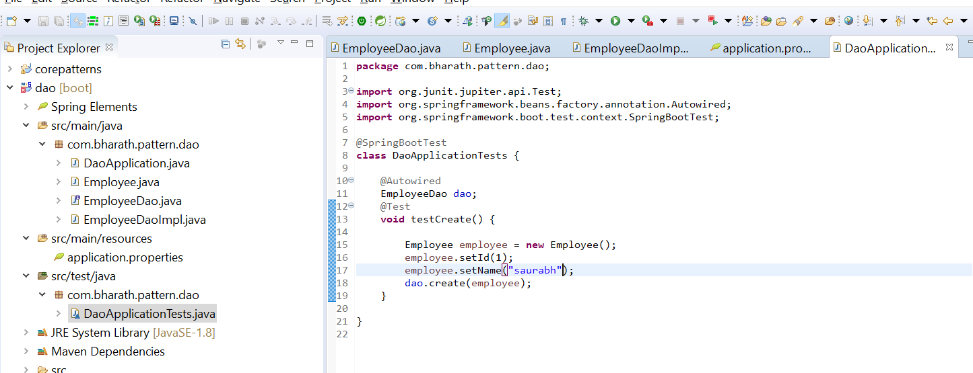

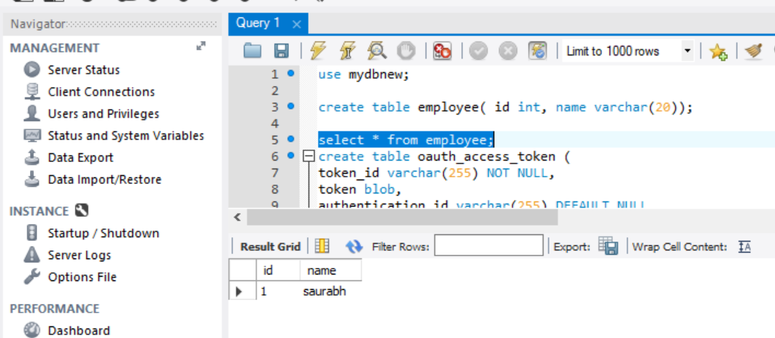

**Mini Project using MVC and business delegate**

**Usecase**

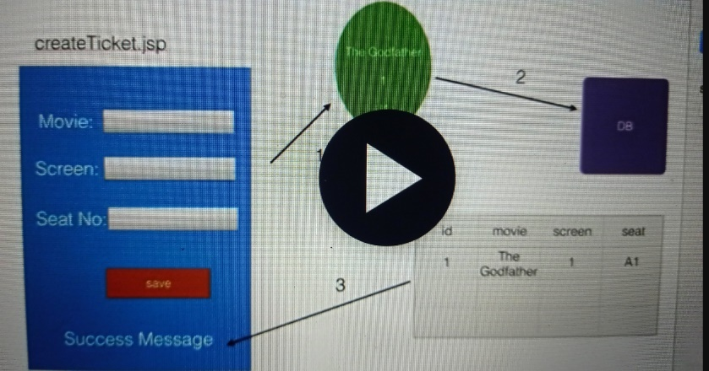

**Layers and classes**

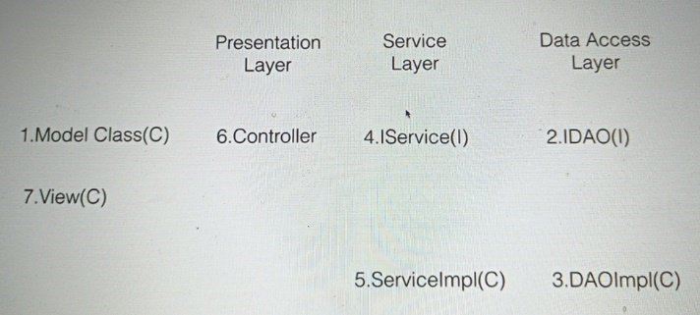

**Create the db table**

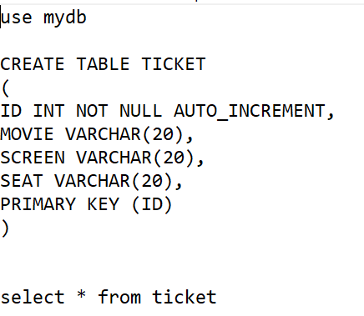

**Create the project**

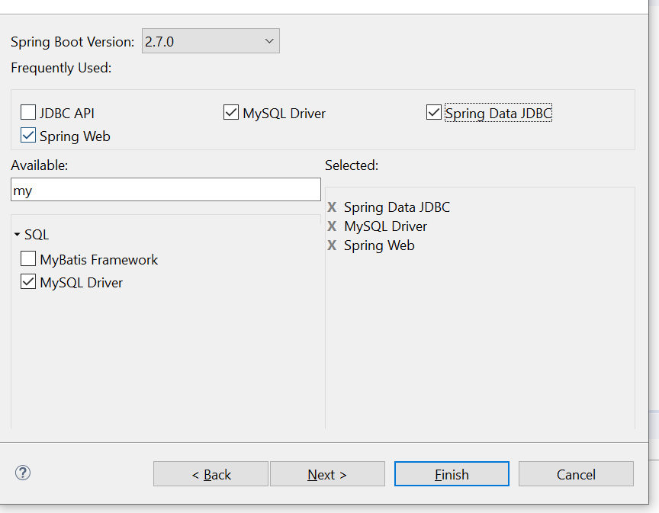

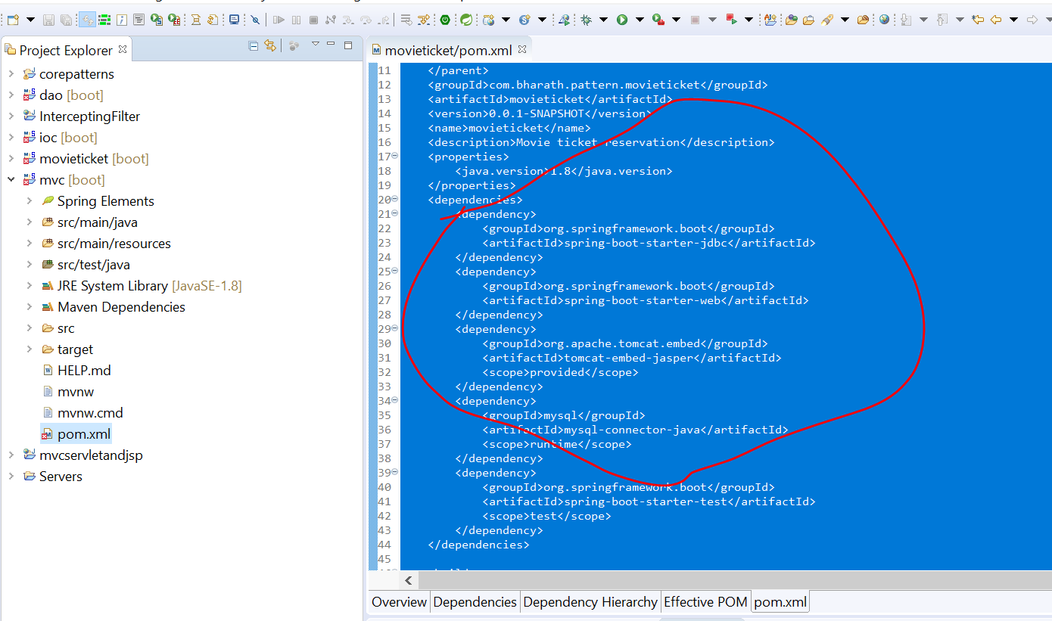

Since we are going to use jsp so we are using jasper

**Create the model**

**Step 1:-** create model class ticket

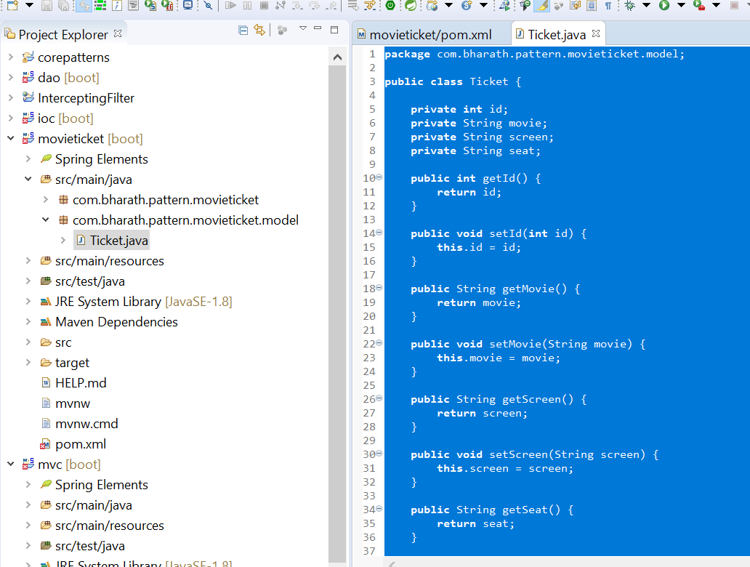

**Create the data access layer**

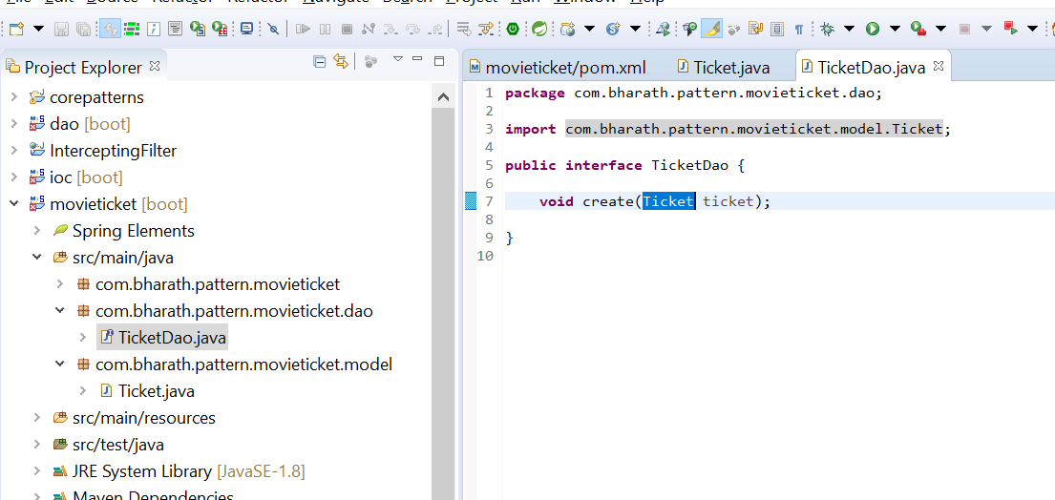

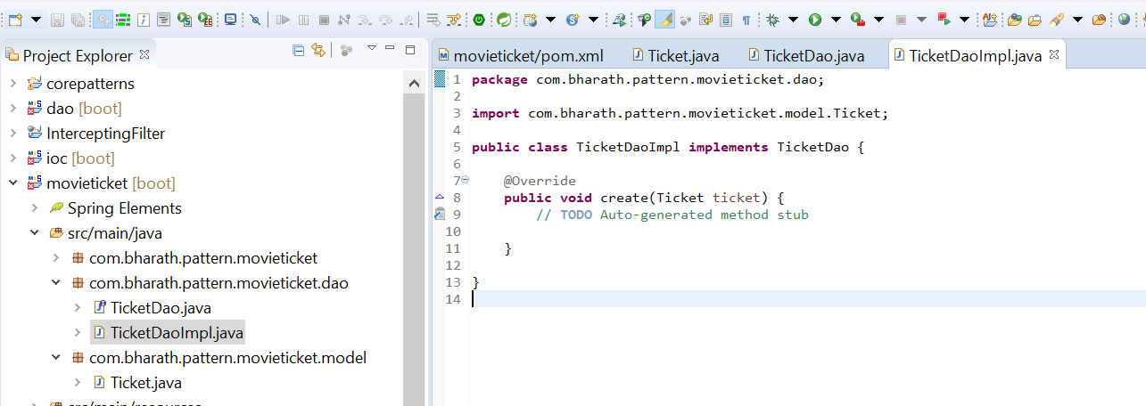

**Implement the create method**

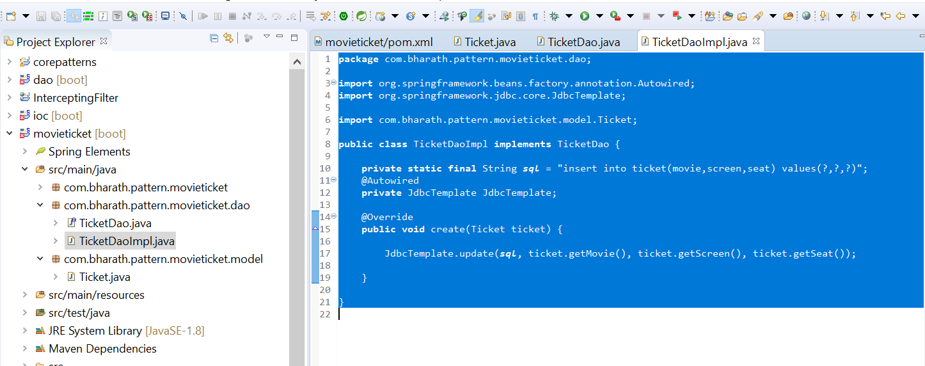

**Create the controller**

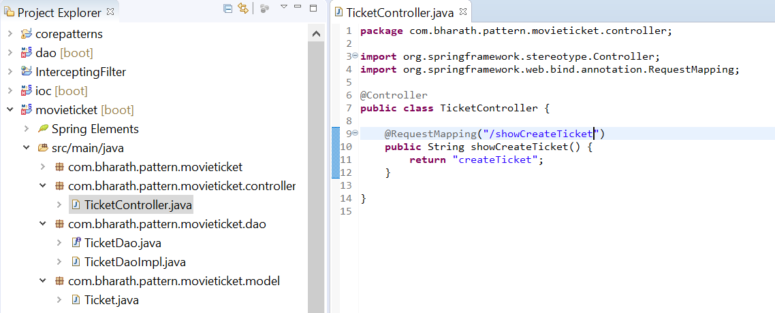

**Create the view**

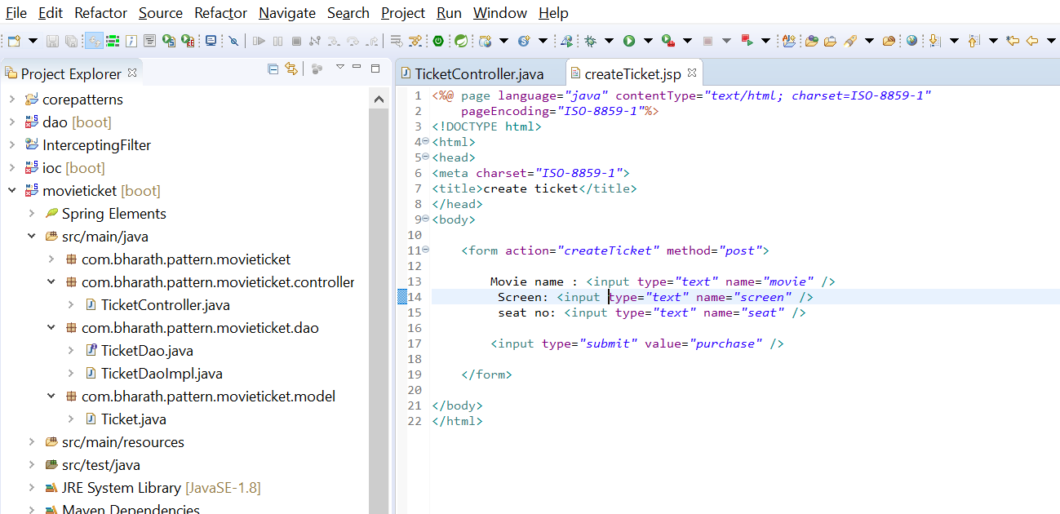

**Handle Ticket Creation**

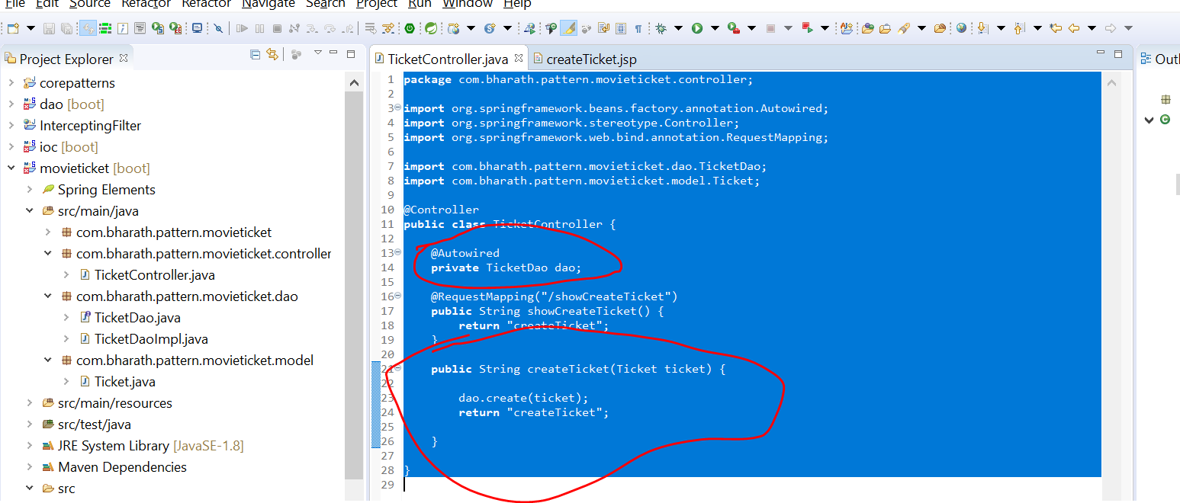

**Send a message back**

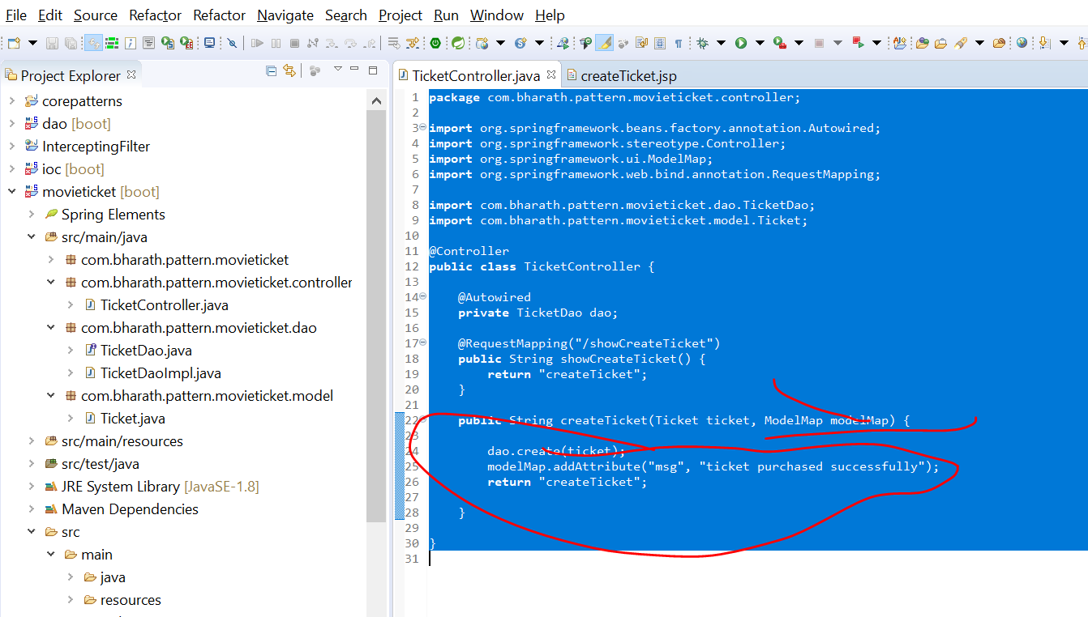

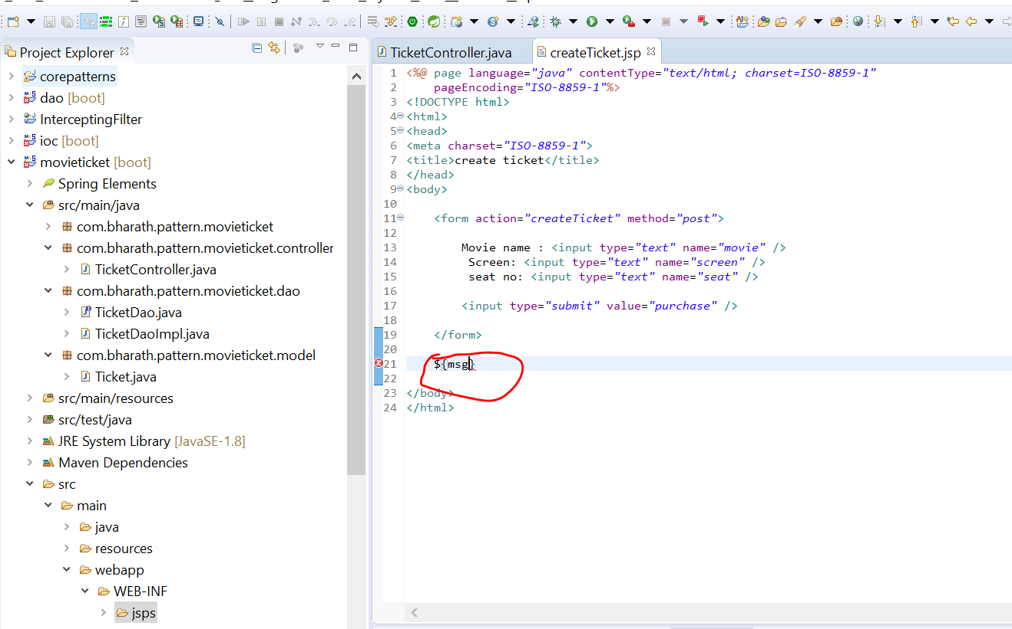

**Refactoring**

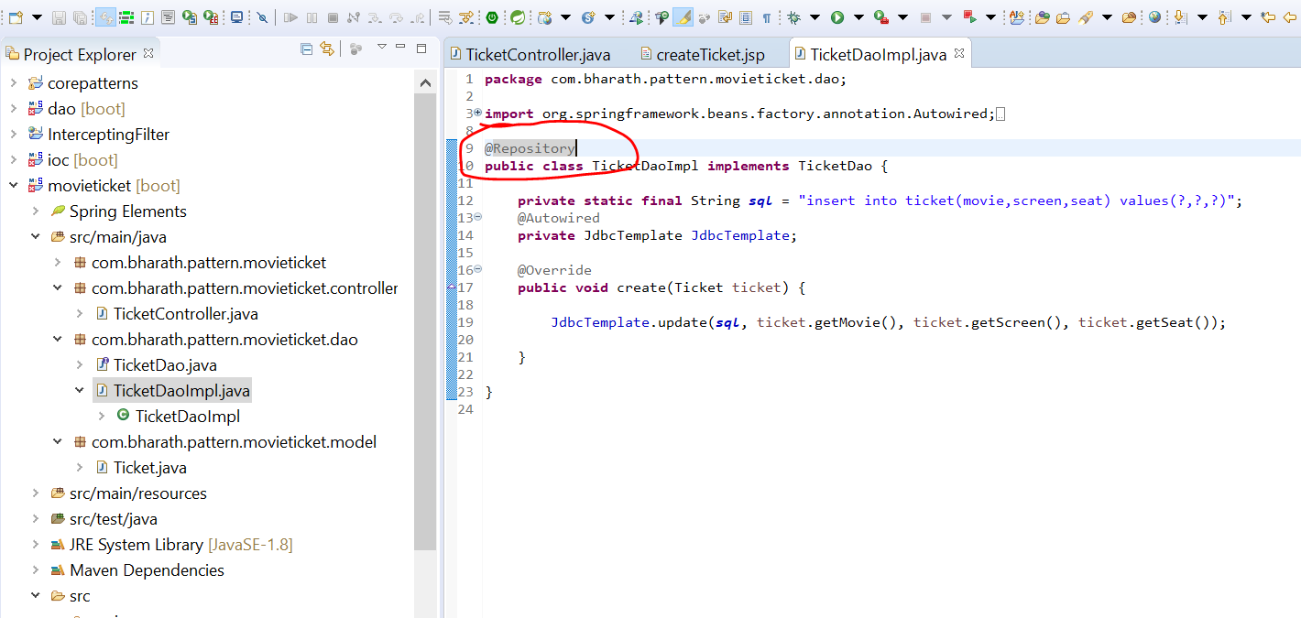

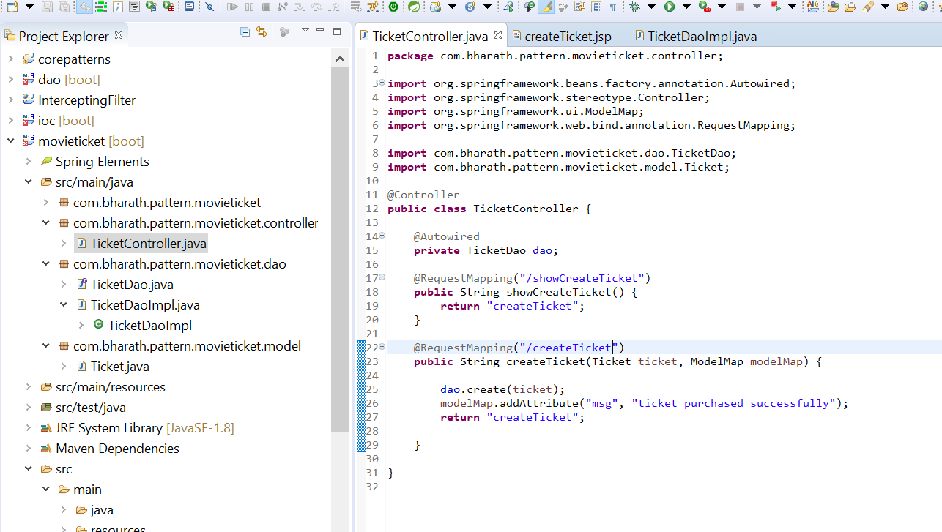

**Configure the spring boot properties**

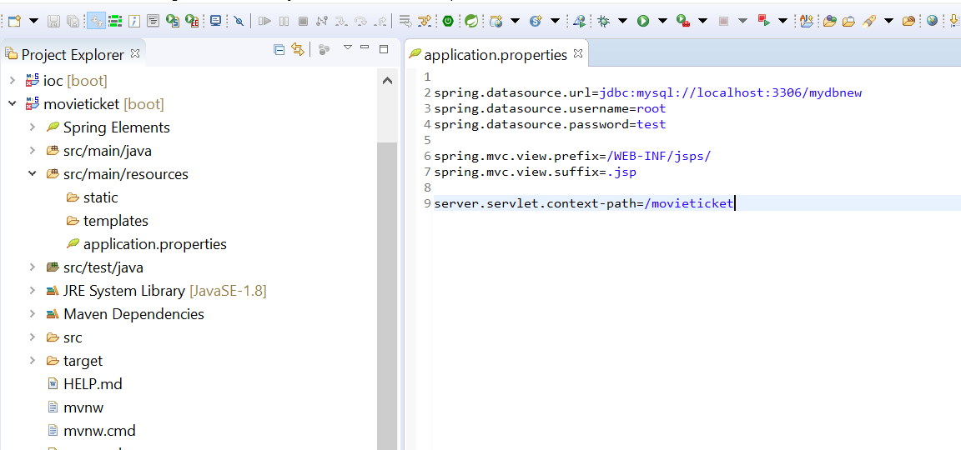

**Run the application**

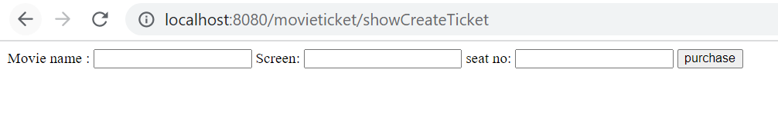



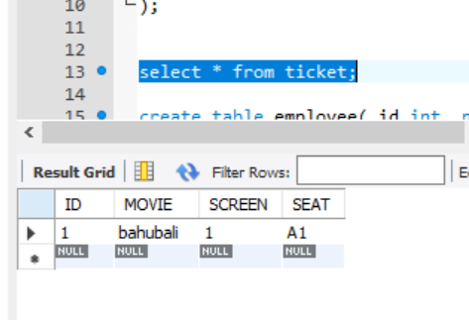

**Business delgate( service)**

**Advantages :---**

it can be reused across the layer

**Create the business delegate layer/ service layer**

Once ticket is created successfully customer need ticket via email or text message

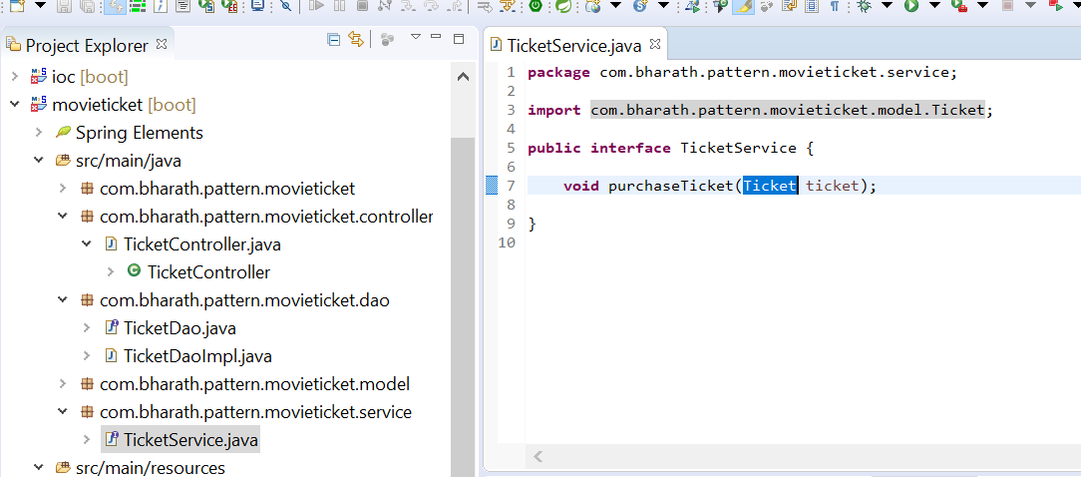

**Dao layer will be use by services layer**

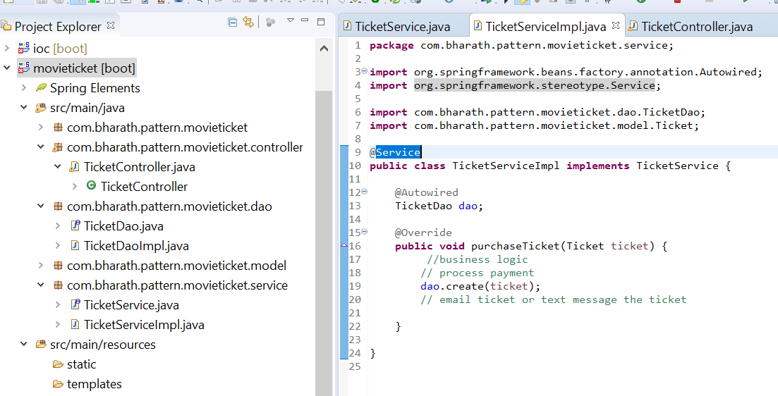

**Use the services layer classes**

**Use service now in controller**

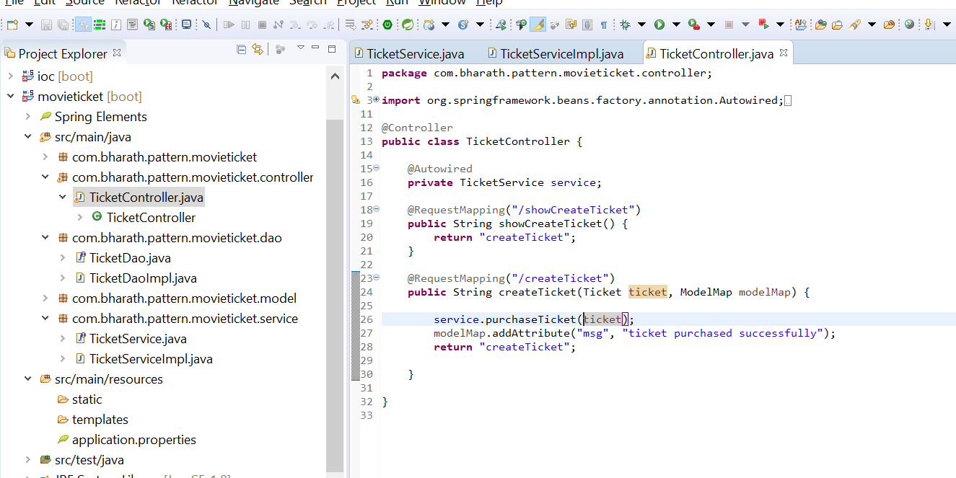

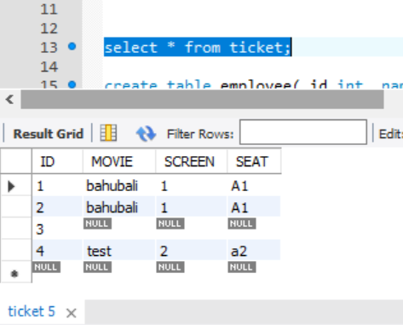

**Business Object**

Model field is tightly coupled with presentation layer and service layer . So once we create Business object then it will not tightly coupled

**Business object pattern** :--- it is simple replica of entity but it can have its own field name instead of exactly being the entity

**Create a BO**

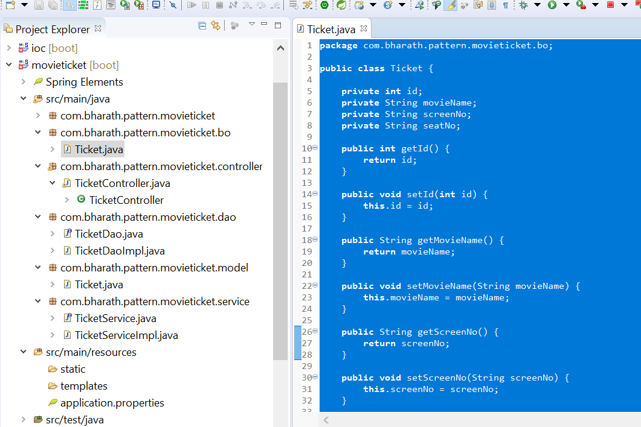

Now we should use this business object inside our controller layer and services layer instead of directly using the entity

**Use the BO**

**First change in Service layer:-**

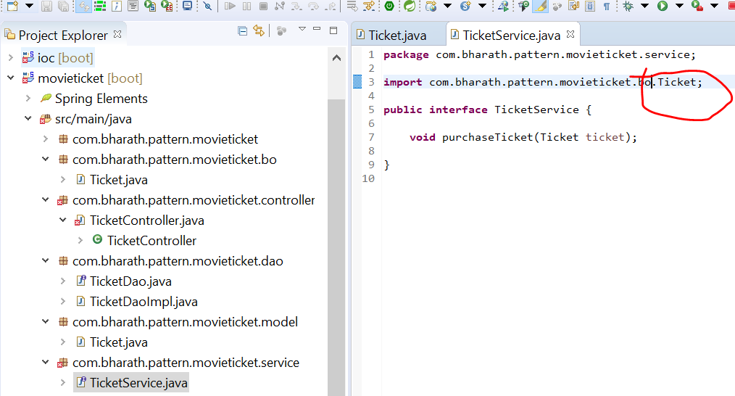

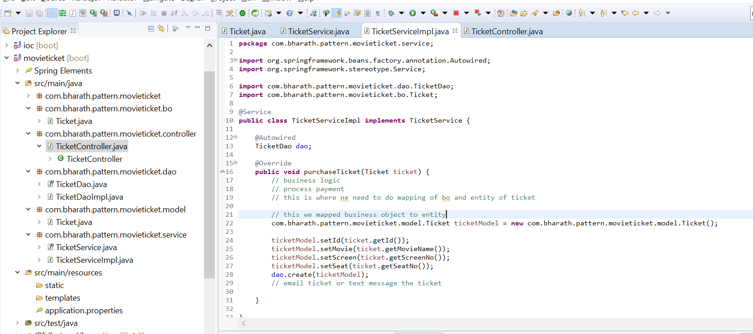

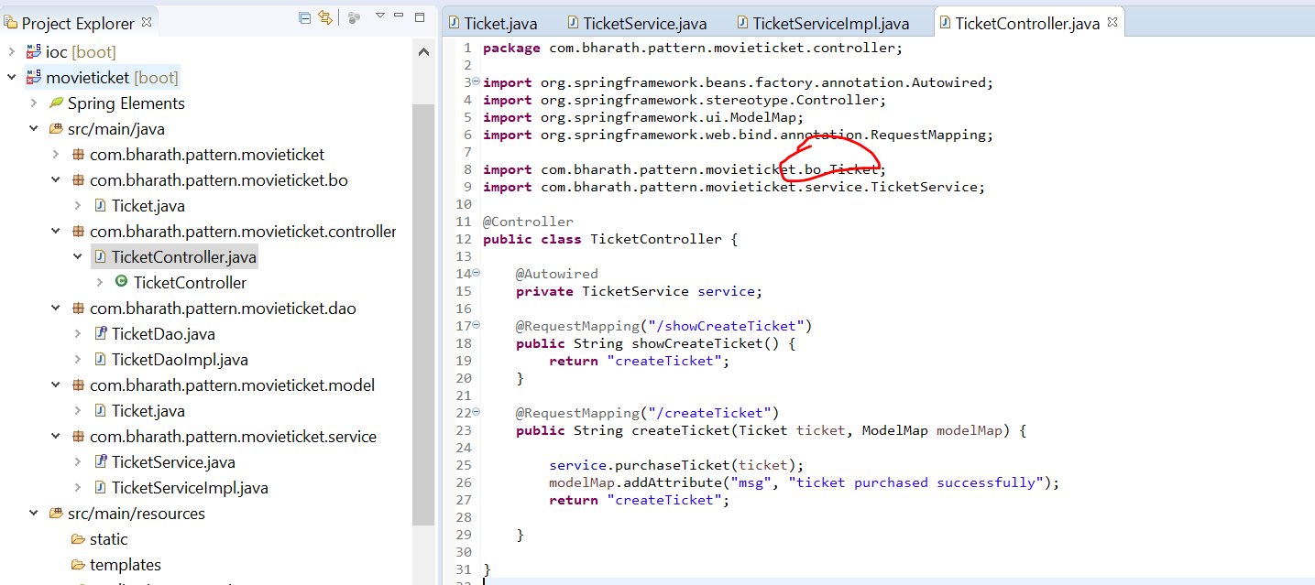

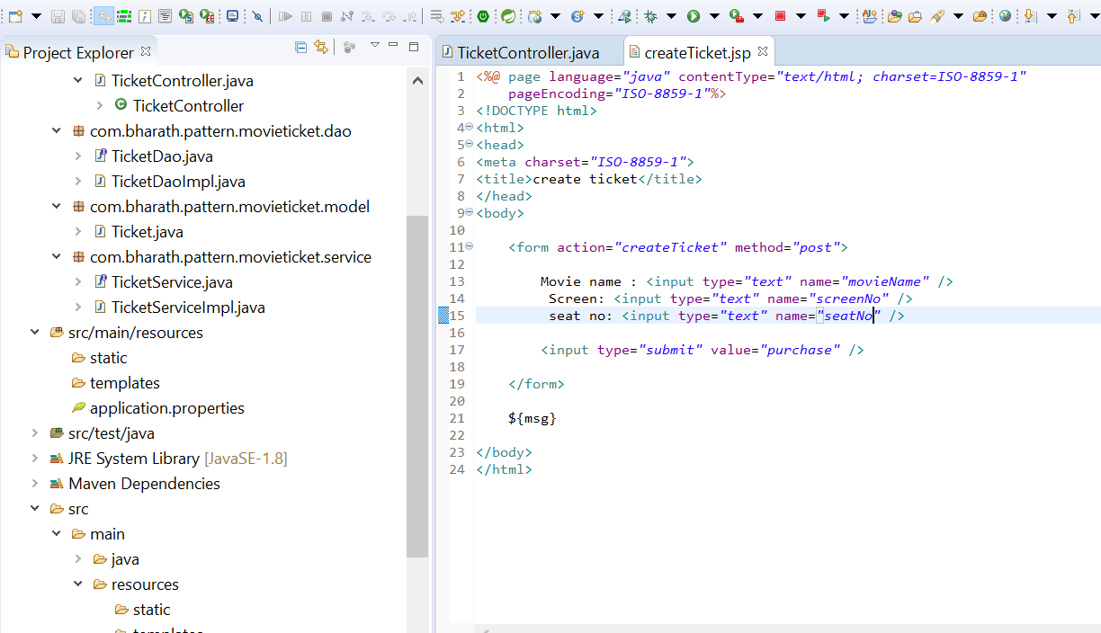

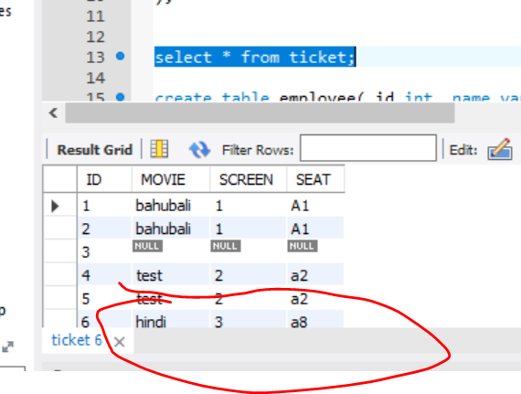

1. **More Patterns**

**A proxy is that something come in place of actual object**

**Proxy Pattern**

A proxy server is a system or router that provides a gateway between users and the internet. Therefore, it helps prevent cyber attackers from entering a private network. It is a server, referred to as an “intermediary” because it goes between end-users and the web pages they visit online.

In place of real object we use proxy object for various reason

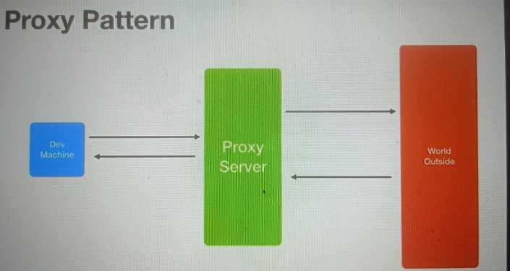

**Remote Proxy**

Client is not aware he is making call on local proxy, he this like he isa making call on web service provider which is running somewhere.

This proxy make our life easier, it will take care all the connection

**In distributed object communication, a local object represents a remote object (one that belongs to a different address space). The local object is a proxy for the remote object, and method invocation on the local object results in remote method invocation on the remote object.**

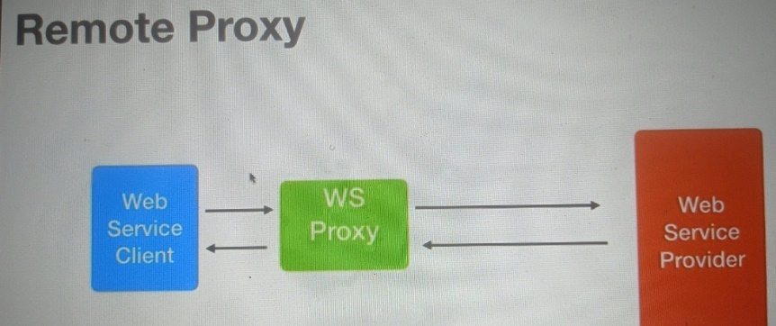

**Virtual Proxy :-**

Which is useful while working tools like spring , hibernate . These tools internally uses virtual proxy.

Orm tool like hibernate can use a virtual proxy to do lazy loading from the d/b so lazy loading is the concept where the entire info need not be loaded from the d/b right away but it loaded lazily as the application need it

Example :- customer.getOrder :- then only data will be loaded. So internally it will create proxy of customer and do this lazy loading

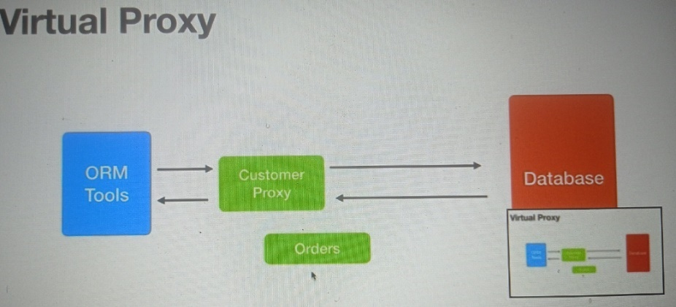

**Security Proxy**

There is security proxy between client and application which is responsible for checking authentication authorize etc.

Only when client passes it will able to make actual call

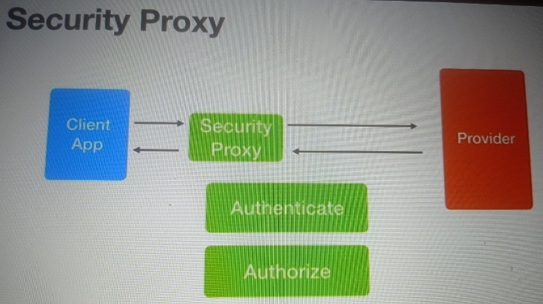

**Create the real classes**

**Requirement :-** will implement lazy loading through virtual proxy pattern

Lazy Loading

Customer

CustomerImpl :- will fetch id

CustomerProxyImpl : will fetch customer oder and it is the proxu class for customerImpl

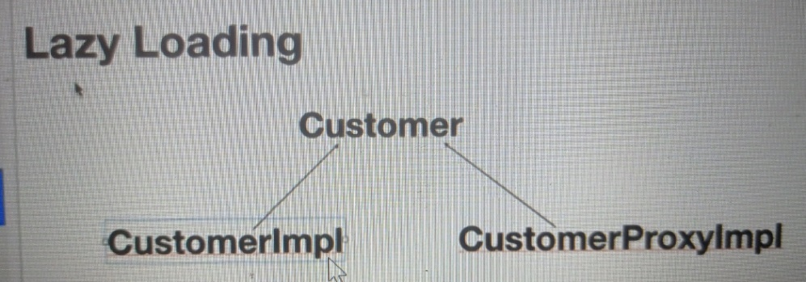

Loading the order information only when it is accessed for the first time

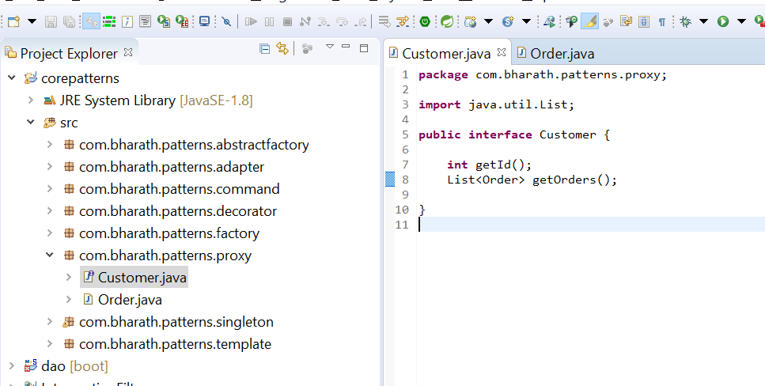

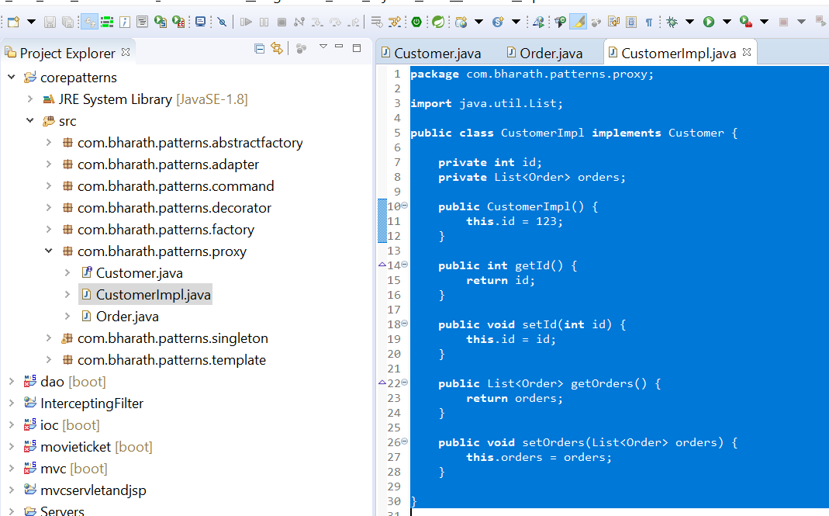

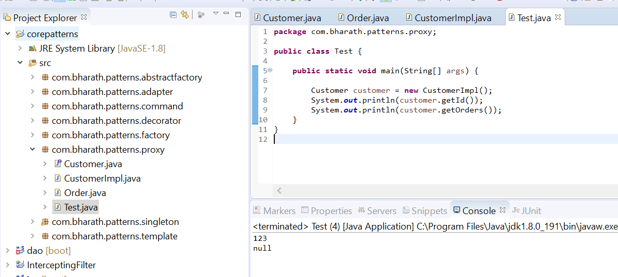

**Note :**

The order is not loaded here

**Proxy in action**

CustomerProxyImpl neede access to CustomerImpl

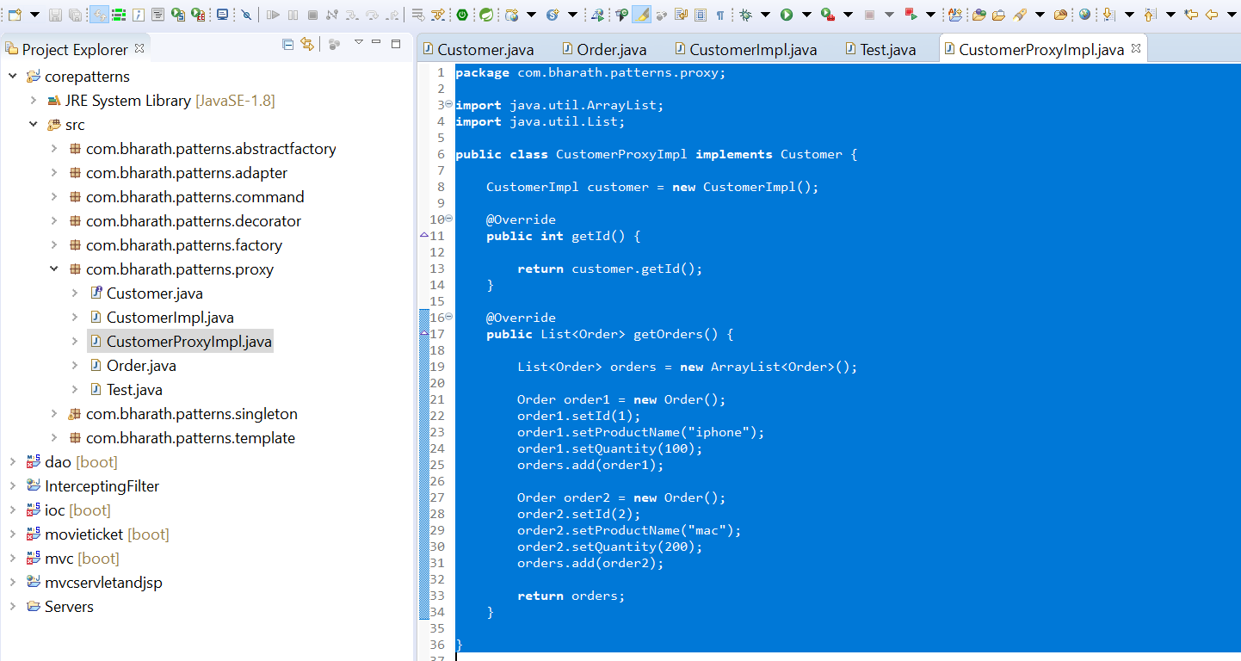

Now in test class instead of using actual customerImpl will use proxy class

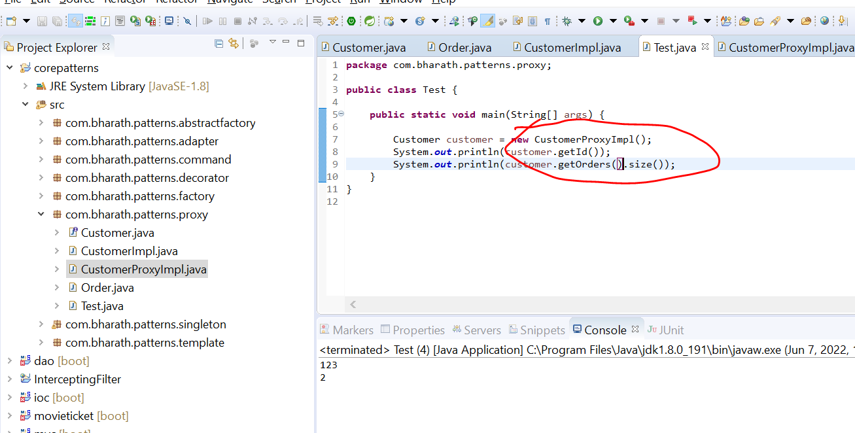

Frame like hibernate using reflection they create proxy on the fly

1. Prototype

It is creational design pattern that uses an existing object to create new object

Example :

Suppose many gamers login the instead of initializing everything again a prototype should be ready

Prototype is a creational design pattern that allows cloning objects, even complex ones, without coupling to their specific classes. All prototype classes should have a common interface that makes it possible to copy objects even if their concrete classes are unknown.

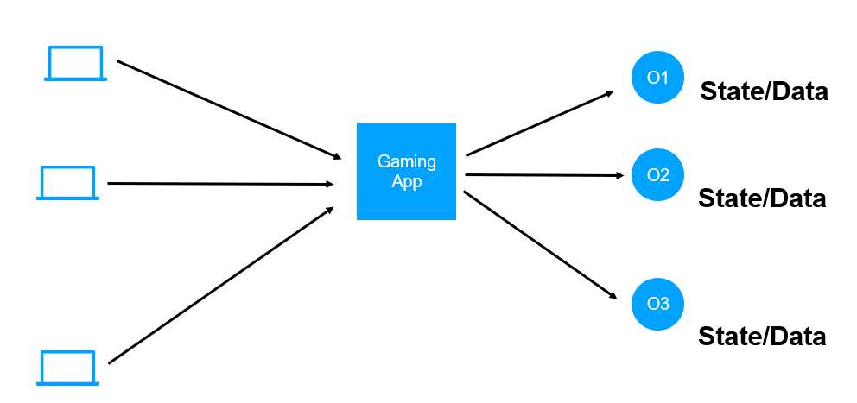

|  |  |
| --- | --- |
| Prototype :-- where it create multiple object very quick |  |

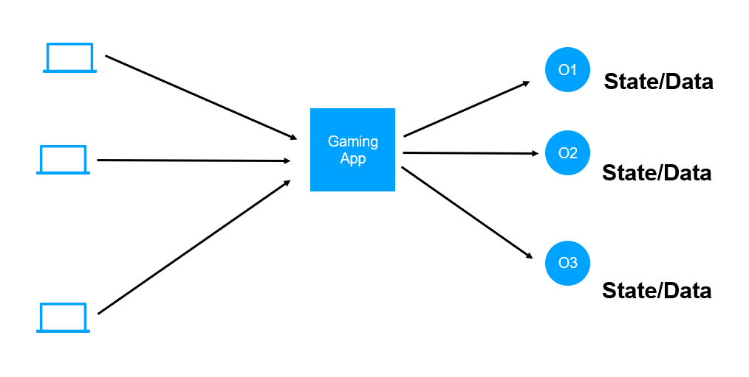

**Implement Prototype pattern**

**Cloneable :- allow instance of class to be cloned**

CloneNotSupportedException is thrown to show that the clone method in class Object has been called to clone an object, but that the object's class does not implement the Cloneable interface.

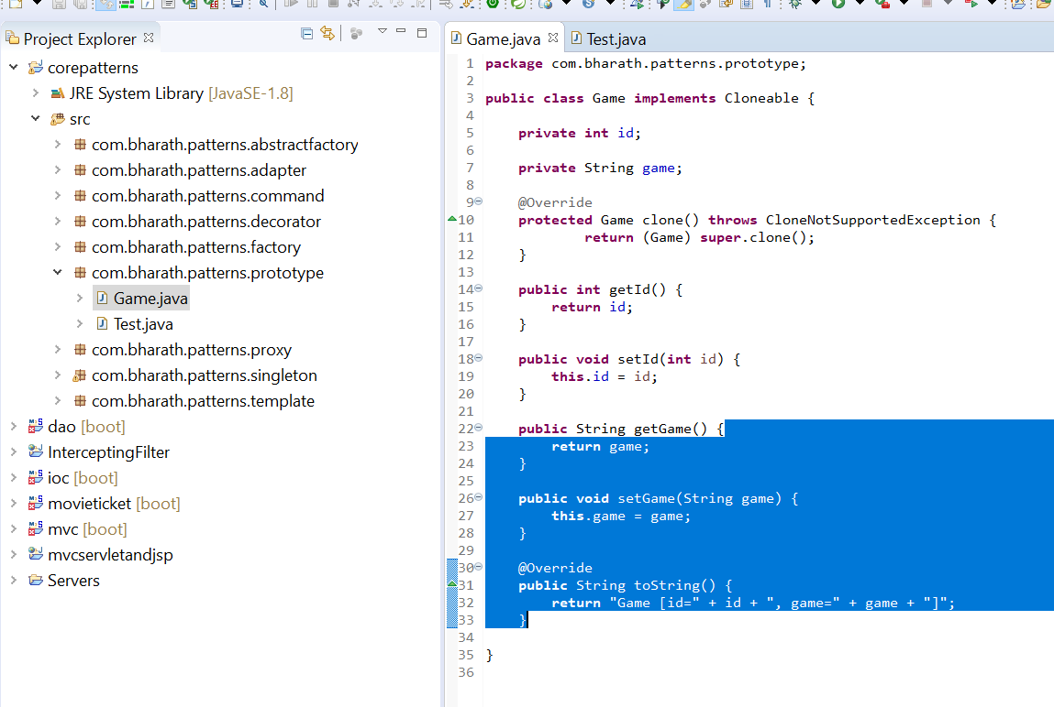

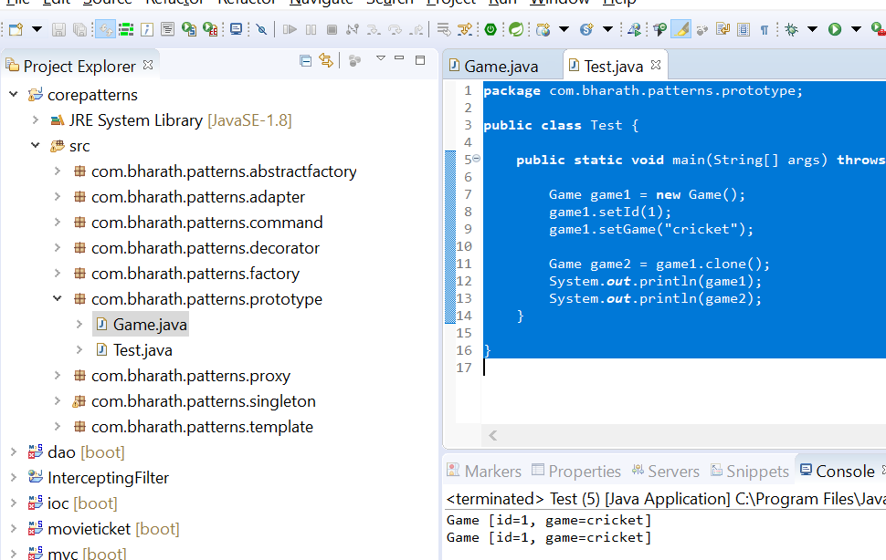

*That is how we can create prototype pattern instead of creating object from scratch which will save lot of time when lot of properties are there like db connection.*

At one object will have all of them then we can create quickly multiple object using clone method.

**Shallow copy**

**Default implementation of clone method is shallow copy**

**Shallow Copy In Java :**

The default version of clone() method creates the shallow copy of an object. The shallow copy of an object will have exact copy of all the fields of original object. If original object has any references to other objects as fields, then only references of those objects are copied into clone object, copy of those objects are not created. That means any changes made to those objects through clone object will be reflected in original object or vice-versa. Shallow copy is not 100% disjoint from original object. Shallow copy is not 100% independent of original object.

**Deep Copy In Java :**

Deep copy of an object will have exact copy of all the fields of original object just like shallow copy. But in additional, if original object has any references to other objects as fields, then copy of those objects are also created by calling clone() method on them. That means clone object and original object will be 100% disjoint. They will be 100% independent of each other. Any changes made to clone object will not be reflected in original object or vice-versa.

To create a deep copy of an object, you have to override the clone()

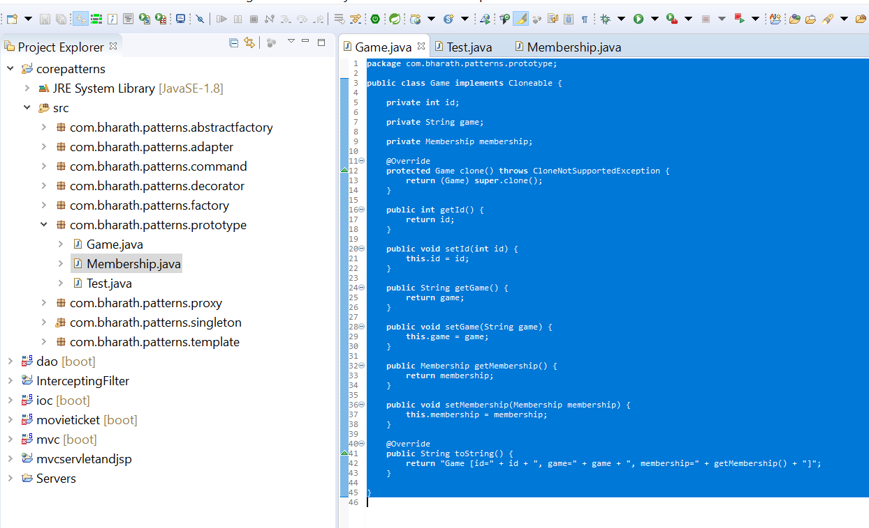

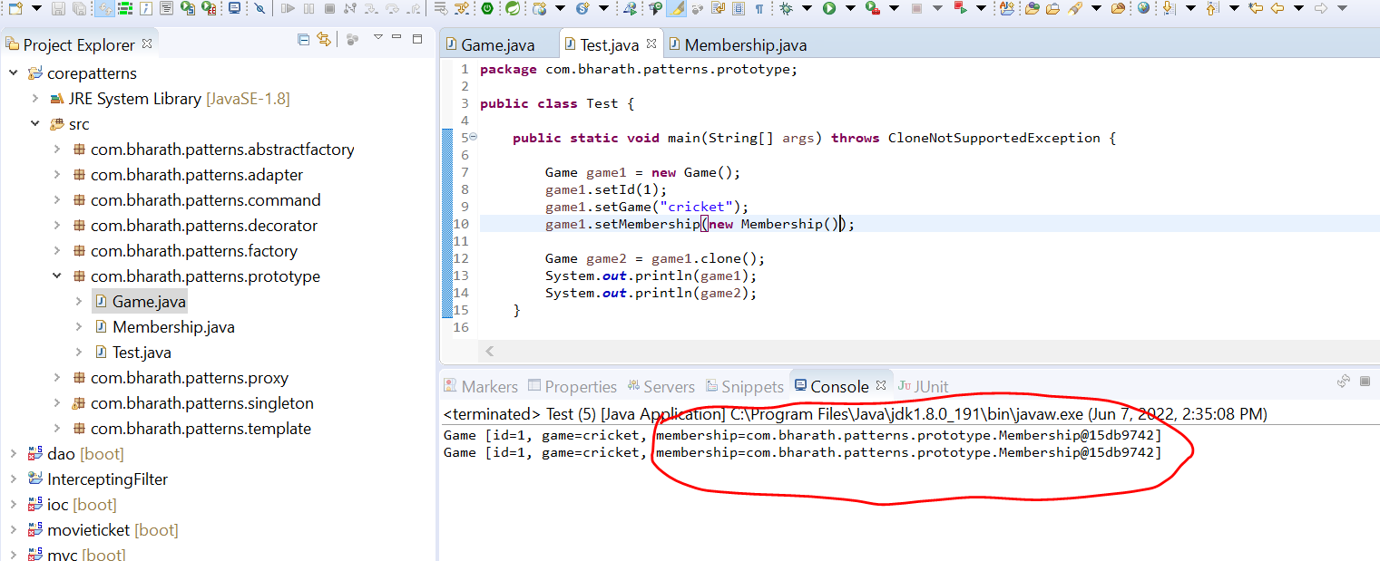

*Note :*

Here we got same membership which is pointing to same object so to get different instance of membership w**e need to use deep copy**

**We need to overwrite clone method**

The same membership cannot be accept by both the player who are playing game

**Deep copy and copy constructor**

**Deep clone**

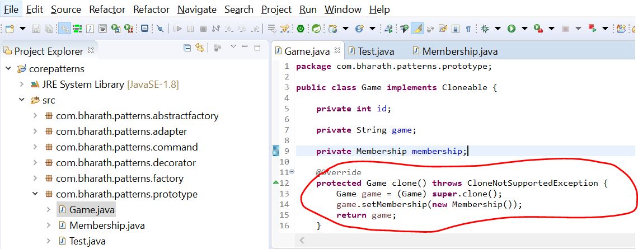

*Now we get two different object of Membership*

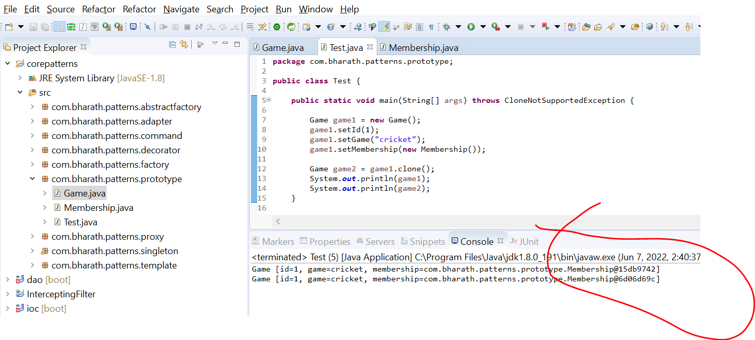

**Using copy constructor deep copy**

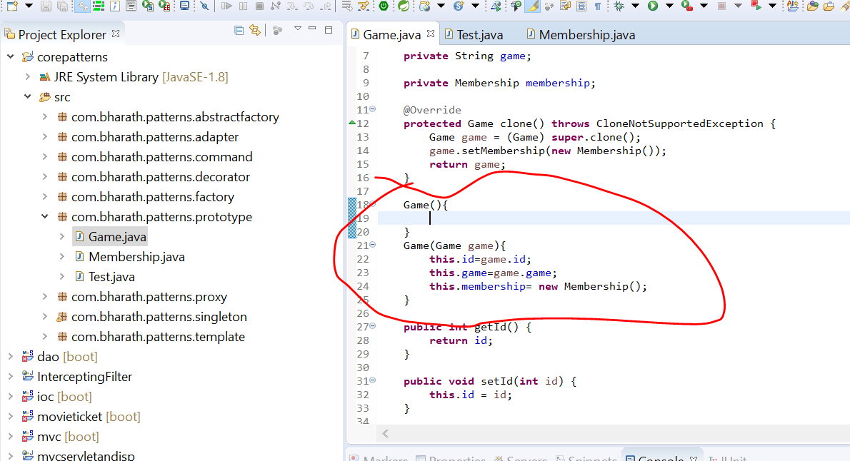

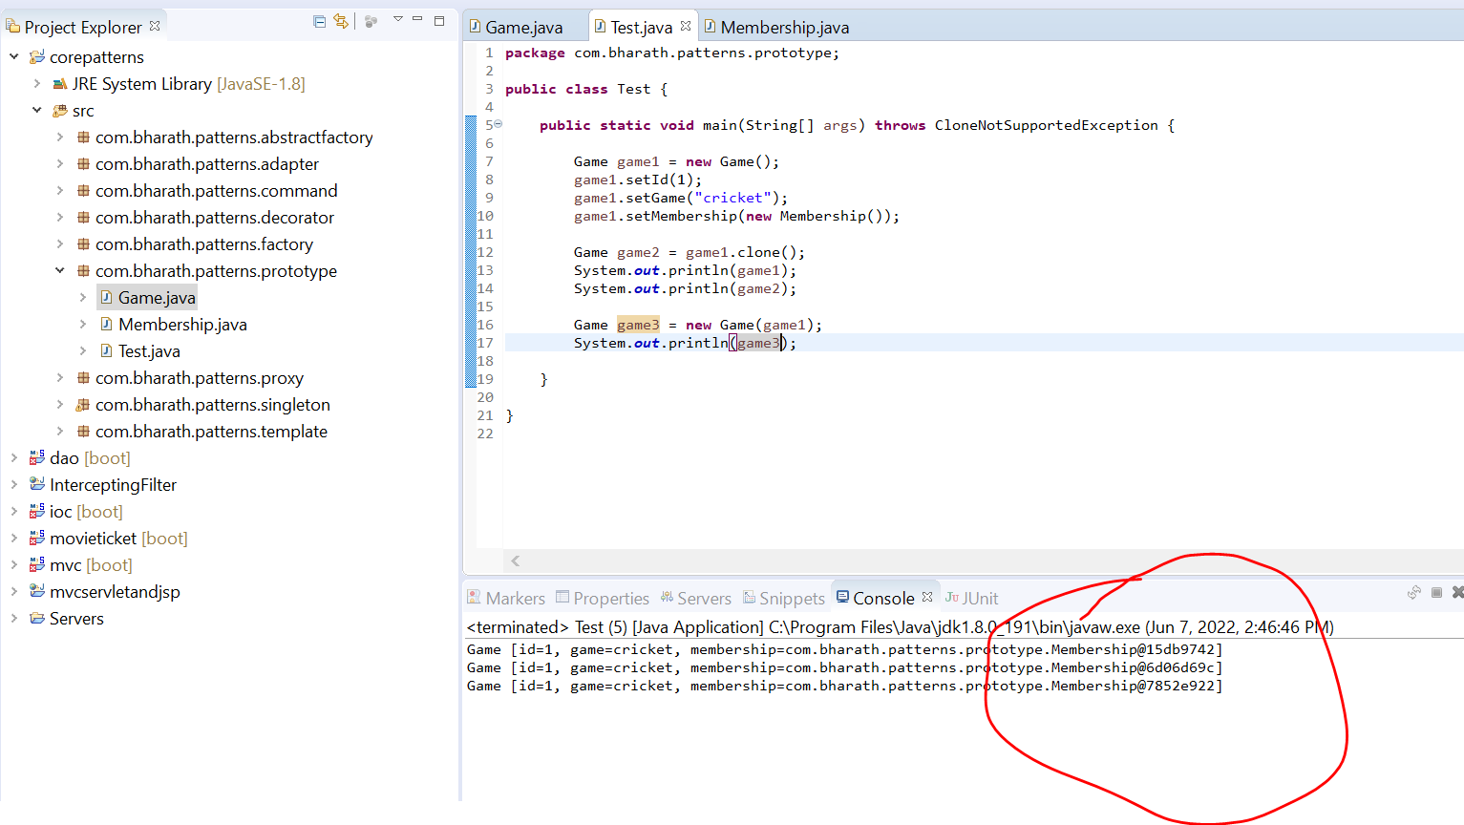

**Note :**

We are getting different membership of object

**Note :--** copy constructor and clone we use for prototype method

**Advantages:--** we can create as many object as we want with same info or initial state

**Disadvantages:-**

we need to make sure to clone all the references as well so we need to make sure there is no circular dependency in deep copy

Means game uses membership and membership uses obj and obj uses game again

14 - Builder Pattern

The builder pattern is a design pattern that allows for the step-by-step creation of complex objects using the correct sequence of actions

**Requirement :**

First will create a problem then solution

Let say we are creating HttpClient class that is responsible for making http calls. And this class can be used by other class which want to make http calls

In http client we can pass method ,url,username,pw but some application don’t want to pass username and pw then we can pass as null.

But for other developer this will become tough what null stands for that is where builder pattern come in picture.

**So once we implement builder pattern the code is much more readable and configurable as well and they can skip other parameter by not**

**Invoking the method**

**The Problem**

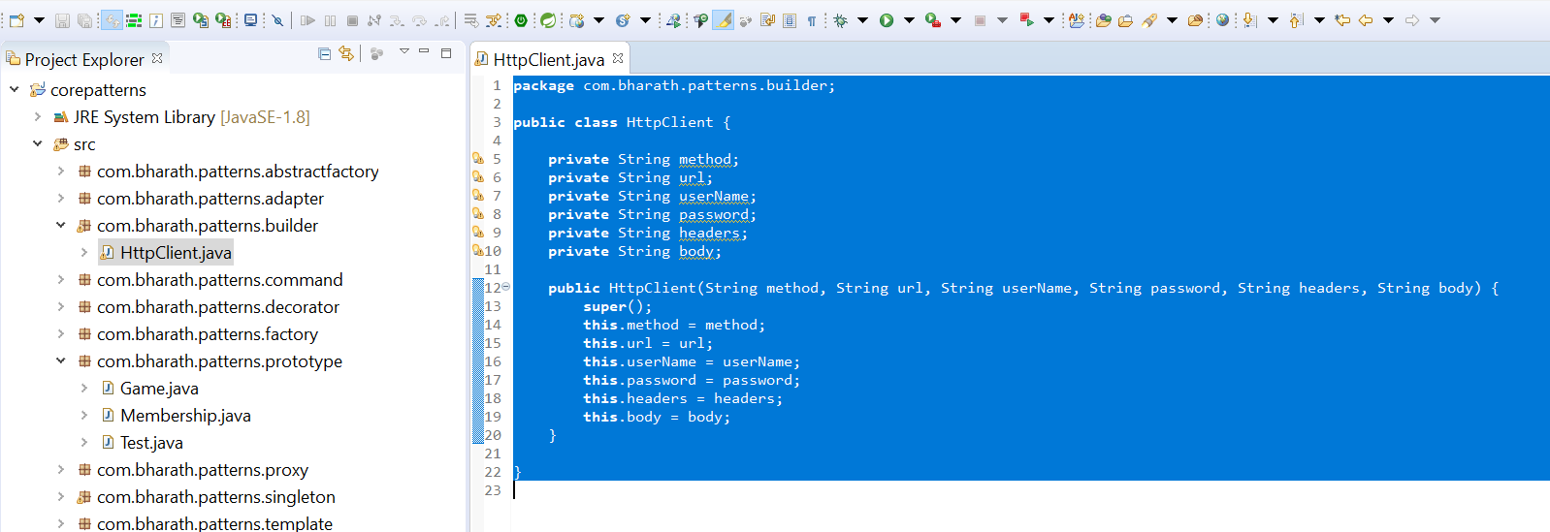

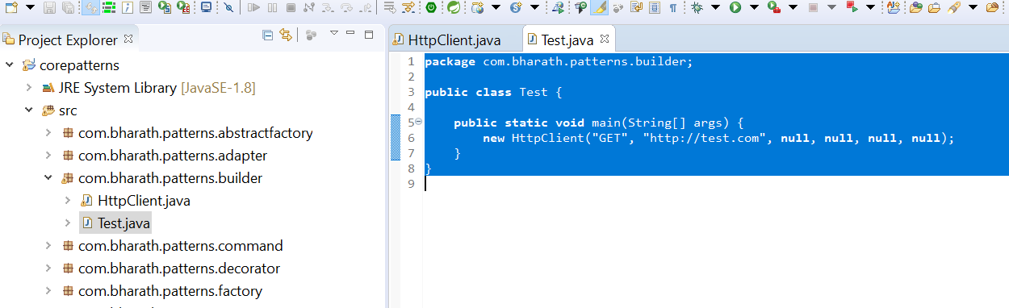

Note :--

If any developer look this code , he will get confuse what this null correspond to. This is not very readable code that is where builder pattern come in picture. Builder pattern give us option what we want and code is more readable.

**Code walk through**

We need a builder class that will make it easy for end client to create an instance of the object just by configuring setting the properties they need and leave the rest

**HttpClientBuilder :---**

will have copy of all the properties the actual class has of which instance we are going to create

And for each of the property we are going to create a method and each of the method will return instance of the same class

.build : instantiation of httpclient happen which all the properties they want to set

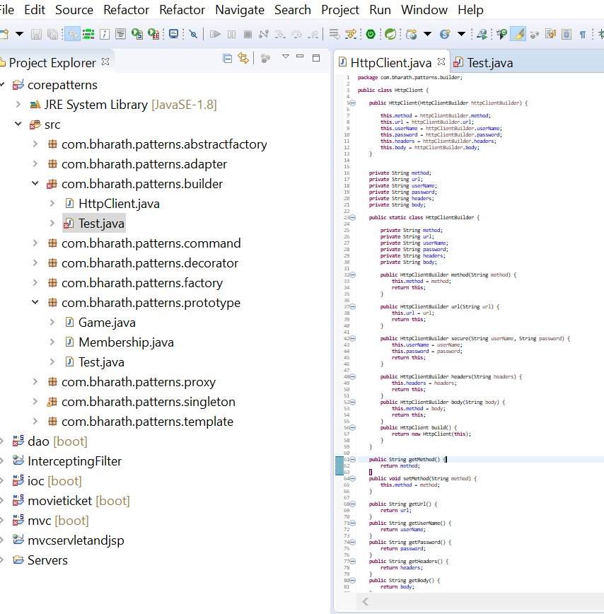

Test

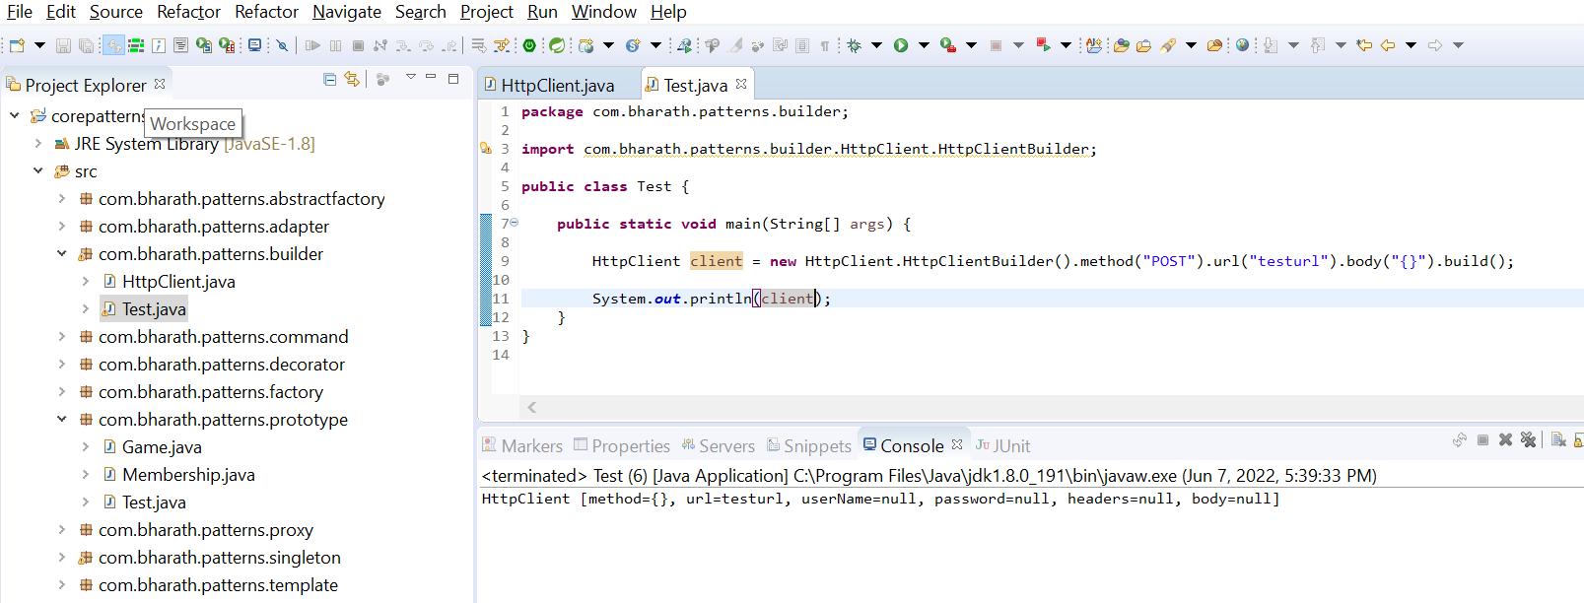

Now the code is much more readable

15-Façade

Facade pattern makes a complex system easy to use for the client application

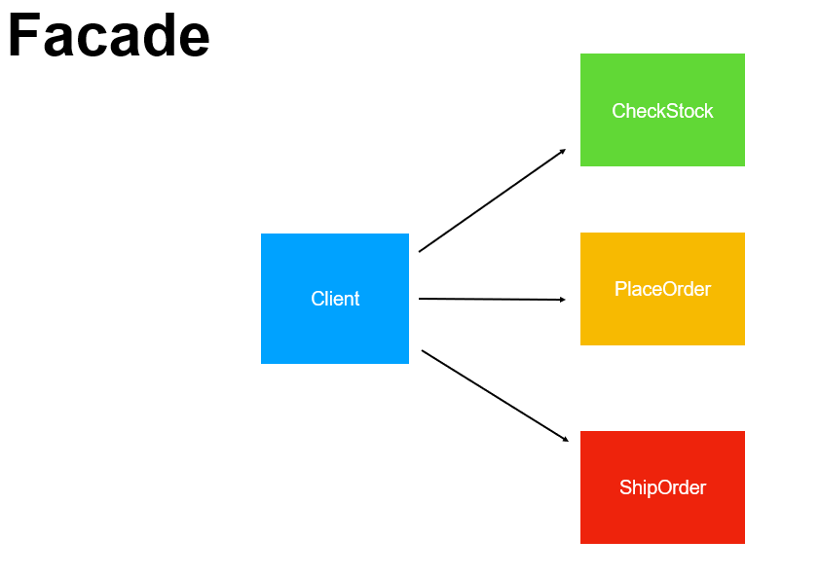

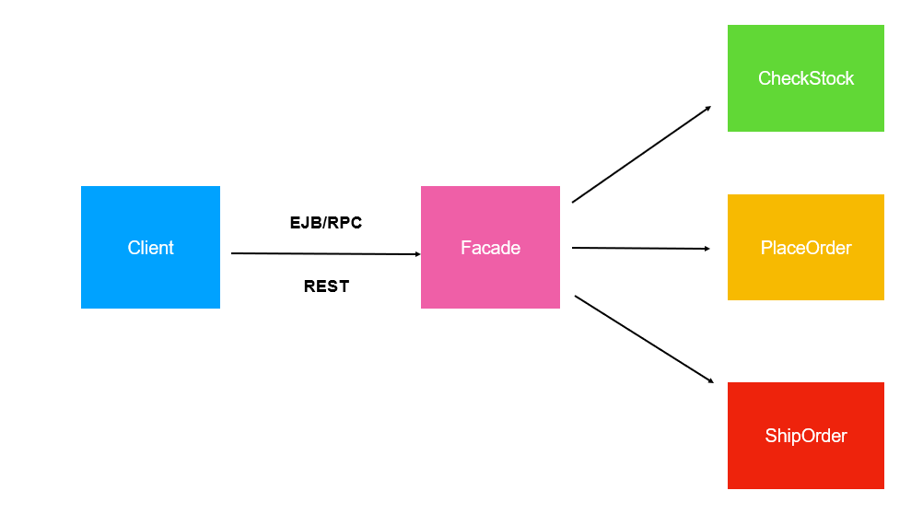

Here façade will have everything . Client just need to interact with façade and façade is responsible for everything else.

Façade will be aware of other classes or method. Client will make single call to façade which will make all other call.

Façade hides the complexity of the system. These can be multiple classes or these can be method within single class

OrderFacade class know how to process OrderProcessor

Façade can deal with multiple classes or multiple method

**Create the problem**

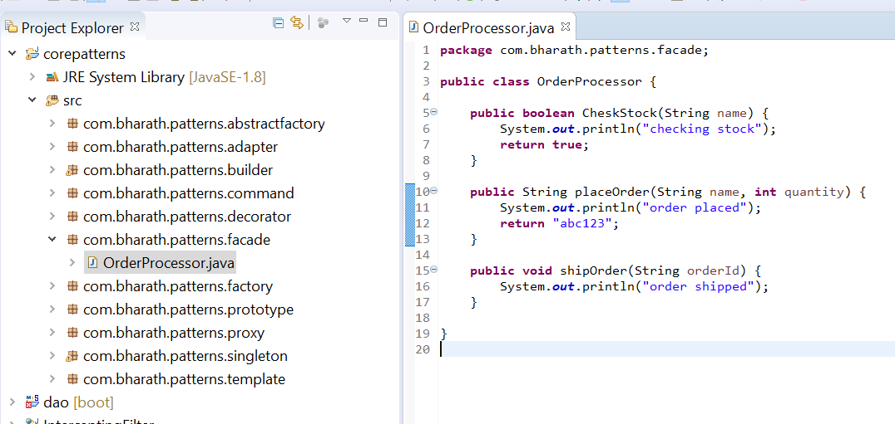

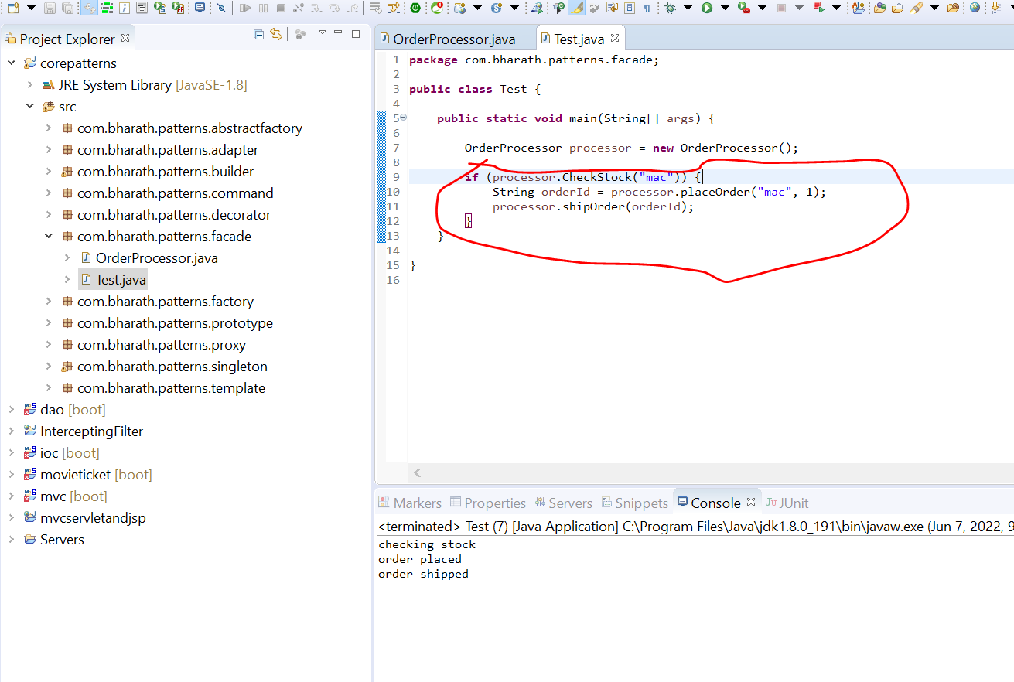

Note :

**This logic is repeated in all client that is where façade come in picture**

**Create The façade Solution**

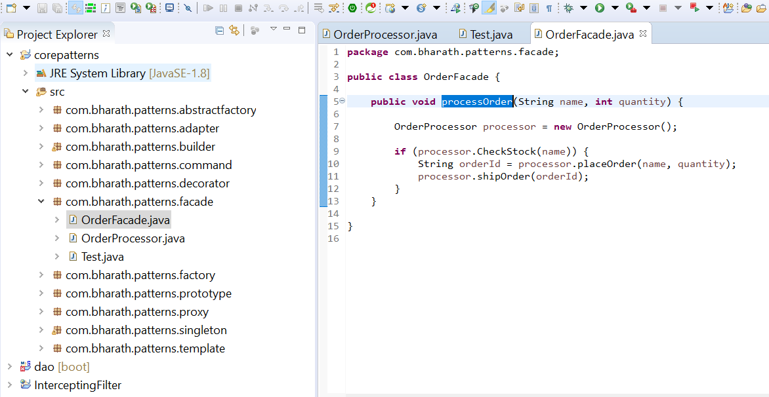

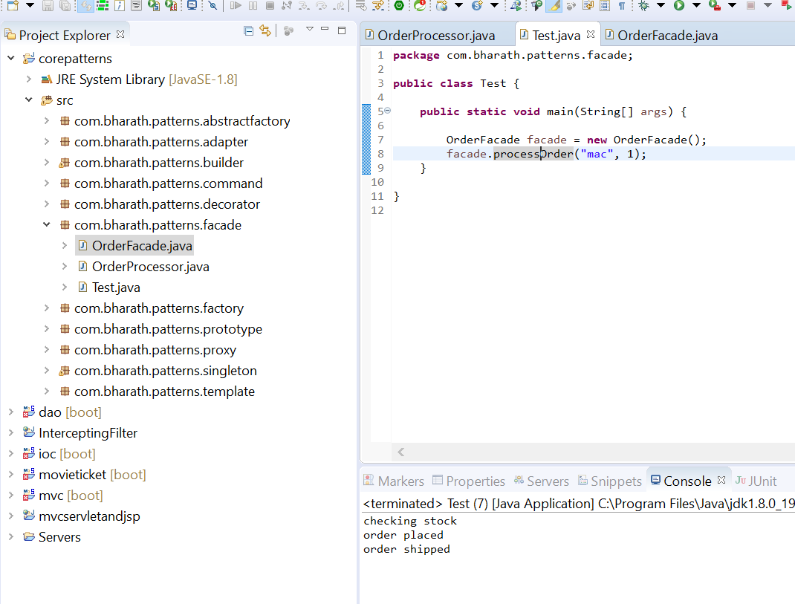

**Note :**

in network call façade is very helpful

Façade will hide entire logic from the client

1. **Iterator**

Iterator help to iterate over element in collection

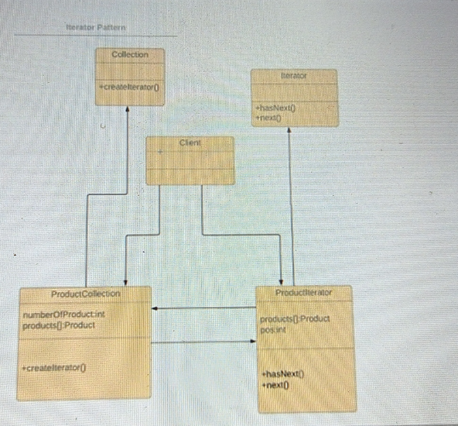

**Code Walkthrough**

**Step:-**

Creating a pojo

Create collection interface

Implement the collection

Create interface iterator

Implement the iterator

**Create Project and implement iterator**

